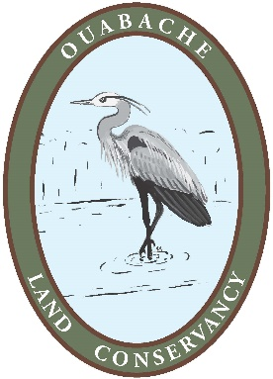
OUABACHE LAND CONSERVANCY
9th ANNUAL MEMBERSHIP MEETING
RESERVATION FORM
Friday, April 5, 2019 @ Rod & Gun Steakhouse (2525 E Lambert Ave, Rosedale, IN)
Social Hour & Silent Auction @ 6:00 PM and Dinner @ 7:00 PM
Guest Speaker: Matt Williams, Director of Conservation Programs for Indiana TNC
MENU Quantity
Strip Steak, 15 oz. @ $18.99 _Enter#_
(medium unless noted otherwise, see below to order otherwise*)
Filet Steak, 9 oz. @ $21.99 _Enter#_
(medium unless noted otherwise, see below to order otherwise*)
Fried Shrimp, 8 pc. @ $18.00 _Enter#_
Chicken Breast, 1 pc. (Grilled) @ $11.99 _Enter#_
Chicken Breast, 1 pc. (Fried) @ $11.99 _Enter#_
Tilapia, 1 pc. (Grilled) @ $14.99 _Enter#_
Tilapia, 1 pc. (Fried) @ $14.99 _Enter#_
Vegetarian, Green Beans, Broccoli, Corn & Baked Potato @ $9.99 _Enter#_
All Dinners include baked potato, roll, tossed salad w/French, Ranch or Italian
Kids Menu, Chicken Strips (2 pc.), Fries, & Apple Sauce @ $7.99 _Enter#_
*If you want steaks prepared other than medium, please state your preference here: _State preference for each steak ordered (unless medium) here__
Note: Prices do not include tax & gratuity. Attendees will pay for meals directly afterwards to the Rod & Gun Steakhouse. Additional cost is $25 per couple/family for renewing OLC members or $15 per couple/family for new members. OLC payment can be made at this meeting if not previously paid for in 2019.
Name(s):__Enter the names of everyone in your party here
Address:_Enter your mailing address here
Email:_Enter your email here________Phone #:__Enter your phone # here___
Email this form to ouabachelandconservancy@gmail.com by March 29.

