Otter Creek –Goal Setting Guidance
Water quality improvement or protection goal statements based on the calculated loads. Social and/or administrative goal statements may also be developed.
Each goal statement needs to include:
a. Problem or pollutant
b. Current pollutant load or current pollutant level (usually expressed as a concentration) for water quality goal statements, or current condition of the problem for social/administrative goal statements
c. The target pollutant load, level, or condition of the problem (the target is your goal)
If water quality standards exist for a pollutant, the goal, at a minimum, must be to meet that standard. If a NPS TMDL has been developed for the watershed, the goal, at a minimum, must be designed to achieve the pollutant load reduction called for in the NPS TMDL.
d. A timeframe for when the group expects the goal to be met. One method of drafting timeframes is to estimate, using the load reductions associated with each BMP, how many BMPs would have to be installed to meet the goal and how long that realistically may take.
Interim load reductions, and thus, goals may also be included: No matter the pollutant, it is acceptable for groups to calculate loads over smaller time periods, such as per season, month, or flow condition.

Otter Creek – Draft Goals

Problem: Area streams are impaired for recreational contact by IDEM’s 303(d) list (high E. coli)
Potential Cause: E.coli levels exceed the water quality standard
Critical Areas: The working group identified the following targets for prioritizing nutrient critical areas:

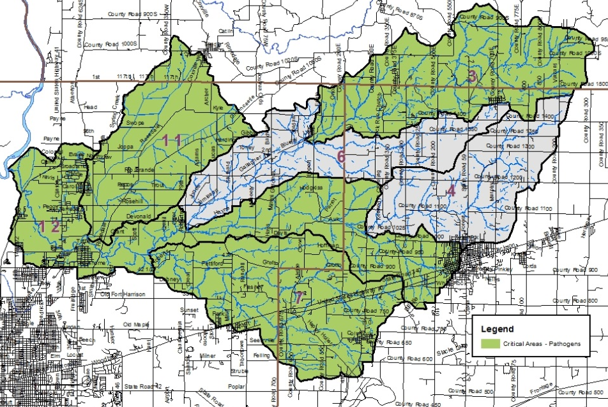
- Percent of samples exceeding target concentrations historic data
- Percent of samples exceeding target concentrations current data
- Manure volumes
- Percent urban land use

E. coli Priority Subwatersheds: Gundy Ditch, North Branch Otter Creek, Sulfur Creek, Wastewaters Creek-Otter Creek

 |  | Current | Target | Reduction | % Reduction | TMDL % Reduction  Required
Site | Subwatershed | Ecoli Annual Load | Ecoli Annual Load | Ecoli Annual Load | Ecoli | E. coli
3 | North Branch | 5.56E+14 | 7.83E+13 | 4.78E+14 | 86% | 63.2%
4 | Head Otter | 2.51E+14 | 5.45E+13 | 1.97E+14 | 78% | 49.3%
6 | Little-North | 7.08E+14 | 1.36E+14 | 5.71E+14 | 81% | 52.5%
7 | Sulfur | 4.54E+14 | 7.82E+13 | 3.76E+14 | 83% | 67.2%
11 | Gundy | 3.17E+14 | 6.32E+13 | 2.54E+14 | 80% | 84.4%
12 | Wastewaters | 2.51E+15 | 4.20E+14 | 2.09E+15 | 83% | 59.8%

Ultimate Goal (Draft): Reduce E. coli inputs so that they do not exceed the state standard: from 2.51x10¹⁵ col/year per year to 2.09x10¹⁵ col per year (83% reduction) in the Otter Creek Watershed by 2049 (30 years). Note: Used Wastewaters-Otter Creek reduction as it represents the entire Ottershed.

Problem: Area streams are very cloudy and turbid
Potential Cause: Total Suspended Sediment concentrations and turbidity levels exceed the targets set by this project
Critical Areas: The working group identified the following targets for prioritizing nutrient critical areas:

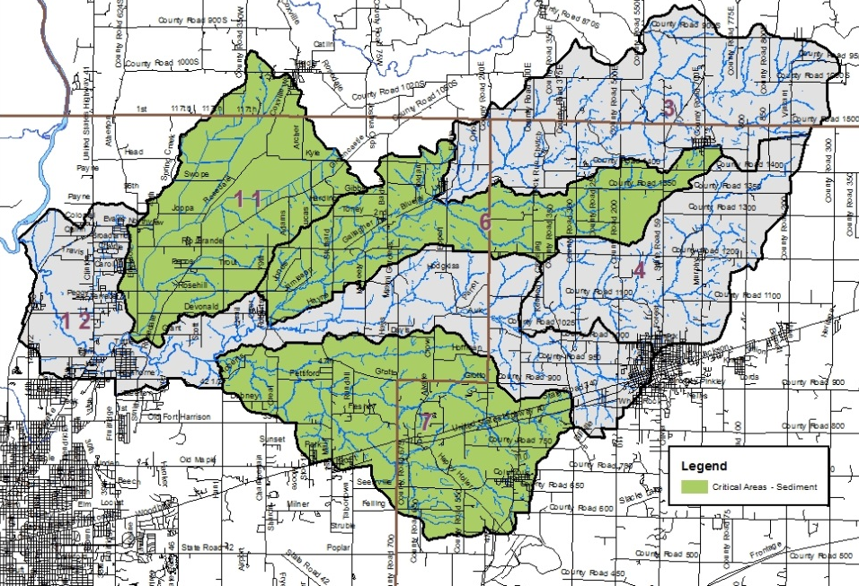

- Percent of samples exceeding target concentrations historic data
- Percent of samples exceeding target concentrations current data
- Percent agricultural land use
- Percent urban land use

Total Suspended Solids Priority Subwatersheds: Gundy Ditch, North Branch Otter Creek, Sulfur Creek

 |  | Current | Target | Reduction | % Reduction
Site | Subwatershed | TSS Annual Load | TSS Annual Load | TSS Annual Load | TSS
3 | North Branch | 8,262,473.3 | 1,101,461.9 | 7,161,011.4 | 87%
4 | Head Otter | 3,649,085.9 | 766,053.5 | 2,883,032.4 | 79%
6 | Little-North | 16,741,675.8 | 1,913,587.6 | 14,828,088.2 | 89%
7 | Sulfur | 13,464,128.5 | 1,099,862.2 | 12,364,266.3 | 92%
11 | Gundy | 8,650,878.4 | 888,394.1 | 7,762,484.3 | 90%
12 | Wastewaters | 41,385,308.8 | 5,910,532.0 | 35,474,776.8 | 86%

Ultimate Goal (Draft): Reduce total suspended solids inputs from 30,377,480 pounds per year to 3,089,718 pounds per year (90% reduction) in the Otter Creek Watershed by 2049 (30 years).

Problem: Area streams have nutrient levels exceeding the target set by this project
Potential Cause: Nutrient levels exceed the target set by this project
Critical Areas: The working group identified the following targets for prioritizing nutrient critical areas:

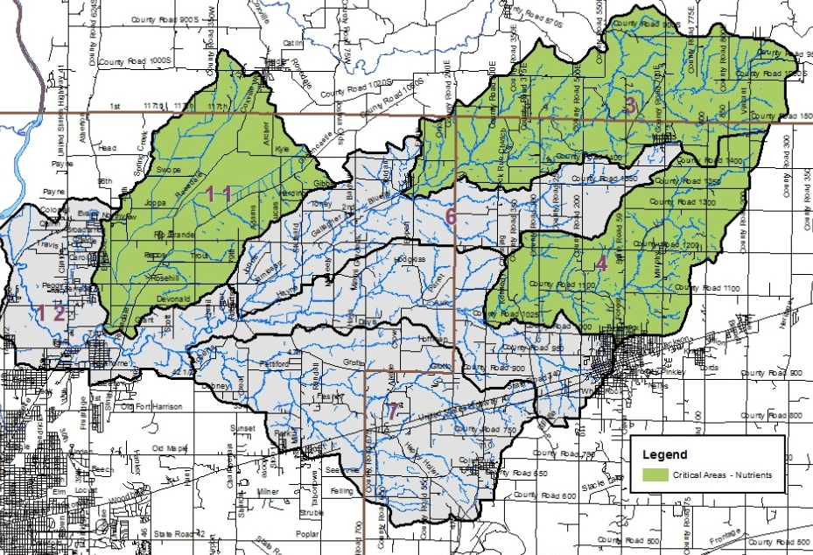
- Percent of samples exceeding target concentrations historic data
- Percent of samples exceeding target concentrations current data
- Tile drainage – percent of watershed
- Row crop + pastureland – percent of watershed

Nutrient Priority Subwatersheds: Gundy Ditch, North Branch Otter Creek, Headwaters Otter Creek

 |  | Current |  | Target |  | Reduction |  | % Reduction
Site | Subwatershed | NO3 Annual  Load | TP Annual  Load | NO3 Annual Load | TP Annual Load | NO3 Annual Load | TP Annual Load | Nitrate | Total Phosphorus
3 | North Branch | 196,284.2 | 47,907.9 | 36,715.4 | 2,202.9 | 159,568.8 | 45,705.0 | 81% | 95%
4 | Head Otter | 177,113.1 | 19,254.8 | 25,535.1 | 1,532.1 | 151,578.0 | 17,722.7 | 86% | 92%
6 | Little-North | 353,033.5 | 104,080.8 | 63,786.3 | 3,827.2 | 289,247.3 | 100,253.6 | 82% | 96%
7 | Sulfur | 219,229.2 | 40,747.6 | 36,662.1 | 2,199.7 | 182,567.2 | 38,547.9 | 83% | 95%
11 | Gundy | 231,861.3 | 37,717.0 | 29,613.1 | 1,776.8 | 202,248.1 | 35,940.2 | 87% | 95%
12 | Wastewaters | 998,641.4 | 189,269.1 | 197,017.7 | 11,821.1 | 801,623.7 | 177,448.0 | 80% | 94%

Ultimate Goal (Draft): Reduce nitrate-nitrogen from 605,258 pounds per year to 91,864 pounds per year (85% reduction) and phosphorus from 104,880 pounds per year to 5,512 pounds per year (95% reduction) in the Otter Creek Watershed by 2049 (30 years).

Problem: A unified education program for entire watershed does not currently exist
Potential Cause: Educational efforts targeting funders, local agencies, and the public are lacking.
Critical Areas: Entire Watershed

Ultimate Goal (Draft): Increase public awareness and knowledge about the Ottershed and what individuals and communities can do to improve the quality of these watersways by 2049 (30 years).

Problem: High quality, non-invasive species impacted forests are limited

Potential Cause: Forest land is impacted by competing land uses and invasive species
Critical Areas: All forested areas in the watershed.

Ultimate Goal (Draft): Reduce the spread of invasive species and improve connectivity of forested parcels throughout the Ottershed by 2049 (30 years).

