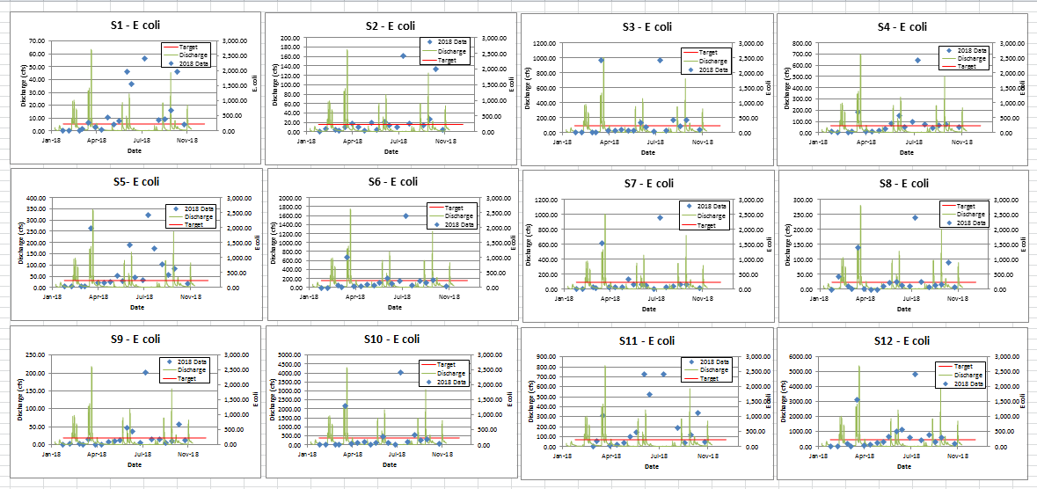
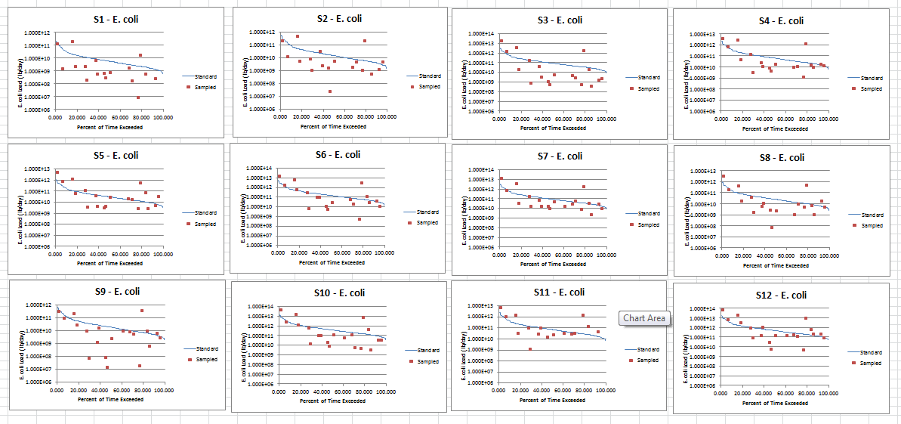

Item | 051201110401 Headwaters | 051201110402 North Branch | 051201110403 Little Creek | 051201110404 Sulfur | 051201110405 Gundy | 051201110406 Wastewaters
Watershed (Acres) | 10,097.9 | 14,500.2 | 10,669.0 | 14,787.5 | 11,716.7 | 17,714.1
Watershed (sq mi) | 15.8 | 22.7 | 16.7 | 23.1 | 18.3 | 27.7
Stream (miles) | 47.1 | 77.6 | 55.1 | 67.4 | 43.4 | 86.9
Impaired Cat 5 (pH) |  |  |  |  |  | 8.2
Impaired Cat 5 % | 0% | 0% | 0% | 0% | 0% | 9%
Impaired Cat 4A (Ecoli) | 25.3 | 43.7 | 31.6 | 36.1 | 28.7 | 46.3
Impaired Cat 4A % | 54% | 56% | 57% | 54% | 66% | 53%
HES (acres) | 2,332.5 | 3,482.4 | 2,488.1 | 3,525.3 | 734.6 | 3,330.7
HES (%) | 23% | 24% | 23% | 24% | 6% | 19%
PHES (acres) | 1,569.5 | 2,392.3 | 2,066.6 | 4,012.7 | 2,700.7 | 3,233.5
PHES (%) | 16% | 16% | 19% | 27% | 23% | 18%
Wetland Loss (acres) | 95% | 93% | 85% | 83% | 87% | 74%
NWI Current (acres) | 228.1 | 527.1 | 572.1 | 800.7 | 127.1 | 1,232.1
NWI Current (%) | 2% | 4% | 5% | 5% | 1% | 7%
Hydric (acres) | 4,215.2 | 7,339.5 | 3,697.7 | 4,797.9 | 987.1 | 4,735.6
Hydric (%) | 42% | 51% | 35% | 32% | 8% | 27%
Septic-VeryLimited | 9,961.2 | 12,928.9 | 10,248.8 | 13,603.2 | 11,525.4 | 17,164.3
Septic-VL (%) | 99% | 89% | 96% | 92% | 98% | 97%
Trash (count) | 7.0 | 0.0 | 1.0 | 1.0 | 3.0 | 7.0
Logjam (count) | 7.0 | 0.0 | 1.0 | 0.0 | 0.0 | 0.0
Abandoned Mine (count) | 1.0 | 0.0 | 1.0 | 1.0 | 1.0 | 5.0
Flooding (count) | 2.0 | 0.0 | 0.0 | 0.0 | 0.0 | 5.0
CFO (animals) |  |  |  | 1,780.0 |  | 2,000.0
Hobby Farm (count) | 25.0 | 10.0 | 21.0 | 20.0 | 13.0 | 24.0
Hobby Farm (animals) | 333.0 | 102.0 | 204.0 | 88.0 | 219.0 | 298.0
Manure estimate (tons) | 2,236.0 | 1,034.0 | 2,097.0 | 8,702.0 | 2,180.0 | 10,282.0
Manure N estimate (lb) | 5,620.0 | 1,336.0 | 2,721.0 | 22,977.0 | 2,449.0 | 28,893.0
Manure P estimate (lb) | 3,713.0 | 755.0 | 1,473.0 | 17,124.0 | 1,314.0 | 21,184.0
MS4 area |  |  |  | 0.5 | 0.6 | 3.5

Item | 051201110401 Headwaters | 051201110402 North Branch | 051201110403 Little Creek | 051201110404 Sulfur | 051201110405 Gundy | 051201110406 Wastewaters
Watershed (Acres) | 10,097.9 | 14,500.2 | 10,669.0 | 14,787.5 | 11,716.7 | 17,714.1
Watershed (sq mi) | 15.8 | 22.7 | 16.7 | 23.1 | 18.3 | 27.7
Stream (miles) | 47.1 | 77.6 | 55.1 | 67.4 | 43.4 | 86.9
Livestock Access (miles) | 3.5 | 3.2 | 15.1 | 0.0 | 0.0 | 0.0
LA (%) | 7% | 4% | 27% | 0% | 0% | 0%
Streambank Erosion (miles) | 13.8 | 14.2 | 0.0 | 12.2 | 1.8 | 9.6
SE (%) | 29% | 18% | 0% | 18% | 4% | 11%
Narrow Buffer (miles) | 1.8 | 0.0 | 0.0 | 0.0 | 4.6 | 0.0
NB (%) | 4% | 0% | 0% | 0% | 11% | 0%
Gully Erosion (miles) | 0.0 | 0.2 | 0.0 | 0.0 | 0.0 | 0.0
Land Use (acres)
Ag - Row +Pasture | 4,767.2 | 6,682.6 | 5,174.2 | 5,189.6 | 8,636.8 | 6,860.7
Forest | 4,451.0 | 6,674.8 | 4,707.8 | 7,991.3 | 2,011.6 | 7,462.9
Wetland + Open water + grass | 182.0 | 238.5 | 174.1 | 570.7 | 90.8 | 429.2
Urban | 697.7 | 904.3 | 612.8 | 1,035.9 | 977.5 | 2,961.2
Land Use (%)
Ag - Row +Pasture | 47% | 46% | 48% | 35% | 74% | 39%
Forest | 44% | 46% | 44% | 54% | 17% | 42%
Wetland + Open water + grass | 2% | 2% | 2% | 4% | 1% | 2%
Urban | 7% | 6% | 6% | 7% | 8% | 17%
Reduced Till (pub mtg) | 0.0 | 652.7 | 144.2 | 639.6 | 727.9 | 776.1
Row crow | 4357.1 | 6281.4 | 4380.9 | 3906.8 | 7950.4 | 6048.4

