Otter Creek Steering Committee Meeting
16 November 2018

Attendees: Larry Owen, Sara Peel, Dana Gadeken, Jim Speer, Sue Berta, Hannah Lynch, Tom Baer, Phil Cox, Betsy Bower

The committee reviewed historic and current water quality date collected to date along with watershed-based data collected through inventory and observation efforts. The committee broke into three groups to identify critical areas for nutrients, sediment and pathogens. There efforts are summarized below.

Nutrients: The working group identified the following targets for prioritizing nutrient critical areas:
- Percent of samples exceeding target concentrations historic data
- Percent of samples exceeding target concentrations current data
- Tile drainage – percent of watershed
- Row crop + pastureland – percent of watershed

Nutrient Priorities: Gundy Ditch, North Branch Otter Creek, Headwaters Otter Creek
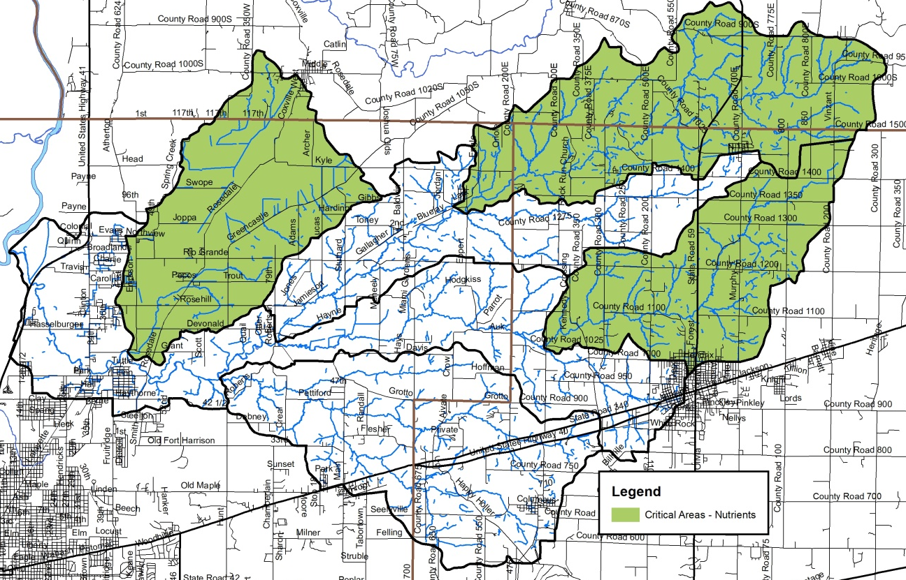

Sediment: The working group identified the following targets for prioritizing nutrient critical areas:
- Percent of samples exceeding target concentrations historic data
- Percent of samples exceeding target concentrations current data
- Percent agricultural land use
- Percent urban land use

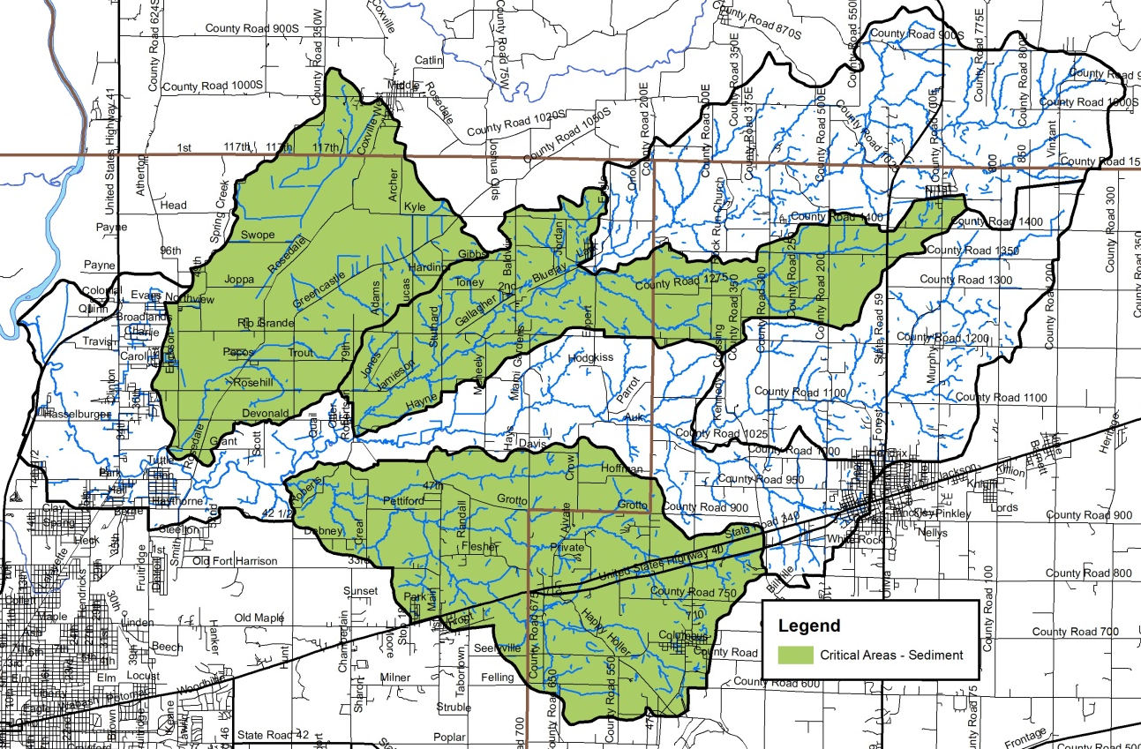

Pathogens: The working group identified the following targets for prioritizing nutrient critical areas:
- Percent of samples exceeding target concentrations historic data
- Percent of samples exceeding target concentrations current data
- Manure volumes
- Percent urban land use

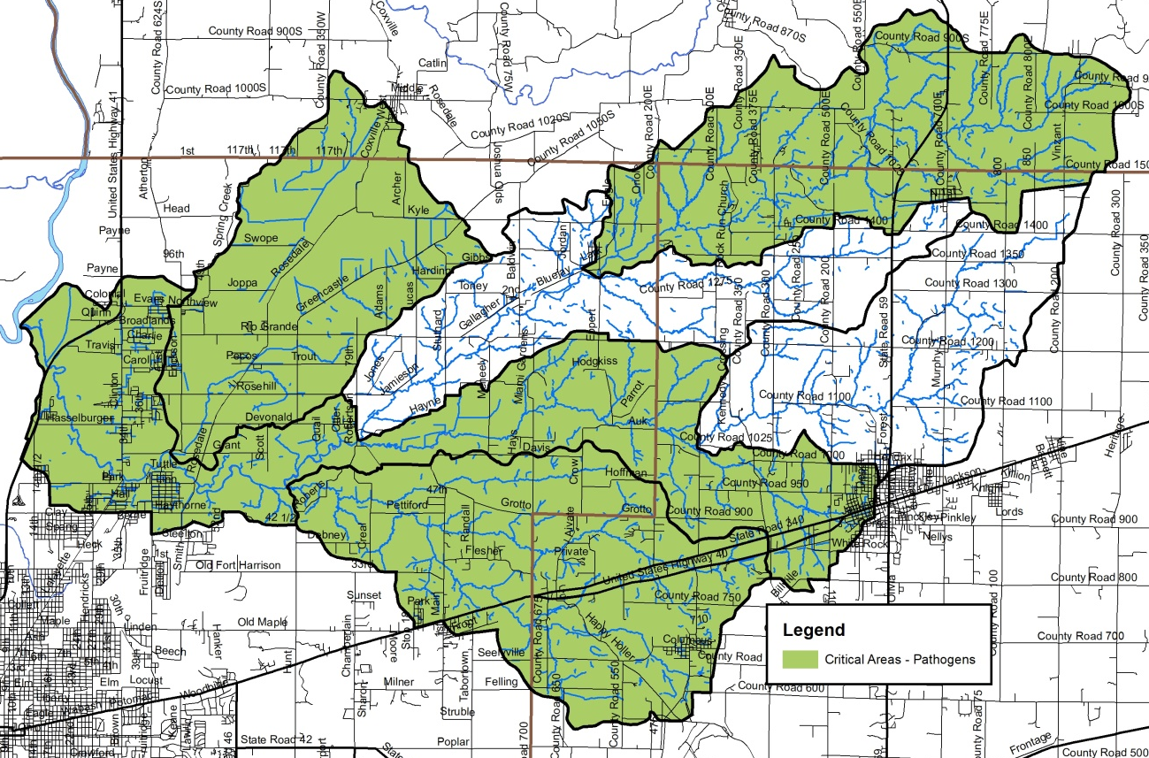

Combined priorities:
