TABLE OF CONTENTS
PAGE
1.0 WATERSHED INTRODUCTION 1
1.1 Watershed Community Initiative 1
1.2 Project History 2
1.3 Stakeholder Involvement 3
1.4 Public Input 4
2.0 WATERSHED INVENTORY I: WATERSHED DESCRIPTION 5
2.1 Watershed Location 5
2.2 Subwatersheds 5
2.3 Climate 6
2.4 Geology and Topography 7
2.5 Soil Characteristics 9
2.6 Wastewater Treatment 14
2.7 Hydrology 19
2.8 Natural History 27
2.9 Land Use 34
2.10 Population Trends 41
2.11 Planning Efforts in the Watershed 42
2.12 Watershed Summary: Parameter Relationships 43
3.0 WATERSHED INVENTORY II-A: WATER QUALITY AND WATERSHED ASSESSMENT 44
3.1 Water Quality Targets 44
3.2 Historic Water Quality Sampling Efforts 45
3.3 Current Water Quality Assessment 54
3.4 Watershed Inventory Assessment 72
4.0 WATERSHED INVENTORY II-B: SUBWATERSHED DISCUSSIONS 73
4.1 Headwaters Otter Creek Subwatershed 74
4.2 North Branch Otter Creek Subwatershed 78
4.3 Little Creek-North Branch Otter Creek Subwatershed 81
4.4 Sulfur Creek Subwatershed 84
4.5 Gundy Ditch Subwatershed 87
4.6 Wastewaters Creek-Otter Creek Subwatershed 91
5.0 WATERSHED INVENTORY III: WATERSHED INVENTORY SUMMARY 94
5.1 Water Quality Summary 94
5.2 Stakeholder Concern Analysis 97
6.0 PROBLEM AND CAUSE IDENTIFICATION 102
7.0 SOURCE IDENTIFICATION AND LOAD CALCULATION 104
7.1 Source Identification: Key Pollutants of Concern 104
7.2 Load Estimates 108
8.0 CRITICAL AND PRIORITY AREA DETERMINATION 110
8.1 Critical Areas for Nitrate-Nitrogen and Total Phosphorus 111
8.2 Critical Areas for Sediment 112
8.3 Critical Areas for E. coli 113
8.4 Critical Areas Summary 114
9.0 GOAL SETTING 114
9.1 Goal Statements 114
10.0 Indicators, Strategies, and Milestones for Reaching Goals 116
10.1 Indicators of Success 117
11.0 LITERATURE CITED 118

TABLE OF FIGURES

PAGE
Figure 1. Wabash River watershed highlighting the Otter Creek Drainage. 1
Figure 2. 12-digit Hydrologic Unit Codes in the Otter Creek Watershed. 6
Figure 3. Bedrock in the Otter Creek Watershed. 7
Figure 4. Surficial geology throughout the Otter Creek Watershed. 8
Figure 5. Surface elevation in the Otter Creek Watershed. 9
Figure 6. Soil associations in the Otter Creek Watershed. Source: NRCS, 2018. 10
Figure 7. Highly erodible (HES) and potentially highly erodible soils (PHES) in the Otter Creek Watershed. Source: NRCS, 2018. 11
Figure 8. Hydric soils in the Otter Creek Watershed. Source: NRCS, 2018. 12
Figure 9. Remnant hydric soils in the Otter Creek Watershed. Source: NRCS, 2018. 13
Figure 10. Tile-drained soils in the Otter Creek Watershed. Source: NLCD, 2011 and NRCS, 2018. 14
Figure 11. Suitability of soils for septic tank usage in the Otter Creek Watershed. Source: NRCS, 2018. 16
Figure 12. NPDES-regulated facilities in the Otter Creek Watershed. 17
Figure 13. Wastewater treatment plant service areas, municipal biosolids land application sites, dense unsewered housing within the Otter Creek Watershed. 18
Figure 14. Streams in the Otter Creek watershed. Source: USGS, 2018. 20
Figure 15. Impaired waterbody locations in the Otter Creek Watershed. Source: IDEM, 2013. 21
Figure 16. Floodplain locations within the Otter Creek Watershed. 23
Figure 17. Wetland locations within the Otter Creek Watershed. Source: USFWS, 2017. 25
Figure 18. Clean Water Coalition – Vigo County, Terre Haute and Seeleyville MS4s. 26
Figure 19. Aquifer sensitivity within the Otter Creek Watershed. Source: IGS, 2015. 27
Figure 20. Subregions of the Southwestern Lowlands natural region in the Otter Creek Watershed. 29
Figure 21. Level III eco-regions in the Otter Creek Watershed. 30
Figure 22. Locations of special species and high quality natural areas observed in the Otter Creek Watershed. Source: Clark, 2018. 32
Figure 23. Recreational opportunities and natural areas in the Otter Creek Watershed. 34
Figure 24. Land use in the Otter Creek Watershed. Source: NLCD, 2011. 35
Figure 25. Agricultural fields noted as using reduced practices on Otter Creek Watershed based on input during the December 2017 public meeting. 36
Figure 26. Confined feeding operation and unregulated animal farm locations within the Otter Creek Watershed. 38
Figure 27. Industrial remediation and waste sites within the Otter Creek Watershed. Source: IDEM. 40
Figure 28. Mining and petroleum production locations within the Otter Creek Watershed. 41
Figure 29. Historic water quality assessment locations. 45
Figure 30. Total phosphorus (TP), nitrate (NO3), and E. coli load reductions identified in the Wabash River TMDL for the confluence with the Vermilion River reach of the Wabash River. Source: TetraTech, 2007. 52
Figure 31. Sites sampled as part of the Otter Creek Watershed Management Plan. 55
Figure 32. Temperature measurements in Otter Creek samples sites from January-December, 2018. 57
Figure 33. Dissolved oxygen measurements in Otter Creek samples sites from January-December, 2018. 58
Figure 34. pH measurements in Otter Creek samples sites from January-December, 2018. 59
Figure 35. Conductivity measurements in Otter Creek samples sites from January-December, 2018. 60
Figure 36. Turbidity measurements in Otter Creek samples sites from January-December, 2018. 61
Figure 37. Nitrate-nitrogen concentrations measured in Otter Creek sample sites January to December 2018. 62
Figure 38. Total phosphorus concentrations measured in Otter Creek samples sites from January-December, 2018. 63
Figure 39. Total suspended solids concentrations measured in Otter Creek samples sites from January-December, 2018. 64
Figure 40. E. coli concentrations measured in Otter Creek samples sites from January-December, 2018. 65
Figure 41. Sulfate concentrations measured in Otter Creek samples sites from January-December, 2018. 66
Figure 42. Nitrate-nitrogen load duration curves for Otter Creek samples sites from January-December, 2018. 67
Figure 43. Total phosphorus load duration curves for Otter Creek samples sites from January-December, 2018. 68
Figure 44. Total suspended solids load curves for Otter Creek samples sites from January-December, 2018. 69
Figure 45. E. coli concentrations load duration curves for Otter Creek samples sites from January-December, 2018. 70
Figure 46. Qualitative Habitat Evaluation Index (QHEI) total and component scores measured for stream sites in the Otter Creek Watershed. 71
Figure 47. Stream-related watershed concerns identified during watershed inventory efforts. 73
Figure 48. 12-digit Hydrologic Unit Codes in the Otter Creek Watershed. 74
Figure 49. Headwaters Otter Creek Subwatershed. 75
Figure 50. Point and non-point sources of pollution and suggested solutions in the Headwaters Otter Creek Subwatershed. 76
Figure 51. Locations of current and historic water quality data collection and impairments in the Headwaters Otter Creek Subwatershed. 77
Figure 52. North Branch Otter Creek Subwatershed. 78
Figure 53. Point and non-point sources of pollution and suggested solutions in the North Branch Otter Creek Subwatershed. 79
Figure 54. Locations of current and historic water quality data collection and impairments in the North Branch Otter Creek Subwatershed. 80
Figure 55. Little Creek-North Branch Otter Creek Subwatershed. 81
Figure 56. Point and non-point sources of pollution and suggested solutions in the Little Creek-North Branch Otter Creek Subwatershed. 82
Figure 57. Locations of historic water quality data collection and impairments in the Little Creek-North Branch Subwatershed. 83
Figure 58. Sulfur Creek Subwatershed. 84
Figure 59. Point and non-point sources of pollution and suggested solutions in the Sulfur Creek Subwatershed. 85
Figure 60. Locations of historic water quality data collection and impairments in the Sulfur Creek Subwatershed. 87
Figure 61. Gundy Ditch Subwatershed. 88
Figure 62. Point and non-point sources of pollution and suggested solutions in the Gundy Ditch Subwatershed. 89
Figure 63. Locations of historic water quality data collection and impairments in the Gundy Ditch Subwatershed. 90
Figure 64. Wastewaters Creek-Otter Creek Subwatershed. 91
Figure 65. Point and non-point sources of pollution and suggested solutions in the Wastewaters Creek-Otter Creek Subwatershed. 93
Figure 66. Locations of historic water quality data collection and impairments in the Wastewaters Creek-Otter Creek Subwatershed. 94
Figure 67. Sample sites with poor water quality, biological communities, and/or habitat (50% or more of samples collected during current or historic water quality monitoring were outside the target values). 96
Figure 68. Critical areas for nutrients in the Otter Creek Watershed: Gundy Ditch, North Branch Otter Creek and Headwaters Otter Creek. 111
Figure 69. Critical areas for sediment in the Otter Creek Watershed 112
Figure 70. Critical areas for E. coli in the Otter Creek Watershed. 113
Figure 71. Prioritized critical areas in the Otter Creek Watershed. 114

TABLE OF TABLES

PAGE

Table 1. Otter Creek Watershed steering committee members and their affiliation. 3
Table 2. Stakeholder concerns identified during public input sessions, DATES, and watershed inventory process. Note: The order of concern listing does not reflect any prioritization by watershed stakeholders. 4
Table 3. 12-digit Hydrologic Unit Code (HUC) watersheds in the Otter Creek Watershed. 6
Table 4. NPDES-regulated facility information. 17
Table 5. Impaired waterbodies in the Otter Creek Watershed 2016 IDEM 303(d) list. 22
Table 6. Wellhead protection areas in and adjacent to the Otter Creek Watershed. 27
Table 7. Surrogate estimates of wildlife density in the IDNR southwest region, which includes the Otter creek Watershed. 31
Table 8. Observed exotic and/or invasive species by county within the Otter Creek Watershed. 33
Table 9. Detailed land use in the Otter Creek Watershed. 35
Table 10. Tillage transect data by county for corn and soybeans (ISDA, 2017). 36
Table 11. Agricultural nutrient usage for corn in the Otter Creek Watershed counties. 37
Table 12. Agricultural herbicide usage in the Otter Creek Watershed counties. 38
Table 13. County demographics for counties within Otter Creek Watershed. 42
Table 14. Estimated watershed demographics for the Otter Creek Watershed. 42
Table 15. Water quality benchmarks used to assess water quality from historic and current water quality assessments. 44
Table 16. Fish Consumption Advisory listing for the Otter Creek Watershed. 47
Table 17. Qualitative Habitat Evaluation Index (QHEI) scores measured in the Otter Creek Watershed. 71
Table 18. Water quality data collected in the Headwaters Otter Creek Subwatershed, January to December 2018. 78
Table 19. Water quality data collected in the North Branch Otter Creek Subwatershed, January to December 2018. 81
Table 20. Water quality data collected in the Little Creek-North Branch Otter Creek Subwatershed, January to December 2018. 84
Table 21. Water quality data collected in the Sulfur Creek Subwatershed, January to December 2018. 87
Table 22. Water quality data collected in the Gundy Creek Subwatershed, January to December 2018. 91
Table 23. Water quality data collected in the Headwaters Otter Creek Subwatershed, January to December 2018. 94
Table 24. Percent of samples historically collected in Otter Creek Subwatersheds which measured outside target values. 95
Table 25. Percent of samples collected in the Otter Creek Watershed during the 2018 which measured outside target values. 96
Table 26. Analysis of stakeholder concerns identified in the Otter Creek Watershed. 97
Table 27. Problems identified for the Otter Creek watershed based on stakeholder and inventory concerns. 102
Table 28. Potential causes of identified problems in the Otter Creek watershed. 104
Table 29. Potential sources causing nutrient problems. 105
Table 30. Potential sources causing sediment problems. 106
Table 31. Potential sources causing E. coli problems. 107
Table 32. Potential sources causing forest management problems. 108
Table 33. Potential sources causing education problems. 108
Table 34. Estimated Nitrogen load reduction by subwatershed needed to meet water quality target concentrations in the Otter Creek Watershed. 109
Table 35. Estimated Phosphorus load reduction by subwatershed needed to meet water quality target concentrations in the Otter Creek Watershed. 109
Table 36. Estimated TSS load reduction by subwatershed needed to meet water quality target concentrations in the Otter Creek Watershed. 109
Table 37. Current and target loads in pounds/year and load reduction needed to meet water quality target concentrations in the Otter Creek Watershed. 110
Table 38. Nitrate-nitrogen short, medium and long term goal calculations for prioritized critical areas. 115
Table 39. Total phosphorus short, medium and long term goal calculations for prioritized critical areas. 115
Table 40. Total suspended solids short, medium and long term goal calculations for prioritized critical areas. 116
Table 41. E. coli short, medium and long term goal calculations for prioritized critical areas. 116

.
APPENDIX LIST

Appendix A: Educational materials
Appendix B: Endangered, Threatened and Rare data
Appendix C: Land Cover Data cover details
Appendix D: Water quality parameters and collected data
Appendix E: Subwatershed sources
OTTER CREEK WATERSHED MANAGEMENT PLAN
CLAY, PARKE AND VIGO COUNTIES, INDIANA

WATERSHED INTRODUCTION

Watershed Community Initiative
A watershed is the land area that drains to a common point, such as a location on a river. All of the water that falls on a watershed will move across the landscape collecting in low spots and drainageways until it moves into the waterbody of choice. All activities that take place in a watershed can impact the water quality of the river that drains it. What we do on the land, such as constructing new buildings, fertilizing lawns, or growing crops, affects the water and the ecosystem that lives in it. A healthy watershed is vital for a healthy river, and a healthy river can enhance the community and helps maintain a healthy local economy. Watershed planning is especially important in that it will help communities and individuals determine how best to preserve water functions, prevent water quality impairment, and produce long-term economic, environmental, and political health.

The Otter Creek Watershed includes all the land that enters Otter Creek from its 79,422.3 acre drainage (HUC 0512011104). The stream starts in western Clay County draining portions of Parke and Vigo Counties before flowing into the Wabash River north of Terre Haute, Indiana. The Wabash River starts in Ohio and drains about 6,265,024 acres by the time it gains water from the Otter Creek Watershed project area (Figure 1).

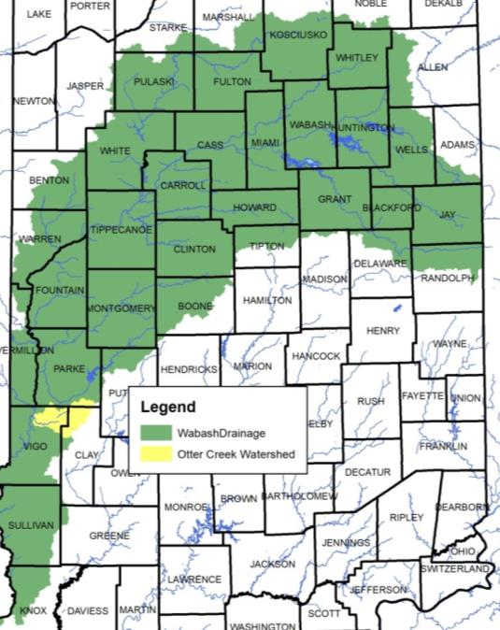
Figure 1. Wabash River watershed highlighting the Otter Creek Drainage.

Project History
Otter Creek has long been an icon of Vigo, Clay, and Parke counties with the Markle Grist-Sawmill serving as a local landmark which contributed to the establishment of Vigo County and the City of Terre Haute, Indiana. The Ouabache Land Conservancy (OLC) targeted Otter Creek and its drainage as one of its primary concerns. OLC’s efforts grew out of previous watershed coordination efforts led by the Vigo County Soild and Water Conservation District (SWCD) and followed publication of the 2013 Indiana Department of Environmental Management’s (IDEM) Total Maximum Daily Load (TMDL) addressing E. coli throughout the Otter Creek Watershed. The IDEM TMDL for Otter Creek addresses E. coli only and identifies 212 miles of streams (96% of the watershed) impaired by E. coli. The TMDL identifies a 49-94% reduction in E. coli within Otter Creek subwatersheds to meet state standards. Two CSO pipes discharge untreated wastewater into Otter Creek; however, only 4% of E. coli can be attributed to urban sources. Nearly 90% of Otter Creek residents utilize septic systems to treat wastewater; however, 95% of watershed soils are classified as very limited for septic treatment. The watershed is predominantly forested and agricultural.Otter Creek includes nearly 80 fish species including the Markel Dam area which contains 37% of Indiana’s fish species.

Limited nutrient, sediment, metal and biological data have been collected. Otter Creek’s watershed is 42% row crop agriculture in soybean/corn rotation. Nearly 24% of watershed soils are considered highly erodible. Couple this with 60% of corn and 14% of soybeans farmed using conventional tillage and these soils become a source of nutrients within the Otter Creek Watershed with an estimated 100,075 tons of soil likely lost from Otter Creek’s watershed to adjacent streams annually. Additionally, there are nearly 4,800 acres of surface mined land and 12,200 acres of underground mined land within the Otter Creek Watershed which can contribute heavy metals to the Otter Creek Watershed. Initial soil sample metals analysis indicate low metal concentrations are currently present within the Otter Creek Watershed.

OLC approached community groups and individuals throughout the watershed that might be interested in working with them to assess and improve water quality within Otter Creek and its tributaries. Identified potential stakeholders include: City of Terre Haute Wastewater Utility, Indiana State University, The Nature Conservancy, Town of Seelyville, West Central Watershed Alliance, Green Leaf Inc, Indiana American Water, Purdue Extension Vigo County, Duke Energy, Vigo County Parks & Recreation, Santucci Communication Synthesized, Vigo School Corporation, Sullivan County Soil and Water District, City of Terre Haute Engineering, Vigo County Surveyors Office, Parke County Soil and Water Conservation District, Vigo County Solid Waste Management District, Staleys Soil Service, Vigo County Council, Helms and Ruble Forestry, Pike Lumber, Clay County Soil and Water Conservation District and Vigo County Soil and Water Conservation District. This group formed a Steering Committee (Table 1), conducted windshield surveys of the watershed, and held several meetings open to the public in order to generate input in the development of a watershed management plan for the Otter Creek Watershed. All of these efforts were guided by the following mission and vision developed by public participants and committee members:

Mission: Ottershed (otter creek watershed) residents improve Otter Creek water quality and build community connections through education and awareness for future generations

Vision: Improved water quality in the Otter Creek Watershed for future generations.

The mission and vision are works in progress and may change as the project moves forward.

Stakeholder Involvement
Development of a watershed management plan requires input from interested citizens, local government leaders, and water resource professionals. These individuals are required to not only buy into the project and the process but must also become an integral part of identifying the solution(s) which will result in improved water quality. We involved stakeholders in the watershed management planning process through a series of public meetings, and education and outreach events including windshield surveys, water quality monitoring opportunities, and meetings with local officials.

Steering Committee
Individuals representing the towns and counties within the watershed, environmental groups, natural resource professionals, agricultural and commercial representatives, and private citizens comprised the steering committee. The steering committee has met nearly every other month to develop the WMP, starting in December 2017. Table 1 identifies the steering committee members and their affiliation.

Table 1. Otter Creek Watershed steering committee members and their affiliation.
Individual | Organization(s) Represented
John Allen | Town of Seeleyville
Tom Baer | Landowner
Sue Berta | Indiana State University
Betsy Bower | Ceres Solutions
Emily Bruner | Vigo County SWCD
Phil Cox | Ouabache Land Conservancy
Dana Gadeken | Vigo County Purdue Extension
Adam Grossman | Vigo County Parks & Rec
Brendan Kearns | Vigo County Commissioner, Indiana DNR
John Kite | Landowner
Hannah Lynch | Ceres Solutions
Larry Owen | Landowner, forester
Michelle Payne | Rose-Hulman
Garrett Pendergast | Landowner
Tyler Trout | Clay County SWCD
Jim Speer | Indiana State University
Brad Smith | The Nature Conservancy

Public Meetings
Public participation is necessary for the long-term success of any watershed planning and subsequent implementation effort. One component of public participation for this project was public meetings. There were two public meetings held December 13, 2017 and XX to introduce the project and develop a concerns list and allow individuals to provide their thoughts on potential projects that will be targeted in future implementation efforts. The purpose of the public meetings was to provide information on the overall planning effort and its progress; solicit stakeholder input, opinions, and participation; create opportunities for the public to recommend programs, policies, and projects to improve water quality; and build support for future phases of the project.

The public meetings were advertised through press releases distributed to local newspapers in the watershed and via postcards and emails sent to local landowners and conservation partners. The meetings were also advertised through word of mouth as staff from the Soil and Water Conservation District put together mailings that advertised the events and the Ouabache Land Conservancy distributed information via their website and social media pages as well as through their email distribution list.

The first public meeting was held on December 13, 2017 at the North Terre Haute Christian Church in Terre Haute, Indiana. Attendees represented citizens, farmers, conservation partners, and city and officials. During this meeting, the Ouabache Land Conservancy detailed the history of the project; described opportunities for individuals to volunteer as part of the project; and provided attendees with the opportunity to identify their concerns about the Otter Creek Watershed and develop goals for the long-term vision of the stream.

A second public meeting was held on XXX.

Educational Materials and Events
Two Otter Creek Watershed brochure were developed to highlight opportunities for individuals to get involved with the project, identify community partners, and provide general information and fun facts about the watershed, watershed management planning, and the project (see Appendix XX). The brochure will be distributed at committee, public, and group meetings and at education events throughout the lifetime of the project.

Public Input
Throughout the planning process, project stakeholders, the steering committee, and the general public listed concerns for the Otter Creek Watershed including the Wabash River, its tributaries, and its watershed. Public and committee meetings were the primary mechanism of soliciting individual concerns. All comments were recorded and included as part of the concern documentation and prioritization process. Concerns voiced throughout the process are listed in Table 2. Similar stakeholder concerns were grouped roughly by topic and condensed by the committee. The order of concern listing does not reflect any prioritization by watershed stakeholders.

Table 2. Stakeholder concerns identified during public input sessions, DATES, and watershed inventory process. Note: The order of concern listing does not reflect any prioritization by watershed stakeholders.
Stakeholder Concerns
E. coli concentrations are elevated
High quality areas/parks are not connected
Septic system inputs to stream – straight pipes, abandoned facilities and poor maintenance
Abandoned strip and surface mines; open mine shafts
Wastewater isn’t treated in/near Carbon
Seelyville Water wellhead protection area
Safe to swim at Mill Dam Park
Heavy metal contamination from previous mining efforts
Biodiversity is limited across the watershed
Impacts of effluent inputs from wastewater plats
Heavy use of tile drainage on agricultural lands
Heavy use pad prevalence
General public needs educated about agricultural practice use
Nitrogen (ammonia) inputs from cattle and turkey manure
Education needed – watershed concept, elevated nutrients, etc – for the general public
Flooding in North Terre Haute/lower Otter Creek, levee area, upstream of Hasselburger Road
Protection of high quality areas – Forest Park Bayou Area
Historic planning efforts – 800 acre lake planned by conservation club/potential to dam Otter Creek
Stream cleaning/log jam removal needed from Mill Dam to Wabash River
Runoff from new subdivisions (Grants Way, others)
Invasive species – especially Asian bush honeysuckle – impacts on forested land
Dividing forest land into smaller parcels – current ordinance allows for 10 acre parcels
Wetland impacts from new development
Riparian impacts that increase rate of stream flow/flashiness
Sand inputs from Parke County
Agricultural producers are not utilizing cover crops or conservation tillage
Urban residents are unaware of their impacts to Otter Creek
Wetland preservation required
High quality forest land preservation
Highly erodible/potentially highly erodible soils density
Septic soils – too many residences are sited on unsuitable soils
Invasive plant impacts to native species including quail and other native plants
Streambed erosion as a source of instream sediment and erosion – internal sources of sediment may be causing issues in the otter creek watershed just as much as overland flow
Stormwater infiltration – slowing the flow of water is required to increase water infiltration, infiltration is necessary to reduce the rate at which water is flowing across easily erodible soils carrying water into stream channels causing down cutting and bed and bank erosion

WATERSHED INVENTORY I: WATERSHED DESCRIPTION

Watershed Location
The Otter Creek Watershed is part of the Middle Wabash-Little Vermilion watershed and covers portions of Clay, Parke and Vigo counties (Figure 1). The Otter Creek Watershed includes all the land that enters Otter Creek from its 79,422.3 acre drainage. The stream starts in western Clay County draining portions of Parke and Vigo Counties before flowing into the Wabash River north of Terre Haute, Indiana. The Wabash River starts in Ohio and drains about 6,265,024 acres by the time it gains water from the Otter Creek Watershed project area.

Subwatersheds
In total, six 12-digit Hydrologic Unit Codes are contained within the Otter Creek Watershed (Figure 2,
Table 3). Each of these drainages will be discussed in further detail under Watershed Inventory II.

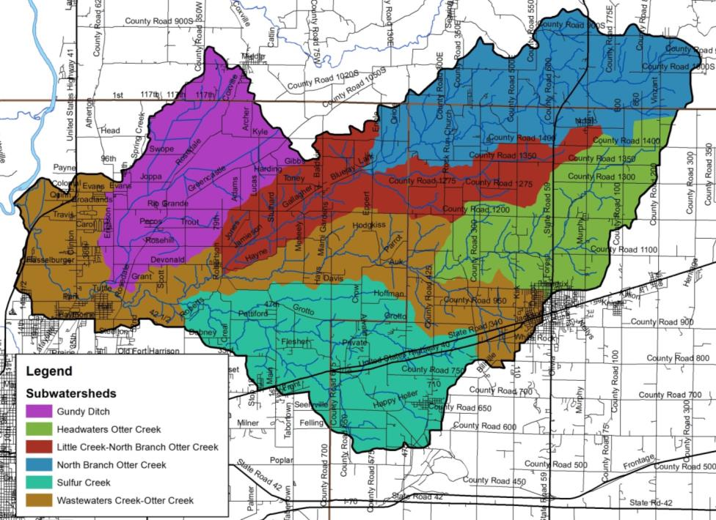
Figure 2. 12-digit Hydrologic Unit Codes in the Otter Creek Watershed.

Table 3. 12-digit Hydrologic Unit Code (HUC) watersheds in the Otter Creek Watershed.
Subwatershed Name | Hydrologic Unit Code | Area (acres) | Percent of Watershed
Headwaters Otter Creek | 51201110401 | 10,089.8 | 12.7%
North Branch Otter Creek | 51201110402 | 14,488.6 | 18.2%
Little Creek-North Branch Otter Creek | 51201110403 | 10,660.5 | 13.4%
Sulfur Creek | 51201110404 | 14,775.8 | 18.6%
Gundy Ditch | 51201110405 | 11,707.5 | 14.7%
Wastewaters Creek- Otter Creek | 51201110406 | 17,700.1 | 22.3%
Watershed Total |  | 79,422.3

Climate
In general, Indiana has a temperate climate with warm summers and cool or cold winters. Climate in the Otter Creek Watershed is no different than the rest of the state. There are four seasons throughout the year. The average temperatures measure approximately 88°F in the summer, while low temperatures measure below freezing (19°F) in the winter. The growing season typically extends from April through September. On average, 43.8 inches of precipitation occurs within the watershed per year; approximately 68% of this precipitation falls during the growing season (US Climate Data, 2018).

Geology and Topography
Bedrock deposits within the Otter Creek Watershed are from the Pennsylvanian ages and generally consist of shale, siltstone, and limestone (Grove, 2009). Raccoon Creek Group bedrock covers most of the Otter Creek Watershed with Carbondale Group deposits along the southern edge of the watershed, Otter Creek’s mainstem, and covering much of Terre Haute within the watershed (Figure 3). The Raccoon Creek Group consists mostly of sandstone and shale with coal, limestone, and mudstone intermixed. Depth to bedrock within this portion of the watershed is typically less than 100 feet. The Carbondale Group is comprised mostly of shale and sandstone with limestone and commercially important coal deposits. Depth to bedrock is shallow ranging from 25 to 75 feet. Lacustrine and outwash surface deposits cover much of the flat, historic lake plain across much of the Gundy Ditch Subwatershed. The mix of undifferentiated outwash and lake silt and clay show the historic extent of the lake. Aeolian deposits cover much of the upland portions of the remainder of the Otter Creek Watershed with loam and sandy loamy till most of the Otter Creek Watershed drainages (Figure 4).

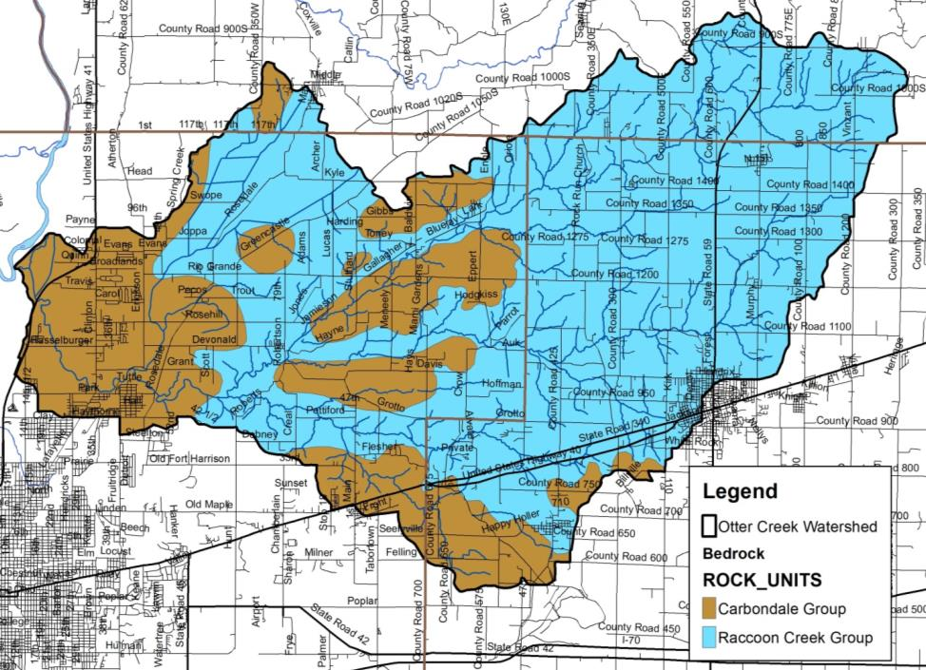
Figure 3. Bedrock in the Otter Creek Watershed.

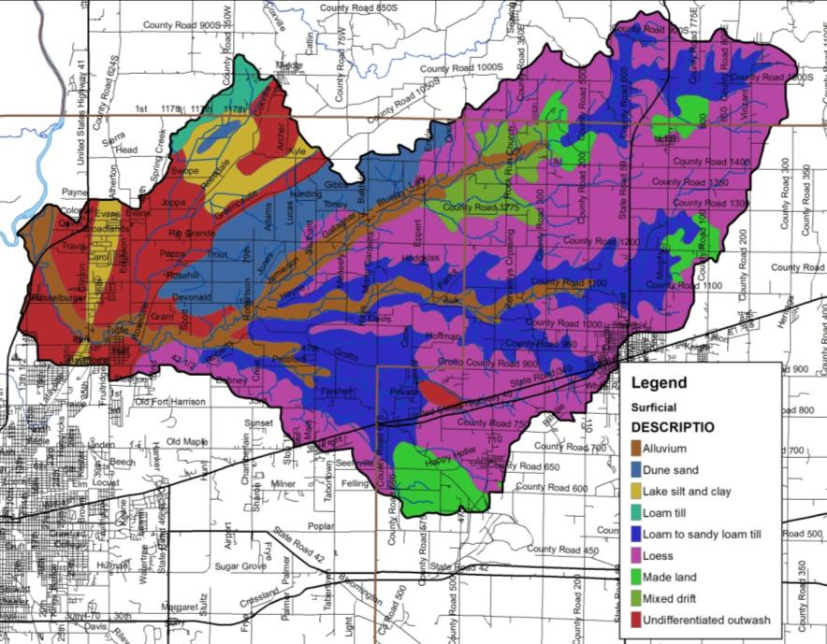
Figure 4. Surficial geology throughout the Otter Creek Watershed.

The topography of the Otter Creek Watershed has an average elevation of 550 feet msl (Figure 5). The landscape changes from gently rolling terrain in the northern part of the watershed to broad lowland tracts in the southern portion of the watershed. The Otter Creek Watershed elevation is highest measuring 750 feet msl northeast of Carbon in the far eastern portion of the watershed. Elevations graduation decrease in north central Vigo County. Steep valleys surround many of the Otter Creek streams. The relatively flat lake plain surrounding Gundy Ditch shows limited topographic elevation changes. The lowest elevation (500 feet msl) occurs near the intersection of Otter Creek with the Wabash River.

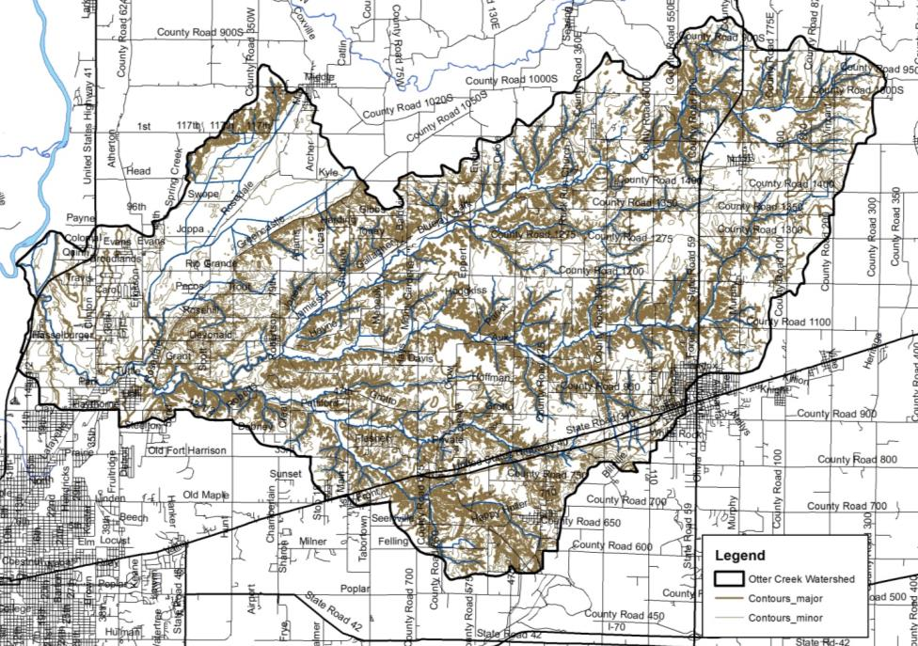
Figure 5. Surface elevation in the Otter Creek Watershed.

Soil Characteristics
There are hundreds of different soil types located within the Otter Creek Watershed. These soil types are delineated by their unique characteristics. The types are then arranged by relief, soil type, drainage pattern, and position within the landscape into soil associations. These associations provide the overall characteristics across the landscape. Soil associations are not used at the individual field level for decision making. Rather, the individual soil types are used for field-by-field management decisions. Some specific soil characteristics of interest, including septic limitations and soil erodibility, for watershed and water quality management are detailed below.

Soil Associations
The watershed is covered by 8 soil associations with three associations combining to cover more than two-thirds of the total watershed area. The Hosmer-Story-Hickory soil association dominates the eastern portion of the watershed covering much of the Otter Creek headwaters (Figure 6; Montgomery, 1974; McCarter, 1982). The Hosmer-Story-Hickory association is generally located on uplands and consists of narrow ridgetops, deep draws and narrow bottomlands. These soils are mainly found in woodlands with ridgetops and divides used for cultivated crops. The Hickory-Cincinnati-Berks association covers much of the North Branch of Otter Creek and Wastewater Creek-Otter Creek Subwatersheds. These soils are found on gently to steeply sloped uplands and primarily cover areas where historic mining occurred. The Elston-Warsaw-Shipshe association covers the western portion of the Otter Creek Watershed (Figure 6). These soils are well drained, sandy loam soils which cover the historic lake plain present in the Gundy Ditch Subwatershed (Montgomery, 1974; Ulrich et al., 1967). These soils are well suited to agricultural production.

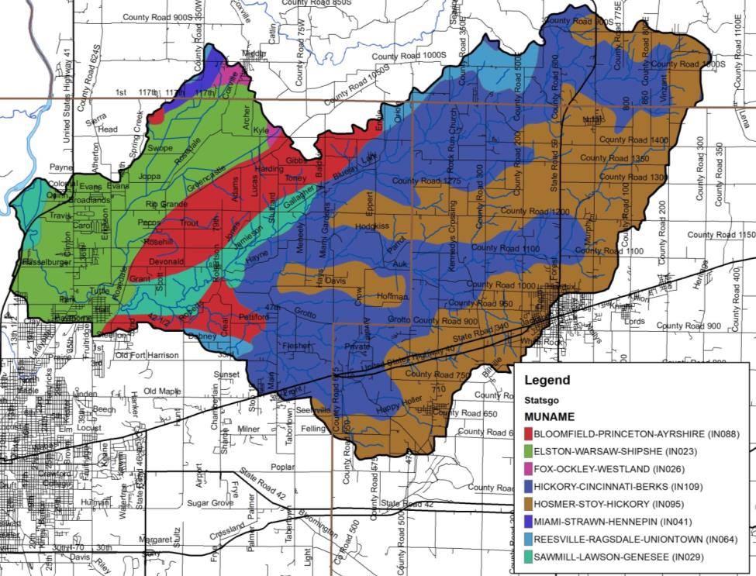
Figure 6. Soil associations in the Otter Creek Watershed. Source: NRCS, 2018.

Soil Erodibility
Soils that move from the landscape to adjacent waterbodies result in degraded water quality, limited recreational use, and impaired aquatic habitat and health. Soils carry attached nutrients and pesticides, which can result in impaired water quality by increasing plant and algae growth or even killing aquatic life. The ability and/or likelihood for soils to move from the landscape to waterbodies are rated by the Natural Resources Conservation Service (NRCS). The NRCS uses soil texture and slope to classify soils into those that are considered highly erodible, potentially highly erodible, and not highly erodible. The classification is based on an erodibility index which is determined by dividing the potential average annual rate of erosion by the soil unit’s soil loss T value or tolerance value. The T value is the maximum annual rate of erosion that can occur for a particular soil type without causing a decline in long-term productivity. Potentially highly erodible soil determinations are based on the slope steepness and length in addition to the erodibility index value.

Watershed stakeholders are concerned about soil erosion. As detailed above, soils which have high erodibility index values are those that are located on steep slopes and are easily moved by wind, water, or land uses. Figure 7 details locations of highly erodible and potentially highly erodible soils within the Otter Creek watershed. Highly erodible soils cover 20% of the watershed or 15,893 acres, while potentially highly erodible soils cover an additional 20% of the watershed or approximately 15,976 acres. Highly erodible soils are found throughout the watershed, but are concentrated along Otter Creek and its tributaries. Potentially highly erodible soils are located adjacent to highly erodible soils along the less steep areas of Otter Creek drainages. Additional potentially highly erodible soils cover the Gundy Ditch and Wastewater Creek-Otter Creek Subwatersheds.

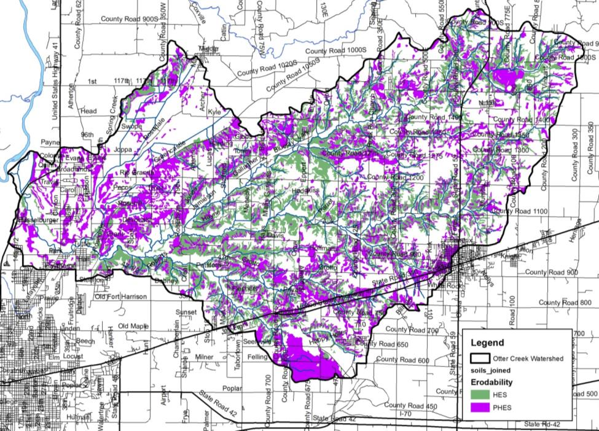
Figure 7. Highly erodible (HES) and potentially highly erodible soils (PHES) in the Otter Creek Watershed. Source: NRCS, 2018.

Hydric Soils
Hydric soils are those which remain saturated for a sufficient period of time to generate a series of chemical, biological, and physical processes. The oxidation and reduction of iron in the soil, or “redox”, causes color changes characteristic of prolonged fluctuations in the water table. After undergoing these processes, the soils maintain the resultant characteristics even after draining or use modification occurs. Watershed stakeholders are concerned about the conversion of wetlands into agricultural and urban land uses. Historically, approximately 25,772 acres (32%) of the watershed was covered by hydric soils (Figure 8). Hydric soils are found throughout the watershed, with the highest densities located on flat plains away from the Otter Creek drainageways. Most of the hydric soils are located in the eastern two thirds of the Otter Creek Watershed. As these soils are considered to have developed under wetland conditions, they are a good indicator of historic wetland locations and therefore will be revisited in the land use section. Many of these soils have been drained for agricultural production or urban development. These efforts leave nearly 5,171 acres (6.5%) of remnant hydric soils in the Otter Creek Watershed (Figure 9). These remnant hydric soils should be considered if any wetland restoration activities are prioritized through this watershed management planning process.

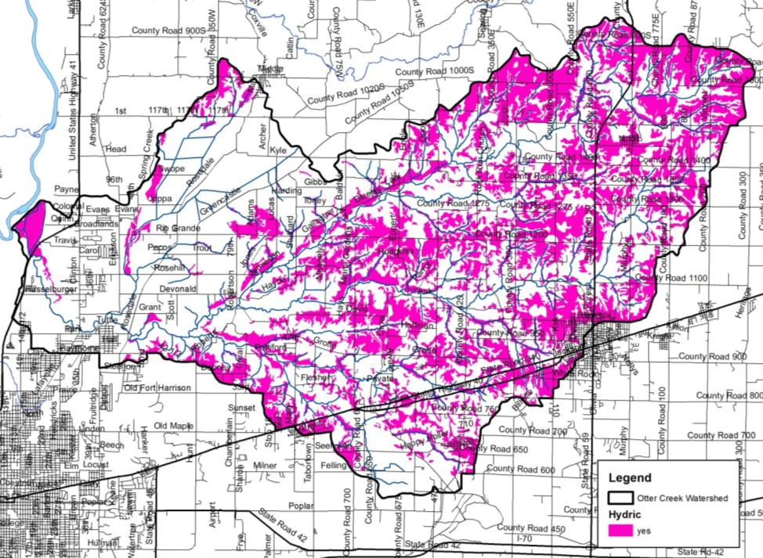
Figure 8. Hydric soils in the Otter Creek Watershed. Source: NRCS, 2018.

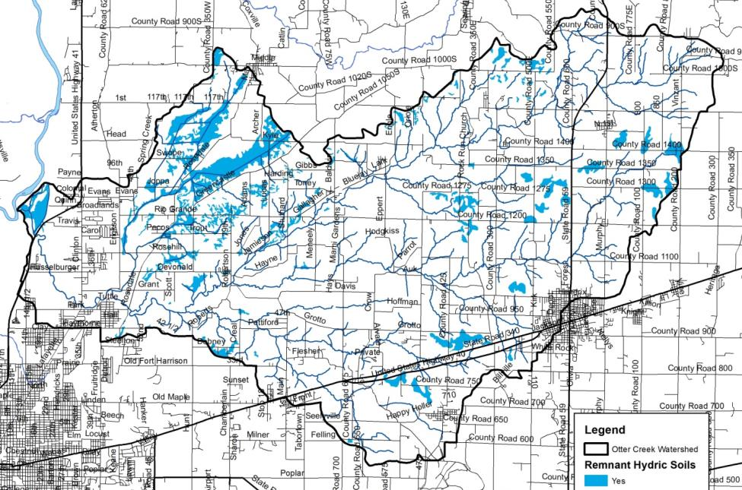
Figure 9. Remnant hydric soils in the Otter Creek Watershed. Source: NRCS, 2018.

Tile-Drained Soils
Soils drained by tile drains cover 22,884 square miles or 28% of the Otter Creek Watershed as estimated utilizing methods details in Sugg, 2007. This method of drainage is widely used in row crop agricultural settings within the watershed, and has become even more intensively used within the last ten years. This results in altered hydrology, allowing the water to drain from the landscape more quickly to improve conditions for farming, but also potentially exacerbating downstream flooding and incising streams which cuts them off from their natural floodplains. In these areas, materials such as nutrients applied to agricultural soils are directly transported downstream, bypassing natural features such as filter strips that might otherwise filter out or assimilate nutrients. As the demands of production on each acre of land increases more tile is put in, typically in a network or series as extensive as 30 to 50 foot spacing between tiles. Impacts to stream water quality can be reduced by the use of tile control structures and drainage water management. A majority of tile-drained soils are located in the Cox Ditch and Swope Ditch drainages within the Gundy Ditch Subwatershed as well as the headwaters of the North Branch Otter Creek and Headwaters Otter Creek subwatersheds (Figure 10). Most of these areas are relatively flat where drainage augmentation is required to move water from agricultural fields in order to produce row crops. In these areas, materials applied to agricultural soils are directly transported to downstream waterbodies.

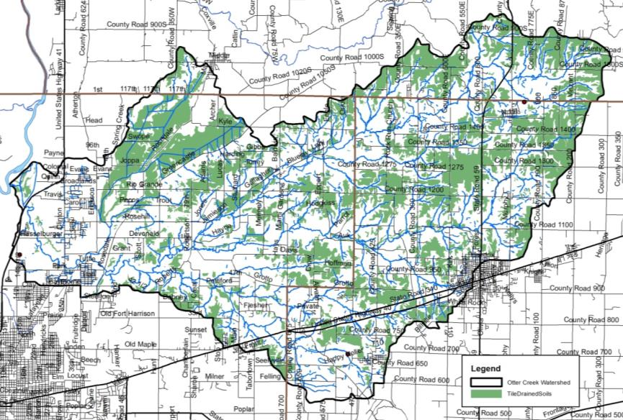
Figure 10. Tile-drained soils in the Otter Creek Watershed. Source: NLCD, 2011 and NRCS, 2018.

Wastewater Treatment

Soil Septic Tank Suitability
Throughout Indiana, households depend upon septic tank absorption fields in order to treat wastewater. Seven soil characteristics, including position in the landscape, soil texture, slope, soil structure, soil consistency, depth to limiting layers, and depth to seasonal high water table, are utilized to determine suitability for on-site septic treatment. Septic tanks require soil characteristics that allow for gradual movement of wastewater from the surface into the groundwater. A variety of characteristics limit the ability for soils to adequately treat wastewater. High water tables, shallow soils, compact till, and coarse soils all limit soils abilities in their use as septic tank absorption fields. Specific system modifications are necessary to adequately address soil limitation; however, in some cases, soils are too poor for treatment and therefore prove inadequate for use in septic tank absorption fields.

Until 1990, residential homes located on 10 acres or more and occurring at least 1,000 feet from a neighboring residence were not required to comply with any septic system regulations. In 1990, a new septic code corrected this loophole. Current regulations address these issues and require that individual septic systems be examined for functionality. Additionally, newly constructed systems cannot be placed within the 100-year floodplain and systems installed at existing homes must be placed above the 100-year flood elevation. However, many residences grandfathered into this code throughout the state have not upgraded or installed fully functioning systems (Krenz and Lee, 2005). In these cases, septic effluent discharges into field tiles or open ditches and waterways and will likely continue to do so due to the high cost of repairing or modernizing systems ($4,000 to $15,000; ISDH, 2001). Lee et al. (2005) estimates that 76,650 gallons of untreated wastewater is expelled in the state of Indiana annually. The true impact of these systems on the water quality in the watershed cannot be determined without a complete survey of systems.

The NRCS ranks each soil series in terms of its limitations for use as a septic tank absorption field. Each soil series is placed in one of three categories: severely limited, moderately limited, and slightly limited. Some soils are also unranked. Severe or very limited limitations delineate areas whose soil properties present serious restrictions to the successful operation of a septic tank tile disposal field. Using soils with a severe limitation increases the probability of the system's failure and increases the costs of installation and maintenance. Areas designated as having moderate or somewhat limited limitations have soil qualities which present some drawbacks to the successful operation of a septic system; correcting these restrictions will increase the system's installation and maintenance costs. Slight limitations delineate locations whose soil properties present no known complications to the successful operation of a septic tank tile disposal field. Use of soils that are rated moderately or severely limited generally require special design, planning, and/or maintenance to overcome limitations and ensure proper function.

Watershed stakeholders are concerned about the lack of maintenance associated with septic tanks, the use of soils that are not suited for septic treatment, and the presence of straight pipe systems within the watershed. These concerns are exacerbated by the fact that severely limited soils cover essentially the entire watershed (Figure 11). Nearly 75,432 acres or 95% of the watershed is covered by soils that are considered very limited for use in septic tank absorption fields. Nearly 319 (3.3%) acres are somewhat limited meaning that these soils are generally suitable for septic systems. The remaining 216 acres (1.7%) not rated for septic usage as it is not generally industry standard to install a septic system in these geographic locations..

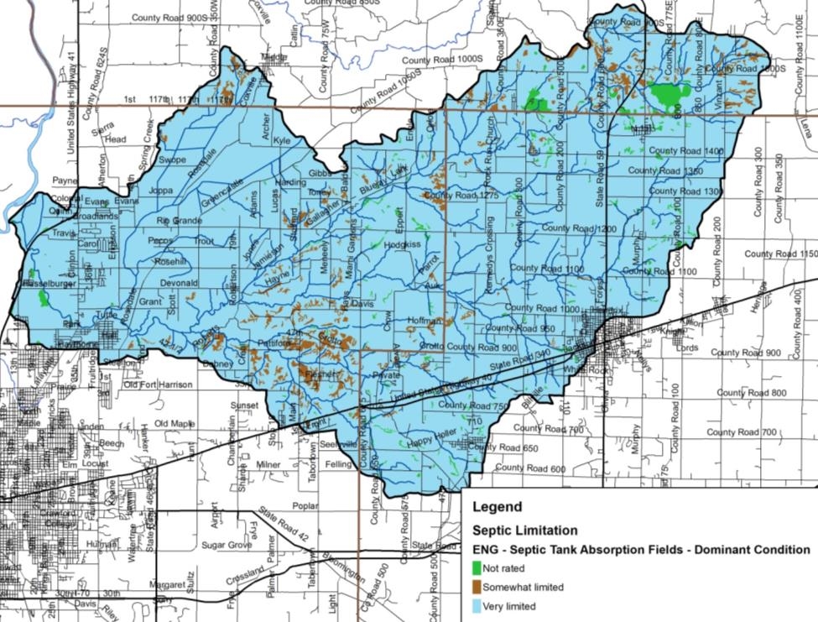
Figure 11. Suitability of soils for septic tank usage in the Otter Creek Watershed. Source: NRCS, 2018.

Wastewater Treatment and Solids Disposal
Several facilities which treat wastewater and are permitted to discharge the treated effluent are located within the watershed. These facilities are regulated by National Pollution Discharge Elimination System (NPDES) permits. These include several wastewater treatment plants ranging in size from small, local plants to larger, publicly-owned facilities, and school facilities. In total, 14 NPDES-regulated facilities are located within the watershed (Figure 12). Table 4 details the NPDES facility name, activity, and permit number. More detailed information for each facility will be discussed on a subwatershed basis in subsequent sections.

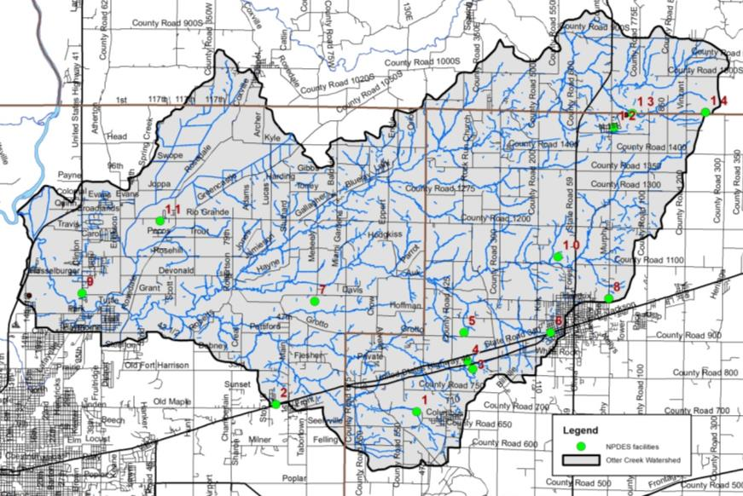
Figure 12. NPDES-regulated facilities in the Otter Creek Watershed.

Table 4. NPDES-regulated facility information.
Map ID | NPDES ID | Facility Name | Activity
1 | IN0025224 | Staunten Wastewater Plant | Sewerage system
2 | INRM00279 | Keebler Company | Sewerage system
3 | INR10H824 | Brazil Road Reconstruction | Short term construction
4 | IN0054879 | Mears Mobile Home Park | Inactive sewerage system
5 | INR10K746 | Pastime Solar Center | Sewerage system
6 | ING080319 | US 40 Construction/Dewatering | Short term construction
7 | ING670022 | Cinergy – Wabash Lateral Project | Short term construction
8 | INRM02209 | Process Development and Fabrication | Sewerage system
9 | INR10H480 | Otter Creek Firehouse | Sewerage system
10 | IN0045721 | Arketex Ceramic Corporation | Sewerage system
11 | IN0030678 | Rio Grande Elementary School | Sewerage system
12 | IN0044725 | Brazil Minerals Inc. | Sewerage system
13 | IN0039829 | Carbon Municipal STP | Sewerage system
14 | IN0053821 | B&LS Contr-Calcutta Rail | Sewerage system
Source: USEPA EnviroFacts Warehouse, 2018

Municipal Wastewater Treatment and Combined Sewer Overflows
In the relatively rural Otter Creek Watershed, there are two wastewater treatment facilities located within and discharging to Otter Creek or a tributary, the Staunten Wastewater Plant and the Carbon Municipal Sewage Treatment Plant, as well as two wastewater treatment facilities which treat portions of the watershed but discharge outside of the watershed, the City of Terre Haute and City of Brazil, as well as the Rio Grande Elementary School. Sludge from municipal wastewater treatment plants is applied on 50.4 acres throughout the watershed. All of this application occurs within the Sulfur Creek and Wastewaters Creek-Otter Creek Subwatersheds (Figure 13).

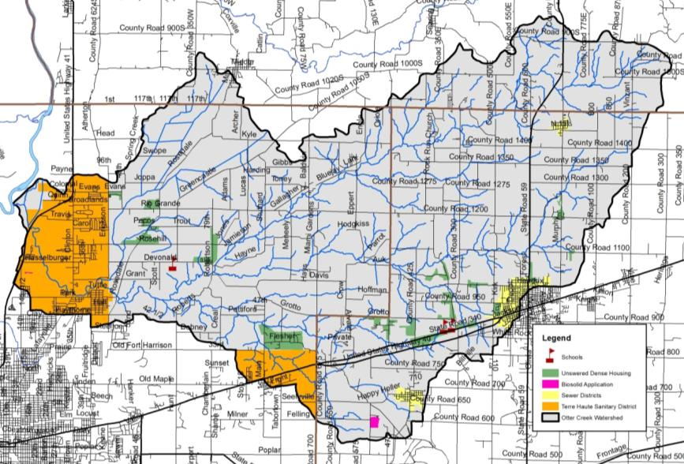
Figure 13. Wastewater treatment plant service areas, municipal biosolids land application sites, dense unsewered housing within the Otter Creek Watershed.

The City of Brazil operates a wastewater treatment plant which serves approximately 4,500 customers. In total, the plant treats 2.5 MGD of wastewater, which when cleaned, discharges outside of the Otter Creek Watershed (Goodrich, unpublished). The system does not include any combined sewer overflow points. If flows above 2.5 MGD occur, these flows are diverted to a lagoon system. The service area is shown in Figure 13.

The Town of Carbon operates a wastewater system which collects effluent from approximately 160 septic tanks which flow to a lift station for pumping to treatment lagoons. The tanks are pumped on a rotational basis. Two lagoons are used for treatment with 90 days storage and the third is used for polishing and storage. Once cleaned to a 10:1 dilution ration, the plant discharges a maximum of 0.0252 MGD of wastewater to Ebenezer Creek (IDEM, 2013). From 2009 through 2012, the plant reported one quarter pH violation and six quarters of nitrogen violations. The service area is shown in Figure 13.

The Town of Staunton operates a Class I 0.1 MGD wastewater treatment plant The extended aeration treatment facility consists of a flow meter, a comminutor, a splitter box, two aeration tanks, two clarifiers, a parshall flume, two polishing lagoons, a chlorine contact tank, step aeration, and dechlorination. The collection system includes 100% separate sanitary sewers with no overflow or bypass locations. Once treated, Staunton WWTP effluent flows into Sulphur Creek. In 2000, IDEM imporsed a connection ban on the Staunton WWTP. In 2007, Staunton completed construction of its sewage collection system and wastewater plant which reduced the wet weather flows at the treatment plant. The connection ban was lifted in 2012. The service area is shown in Figure 13.

The City of Terre Haute operates a wastewater treatment plant which is designed for an average flow of 24 MGD with a peak wet weather discharge capacity of 48 MGD. In 2012, the treatment plant expansion included demolition of the existing grit tank and pre-aeration tank, construction of an anoxic tank, creation of internal recycling division structure, 4 new aeration tanks, a new blower building, upgrades to existing aeration tanks, upgrades to the secondary clarifier, construction of 2 new clarifiers, conversion from chlorine disinfection to UV disinfection, removal and replacement of the sludge processing system, upgrades to the liquid storage tanks, and conversion of waste sludge holding tanks (Terre Haute Clean Water, 2014). The service area includes portions of North Terre Haute and Seelyville and is shown in Figure 13.

Unsewered Areas
Approximately 16 unsewered areas were identified within the watershed (Figure 13). The largest unsewered, dense housing area is located along the northern edge of Seelyville. Additionally, several developments are located north of the U.S. Highway 40 corridor and east of Terre Haute along Rio Grande Road near Sand Cut. Areas that have at least 25 houses within a square mile outside of the sanitary district boundaries were classified as dense, unsewered areas.

Hydrology
Watershed streams, reservoirs, legal drains, floodplains, wetlands, storm drains, groundwater, subsurface conveyances, and manmade drainage channels all contribute to the watershed’s hydrology. Each component moves water into, out of, or through the system. Their contributions will be covered in further detail in subsequent sections.

Watershed Streams
The Otter Creek Watershed contains approximately 368 miles of streams, regulated drains, and regulated tile drains. Of these, approximately 6.1 miles are regulated drains. Cox Drain and Swope Ditch are the only regulated drains within the Vigo County portion of the Otter Creek Watershed. Fairwood Drain flows for 9.1 miles in Clay County. The majority of streams in the Otter Creek Watershed are not regulated. It should be noted that regulated drains are maintained by the county surveyor’s office and both of the regulated drains within the watershed have both a regular maintenance fund and a regular maintenance schedule. Maintenance practices can include dredging with large construction equipment to maintain flow, debris removal, and vegetation management both within the regulated drain and the riparian zone. As these waterbodies are subject to periodic cleaning, it is important to work with the county surveyor to establish priorities for these waterbodies in terms of water quality improvement and erosion control. Each time a ditch is cleaned out or maintained, this action increases the amount of sediment going downstream towards the mainstem of Otter Creek. Therefore, practices such as the two-stage ditch that minimize sediment transport should be considered in areas of the watershed with high densities of legal drains, or where they are otherwise desirable for reducing sediment and nutrient loads.

The major tributaries to Otter Creek include Branch Cut Creek, Cox Ditch, Diamond Creek, Ebenezer Creek, Little Creek, North Branch Otter Creek, Orchard Run, Snake Creek, Sulphur Creek, Swim Creek, Swope Ditch, and Waterworks Creek (Figure 14). Several minor tributaries also drain to Otter Creek including Dam Brook, Sharon Brook, Rio Grande Stream, Rio West Run, Scrouge Branch, Pit Run, Penial Run, Purdy Run, No End Creek, No Brook, Orchard Run, Kilns Creek, Landing Run, Johnson Run, Harpold Run, Green Brook, Gold Run, Dive Branch, Dick Run, Dam Brook, Coal Run, Cottage Run, Clago Creek, Cardonia Run, Blue Brook, Black Run, Benwood Run, Calcutta Run, Ash Run and Aqua Creek within this watershed. Otter Creek and North Branch Otter Creek are used for recreational kayaking and canoeing, as well as fishing, swimming, and aesthetic enjoyment. Stakeholders are concerned with maintaining the recreational value of the creek, and have some concerns because portions of the watershed have been designated as impaired by IDEM for E. coli, nutrients, and impaired biotic communities.

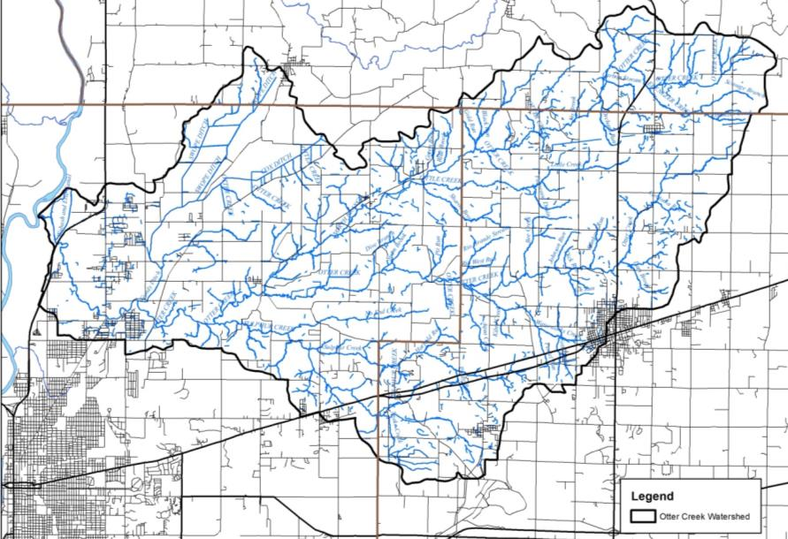
Figure 14. Streams in the Otter Creek watershed. Source: USGS, 2018.

A short remnant of the Wabash and Erie Canal measuring 1.66 miles lies along the western edge of the Otter Creek Watershed. This short segment formed the northern section of the canal’s entrance into the City of Terre Haute. This portion of the canal carried canal traffic south to Terre Haute entering the city from the north immediately west of Fort Harrison, now known as The Landing. The Wabash and Erie Canal flowed south through the Otter Creek Watershed staying west of Water Street with a canal boat basin located between First and Second streets immediately between Eagle and Chestnut (Tribune Star, 2016). Small remnants of the historic canal channel are visible within the Otter Creek Watershed and stakeholders are concerned with preserving this history.

Lakes, Ponds and Impoundments
Multiple small lakes and ponds dot the Otter Creek Watershed landscape. Lakes range in size from 0.04 acres to 13.5 acres covering more than 830 acres throughout the watershed. These provide local swimming holes, recreational boating options, and localized fishing as well as providing water storage and retention to assist with flooding. Many are located in tributary headwaters and offer some water retention; however, most are insignificant in size or water quality impact. Izaak Walton Lake on Isaak Walton League property near Cloverland, Twin Beach, a well-known swimming beach and lake north of Staunton, and lakes on the Fish and Wildlife Area provide the highest quality fishing and swimming access of any waterbodies in the Otter Creek Watershed.
Markle Mill and the associate low head dam provide significant recreational, aesthetic, and historic context within the Otter Creek Watershed. Markle Mill was constructed in 1817 serving as the City of Terre Haute’s first business venture (DNR, 2001). The dam originated as timber and was replaced with stone and concrete in the 1820s. The Markle Mill Dam spans the entire stream diverting water toward Otter Creek’s western streambank where the water ran into the foundation of the historic gristmill (Tribune Star, 2017). Remnants of the gristmill foundation are still visible adjacent to the remnant dam, which limits fish passage up and downstream. The presence of the dam creates unique habitat including clean-scoured bedrock immediately downstream of the dam. This, combined with the impoundment and naturally flowing river downstream, creates high fish species diversity with more than 80 species documented (Whitaker, unpublished) making the Markle Mill Dam and impoundment a favorite fishing site. This area is also historically significant having been noted as a likely underground railroad location and is frequently painted or photographed (Vigo County Historical Museum, personal communication).

Impaired Waterbodies (303(d) List)
The impaired waterbodies, or 303(d), list is prepared biannually by the Indiana Department of Environmental Management. Waterbodies are included on the list if water quality assessments indicate that they do not meet their designated use. More information on the listing process is included in section 3.2.1. Twenty-five stream segments within the Otter Creek Watershed are included on the list of impaired waterbodies. Table 5 details the listings in the watershed, while Figure 15 maps the segments and their locations within the watershed. Waterbodies are listed as impaired for E. coli (211.8 miles) and pH (8.2 miles). Based on the development of the E. coli TMDL Report for the Otter Creek Watershed (IDEM, 2013), the E. coli impaired segments are considered category 4 impaired waterbodies, while pH impaired segments are considered category 5 impairments.

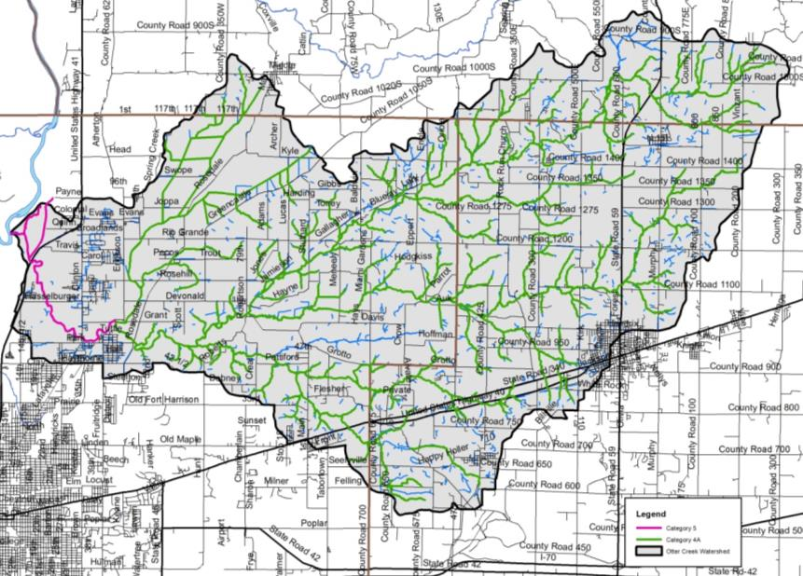
Figure 15. Impaired waterbody locations in the Otter Creek Watershed. Source: IDEM, 2013.
Table 5. Impaired waterbodies in the Otter Creek Watershed 2016 IDEM 303(d) list.
HUC | Waterbody | Assessment Unit | County | Impairment
051201110406 | Otter Creek | INB1146_03 | Vigo County | pH
051201110401 | Otter Creek | INB1141_01 | Clay County | E. coli
051201110402 | Otter Creek | INB1142_01 | Clay County | E. coli
051201110402 | Otter Creek-Unnamed Tributary | INB1142_01A | Clay County | E. coli
051201110402 | Otter Creek-Unnamed Tributary | INB1142_01B | Parke County | E. coli
051201110402 | Otter Creek-Unnamed Tributary | INB1142_01C | Parke County | E. coli
051201110402 | Ebenezer Creek | INB1142_T1001 | Parke County | E. coli
051201110402 | Orchard Run | INB1142_T1003 | Clay County | E. coli
051201110402 | Diamond Creek | INB1142_T1004 | Clay County | E. coli
051201110402 | Green Brook-Blue Brook | INB1142_T1005 | Vigo County | E. coli
051201110403 | North Branch | INB1143_01 | Vigo County | E. coli
051201110403 | Little Creek | INB1143_T1001 | Vigo County | E. coli
051201110403 | Little Creek-Unnamed Tributary | INB1143_T1001A | Clay County | E. coli
051201110403 | North Branch-Unnamed Tributary | INB1143_T1002 | Vigo County | E. coli
051201110404 | Sulphur Creek | INB1144_01 | Vigo County | E. coli
051201110404 | Sulphur Creek-Unnamed Tributary | INB1144_T1001 | Clay County | E. coli
051201110404 | Sulphur Creek-Unnamed Tributary | INB1144_T1001A | Clay County | E. coli
051201110405 | Otter Creek | INB1145_01 | Vigo County | E. coli
051201110405 | Swope Ditch | INB1145_T1001 | Vigo County | E. coli
051201110405 | Otter Creek-Unnamed Tributary | INB1145_T1002 | Vigo County | E. coli
051201110406 | Wabash River | INB1164_01 | Vigo County | E. coli
051201110406 | Otter Creek | INB1146_01 | Vigo County | E. coli
051201110406 | Otter Creek | INB1146_02 | Vigo County | E. coli
051201110406 | Otter Creek | INB1146_03 | Vigo County | E. coli
051201110406 | Otter Creek-Unnamed Tributary | INB1146_T1001 | Clay County | E. coli

Floodplains
Flooding is a common hazard that can affect a local area or an entire river basin. Increased imperviousness, encroachment on the floodplain, deforestation, stream obstruction, tiling, or failure of a flood control structure all are mechanisms by which flooding occurs. Impacts of flooding include property and inventory damage, utility damage and service disruption, bridge or road impasses, streambank erosion and riparian vegetation loss, water quality degradation, and channel or riparian area modification.

Floodplains are lands adjacent to streams, rivers, and other waterbodies that provide temporary storage for water. These systems act as nurseries for wildlife, offer green space for humans and wildlife, improve water quality, and buffer the waterbody from adjacent land uses. Local stakeholders are concerned about impacts to floodplains from development, lack of landowner maintenance, and soil erosion and deposition within the floodplain.

Figure 16 details the locations of floodplains within the Otter Creek Watershed. Extensive floodplains lie adjacent to Otter Creek, North Branch Otter Creek, and Sulphur Creek. Flooding in portions of North Terre Haute and near the confluence of Otter Creek with the Wabash River has been noted as a historic issue and continues to be of concern to stakeholders. Approximately 3% (5,972 acres) of the Otter Creek Watershed lies within the 100-year floodplain (Figure 16). This 100-year floodplain is composed of three regions:
- Zone A is the area inundated during a 100-year flood event for which no base flood elevations (BFE) have been established. Slightly less than half of the Otter Creek Watershed floodplain is in Zone A or nearly 3,025 acres (3.8% of the watershed).
- Zone AE is the area inundated during a 100-year flood event for which BFEs have been determined. The chance of flooding in Zone AE is the same as the chance of flooding in Zone A; however, floodplain boundaries in Zone A are approximated, while those in Zone AE are based on detailed hydraulic models which allows Zone AE floodplains to be more accurate. Nearly half of the Otter Creek Watershed floodplain is in Zone AE or 3,240 acres (4.1 % of the watershed).
- Zone X includes areas outside the 100-year and 500-year floodplains which have a 1% chance of flooding to a depth of one foot of water. No BFEs are available for these areas and no flood insurance is required. The remainder of the watershed is classified as Zone X. An additional 250 acres (0.3 %) of Otter Creek Watershed floodplain lies in Zone 3.

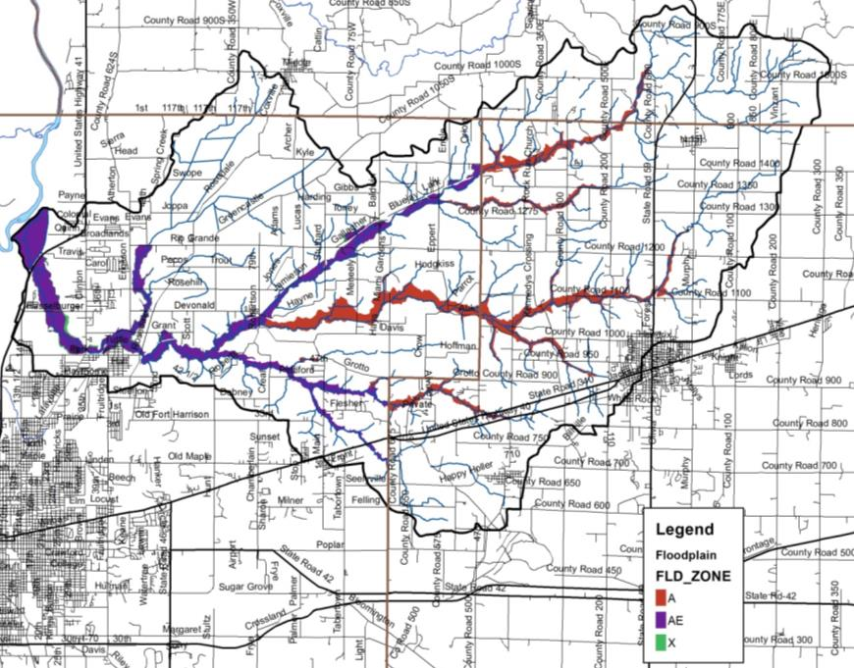
Figure 16. Floodplain locations within the Otter Creek Watershed.

Wetlands
Approximately 25% of Indiana was covered by wetlands prior to European settlement (IDEM, 2007). Overall, 85% of wetlands have been lost resulting in Indiana ranking fourth in the nation in terms of percentage of wetland loss. Wetlands provide numerous valuable functions that are necessary for the health of a watershed and waterbodies. Wetlands play critical roles in protecting water quality, moderating water quantity, and providing habitat. Wetland vegetation adjacent to waterways stabilizes shorelines and streambanks, prevents erosion, and limits sediment transport to waterbodies. Additionally, wetlands have the capacity to increase stormwater detention capacity, increase stormwater attenuation, and moderate low water levels or flow volumes by allowing groundwater to slowly seep back into waterbodies. These benefits help to reduce flooding and erosion. Wetlands also serve as high quality natural areas providing breeding grounds for a variety of wildlife. They are typically diverse ecosystems which can provide recreational opportunities such as fishing, hiking, boating, and bird watching. It should be noted that natural wetlands are regulated through the IDEM and the U.S. Army Corps of Engineers while USDA has jurisdiction over wetlands on agricultural fields. Any modification to wetlands requires permits from these agencies.

Wetlands cover 2,487 acres, or 4.4%, of the watershed. When hydric soil coverage is used as an estimate of historic wetland coverage, it becomes apparent that more than 85% of wetlands have been modified or lost over time. This represents 34.7 square miles of wetland loss within the Otter Creek Watershed. As commodity prices continue to go up and down, area land values remain high and as a result individuals are spending a great deal of money to drain small natural wetlands in their fields in order to be able to farm that additional couple acres of land as it is cheaper to tile it than to buy ground already in production.

Figure 17 shows the current extent of wetlands within the Otter Creek Watershed. Wetlands displayed in Figure 17 results from compilation efforts by the U.S. Fish and Wildlife Service as part of the National Wetland Inventory (NWI). The NWI was not intended to map specific wetland boundaries that would compare exactly with boundaries derived from ground surveys. As such, NWI boundaries are not exact and should be considered to be estimates of wetland coverage. Using this map will help us to identify which portions of the watershed would make ideal candidates for wetland restoration efforts which would reduce the amount of sediment and nutrients reaching the creek, as well as helping to restore the natural hydrology of the area which could help to reduce flooding impacts locally.

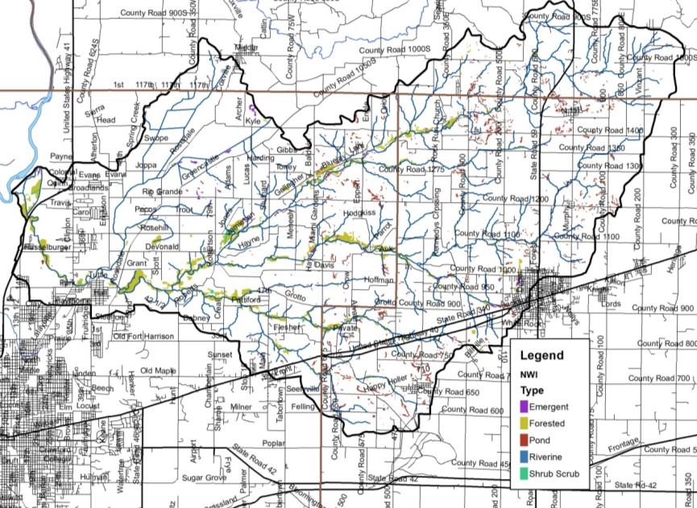
Figure 17. Wetland locations within the Otter Creek Watershed. Source: USFWS, 2017.

Stormwater and Storm Drains
Under natural conditions, the majority of precipitation is allowed to infiltrate the soil and recharge groundwater resources. The volume of infiltration and groundwater recharge diminishes as development increases. To handle the large volume of precipitation falling in urban areas, stormwater systems have been constructed. Storm drain systems are present in most urban areas throughout the watershed. In total, more than 80 miles of storm drain pipe are present within the watershed. The Vigo County, Terre Haute, and Seelyville MS4s work to mitigate stormwater impacts to Otter Creek and its tributaries via the Clean Water Coalition (Figure 18).

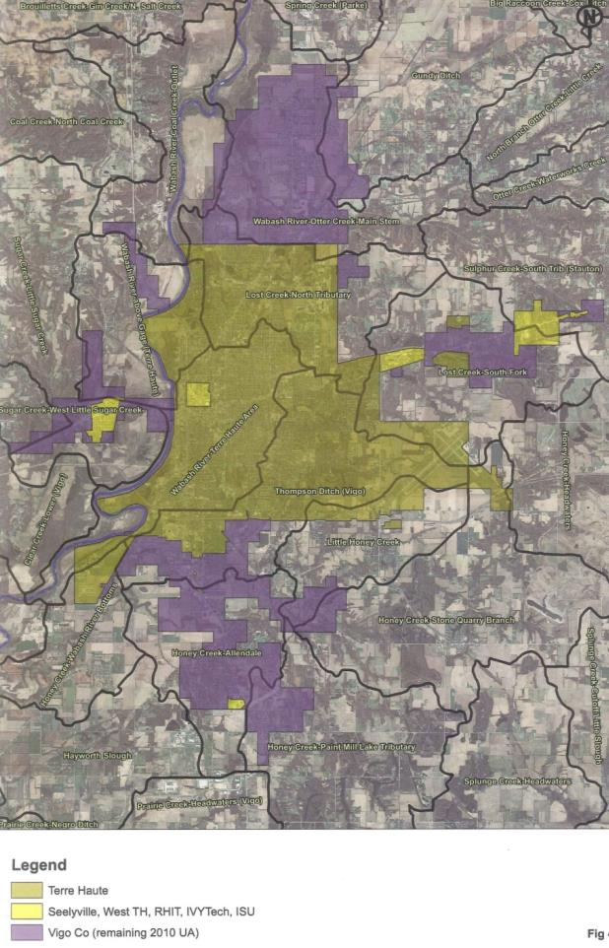
Figure 18. Clean Water Coalition – Vigo County, Terre Haute and Seeleyville MS4s.

Wellfields/Groundwater
In general, municipal water which supplies Brazil, Seelyville, and Terre Haute is taken from unconsolidated deposits of relatively clean, coarse-textured sand and gravel deposited in gravel outwash (Cable et al., 1971) These sand and gravel deposits are part of the Wabash River Valley system and form a productive aquifer that yields more than 2,500 gallons of water per minute. The Wabash River Valley extends five to six miles in width across the entirely of western Vigo County and includes major drainages, like Otter Creek. The Wabash Valley aquifer is comprised of sandstone of the sheet and channel phases – the sheet is widespread but thin, while the channel is laterally restricted but relatively thick (Cable et al., 1971). The Town of Seelyville draws water from their 123 feet deep well, while Indiana-American Water Terre Haute draws water from a 120 foot deep well (Greninger, 2016).

Recharge to the bedrock aquifer occurs at bedrock outcrops where precipitation enters the aquifer directly or indirectly via unconsolidated deposits. Table 6 lists wellhead protection areas within and adjacent to the Otter Creek Watershed. The wellhead protection areas and wellhead protection plans associated with each area will be discussed in additional detail in subsequent sections. Potential pollution from construction, sewage outfalls or overflows, illegal dumping, agriculture, and storm water runoff must be avoided or controlled due to the recharge of these aquifers from runoff and river water. The sensitivity to surface contamination is shown in Figure 19. While small areas of aquifer within Clay County are highly sensitive to contamination, much of the Gundy Ditch Subwatershed are highly sensitive to surface contamination.

Table 6. Wellhead protection areas in and adjacent to the Otter Creek Watershed.
County | PWSID | System name | Population | Next Plan due | Due date
Clay | 5211001 | Brazil City Water Works | 12,000 | 5 Year Update | Oct. 15, 2020
Clay | 5211007 | Staunton Municipal Water | 550 | 5 Year Update | June 22, 2021
Vigo | 5284011 | Seelyville Water Works | 7,500 | 5 Year Update | May 19, 2022
Vigo | 5284012 | IN American Water - Terre Haute | 60,723 | 5 Year Update | Oct. 28, 2018

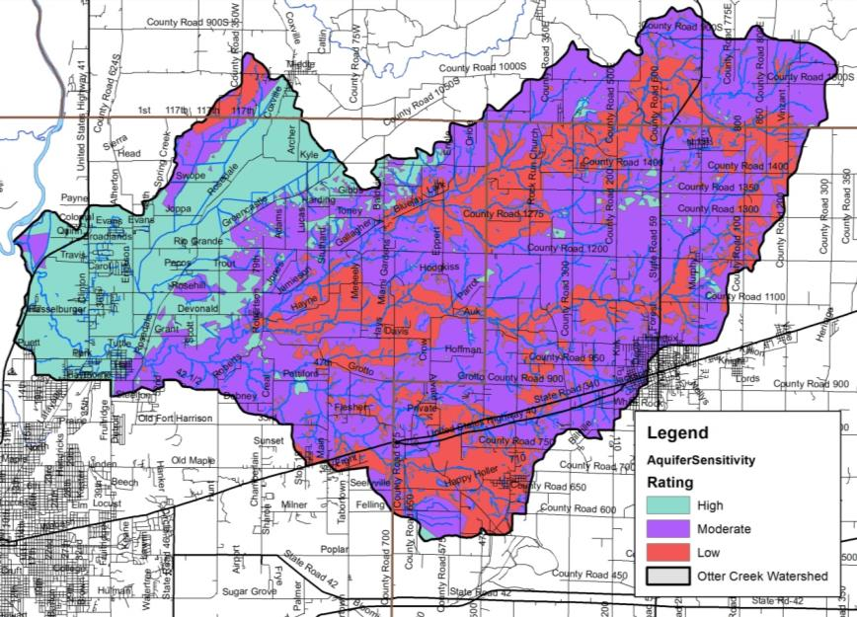
Figure 19. Aquifer sensitivity within the Otter Creek Watershed. Source: IGS, 2015.

Natural History
Geology, climate, geographic location, and soils all factor into shaping the native flora and fauna which occurs in a particular area. Categorization of these floral and faunal communities has been completed by a number of ecologists since the earliest efforts by Coulter in 1886. Since this time, Petty and Jackson (1966) identified regional communities; Homoya et al. (1985) classified Indiana into natural regions, while Omernik and Gallant (1988) categorized Indiana into ecoregions. In 1886, Professor John Coulter placed the Otter Creek Watershed in the Lower Wabash Valley Region. The Lower Wabash Valley Region was characterized by plants found in protected ravines and on steep hillsdies and most commonly include plum, black hickory, sand hickory, Carolina poppymallow, narrowleaf dayflower, new jersey tea, black jack oak, fleabane, sweet sunflower, yellow passionflower, overcup oak and others that likely find this the northern edge of their Indiana territory. Bradsby (1891) details the presence woodlands and prairies and notes woods deep and dark with heavy undergrowth, prairies jutting up to defined timber walls and rolling swells similar to a lazy ocean. Bradsby noted the large sandy areas, now drained by Swope and Cox ditches, formerly covered by lakes and ponds full of nearly every variety of waterfowl.

Natural and Ecoregion Descriptions
According to Homoya et al.’s (1985) classification of natural regions in Indiana, the Otter Creek Watershed lies within the Southwestern Lowlands natural region with two subregions: the Glaciated Section and the Plainfield Sand Section (Figure 20). The Southwestern Lowlands natural region is characterized by low relief and extensive, aggraded valleys created by glaciation associated with the Illinoian ice sheet (Homoya et al., 1985). Much of this natural region is nearly level, undissected and poorly drained with areas of hilly, well drained topography. The Plainville Sand Section is a unique area of eolian sand dunes covered by sandy, acid soils. Historically, this area typically consisted of barrens land uses on ridges with swamp or wet prairie occurring in swales. The Glaciated Section coincides with the Illinoian till plain with soils neutral silt loams with thick layers of loess. Common species include shagbark hickory, shellbark hickory, pin oak, green ash, red maple, silver maple and in marshy areas, black ash. Historically, large prairies were also present in this natural region.

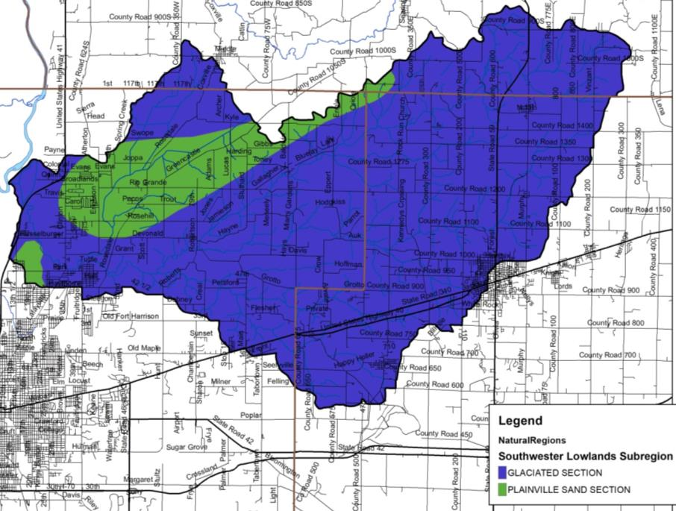
Figure 20. Subregions of the Southwestern Lowlands natural region in the Otter Creek Watershed.

On a national scale, the watershed lies fully within the Wabash Lowlands level 4 ecoregion and is narrowly split between two ecoregions with most of the watershed lying in the Interior River Valley and Hills ecoregion and a small area of the watershed northeast of Carbon lying in the Interior Plateau ecoregion (Figure 21). The interior River Valleys and Hills ecoregion is comprised of wide, flat-bottomed terraced valleys and forested valley slopes. Bottomland deciduous forest and swamp forests were common in wet, lowland areas with mixed oak and oak-hickory forests on uplands. The Interior Plateau ecoregion is typically comprised of limestone, sandstone and shale land forms located on irregular plains. Oak-history forest historically mixed with bluestem prairie and cedar groves in this ecoregion.

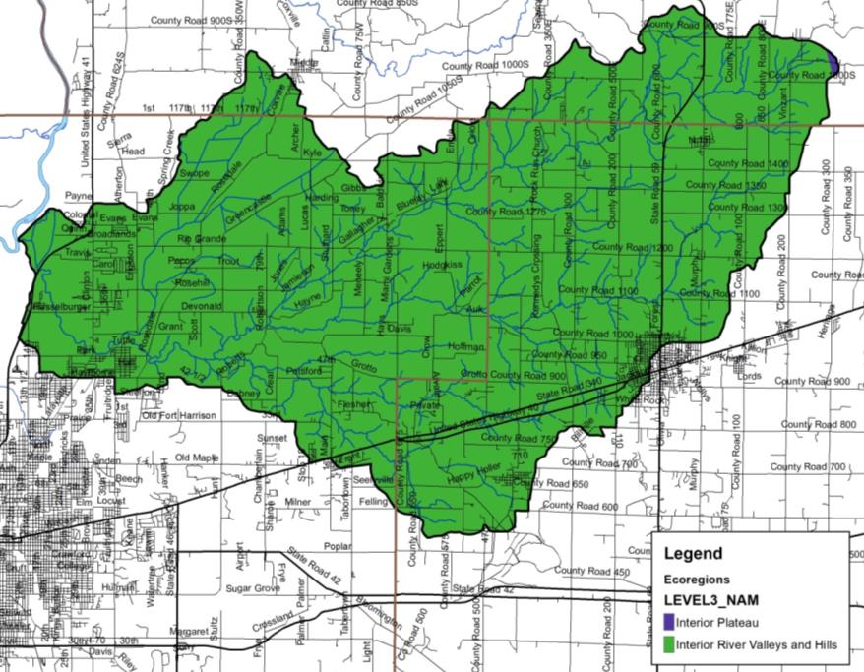
Figure 21. Level III eco-regions in the Otter Creek Watershed.

Wildlife Populations and Pets
Individuals are concerned about local wildlife and pet populations, the impact that these have on pathogen levels, and the impact that changing land uses could have on these populations. These will be quantified in subsequent sections. With these concerns in mind, wildlife density can be estimated from a variety of sources. The Indiana Department of Natural Resources (IDNR) is tasked with managing wildlife populations throughout the state. In order to complete this task, the IDNR must have an idea of the population density within specific areas, counties, or regions. The most recent survey of wildlife populations for which data are publicly available occurred in 2005. Those densities are shown in Table 7 with deer, squirrels and turkey being the most common wildlife present within the region. It should be noted that these numbers could both underestimate and overestimate populations within the watershed. Densities are recorded based on animal observations per 1000 hours of overall observation. If observations areas are not equally spread throughout the region, over or underestimates of the populations could occur. Likewise, animals are not likely equally distributed throughout the region; therefore, the regional density may again over or underestimate the true density of the animal in question. Nonetheless, these estimates provide the best guess at wildlife densities.

Table 7. Surrogate estimates of wildlife density in the IDNR southwest region, which includes the Otter creek Watershed.
Animal | 2005 Population Observation  (per 1000 hrs of observation)
Beaver | 0.4
Bobcat | 1.2
Bobwhite | 38.6
Coyote | 43.4
Deer | 806.3
Fox squirrel | 572
Gray fox | 1.2
Gray squirrel | 156.3
Grouse | 4
Domestic cat | 12.3
Muskrat | 0.8
Opossum | 14.7
Rabbit | 19.9
Raccoon | 41.8
Red fox | 3.6
Skunk | 7.6
Turkey | 255.8
Source: Plowman, 2006.

Pet populations can affect pathogen levels similar to the impacts provided by wildlife. While a count of pets for the Otter Creek Watershed was not completed, dog and cat populations were estimated for the Watershed using statistics reported in the 2012 U.S. Pet Ownership & Demographics Sourcebook. Specifically, the Sourcebook reports that on average 37.4 percent of households own dogs and 32.9 percent of households own cats. Typically, the average number of pets per household is 1.7 dogs and 2.2 cats. However, pets are likely only a significant source of E. coli in population centers. The estimated number of domestic pets in cities and towns in the Otter Creek Watershed is based on the average number of pets per household multiplied by the population of the watershed resulting in a suggested population of 8,378 cats and 6,115 dogs.

Endangered Species
The Indiana Natural Heritage Data Center, part of the Indiana Department of Natural Resources, Division of Nature Preserves, maintains a database documenting the presence of endangered, threatened, or rare species; high quality natural communities; and natural areas in Indiana. The database originated as a tool to document the presence of special species and significant natural areas and to assist with management of said species and areas where high quality ecosystems are present. The database is populated using individual observations which serve as historical documentation or as sightings occur; no systematic surveys occur to maintain the database.

The state of Indiana uses the following definitions to list species:
- Endangered: Any species whose prospects for survival or recruitment with the state are in immediate jeopardy and are in danger of disappearing from the state. This includes all species classified as endangered by the federal government which occur in Indiana. Plants currently known to occur on five or fewer sites in the state are considered endangered.
- Threatened: Any species likely to become endangered within the foreseeable future. This includes all species classified as threatened by the federal government which occur in Indiana. Plants currently known to occur on six to ten sites in the state are considered threatened.
- Rare: Plants and insects currently known to occur on eleven to twenty sites.

In total, 28 observations of listed species and/or high quality natural communities occurred within the Otter Creek Watershed (Figure 22; Clark, personal communication). These observations include four amphibians, one bird, three mammals, one mollusk, one reptile, twelve plants, and four community types. Many of these species were historically located adjacent to Otter Creek or a tributary or within their riparian habitats. State endangered species include the Northern crawfish frog (2007 and 2010), Indiana bat (1947), round hickorynut (2005), water purslane (1918), narrow-leaved puccoon (no date), Canada burnet (1890 and 1917), and buffalo clover (no date). While state threatened species include royal catchfly (1953), cattail gay-feather (1917), slender-stalked guara (1980), prairie gray sedge (1938), and atlantic sedge (1985) and state extirpated species include carlina tassel-rue (1889) and carolina anemone (1933). High quality natural communities include the Southwestern Lowlands Mesic Upland Forest, marsh, acid seep, and shrub swamp most of which are located on protected areas including Otter Creek Woods, Sulphur Creek Springs, and PNA 4. Appendix B includes the database results for the Otter Creek Watershed, as well as county-wide listings for Clay, Parke, and Vigo Counties.

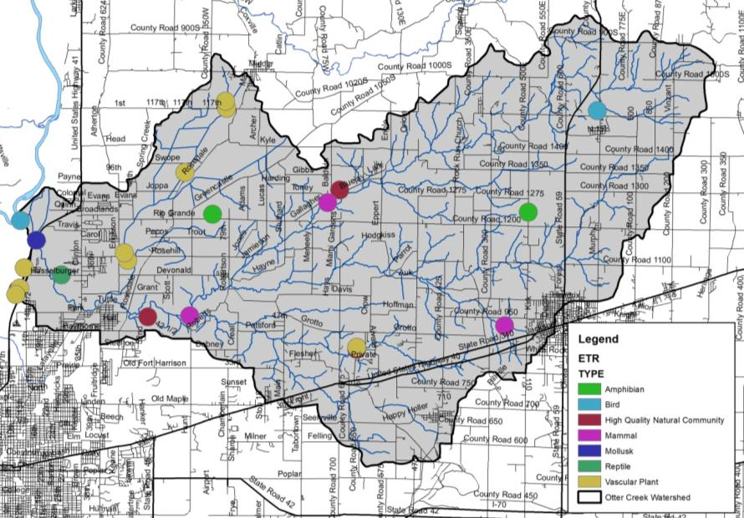
Figure 22. Locations of special species and high quality natural areas observed in the Otter Creek Watershed. Source: Clark, 2018.

Exotic and Invasive Species
Exotic and invasive species are prevalent throughout the state of Indiana. Their presence throughout the watershed and their potential impacts on high quality natural communities and regional species are of concern to stakeholders. Individuals are especially concerned about the prevalence of garlic mustard and honeysuckle species as well as other terrestrial species which negatively impact forests and timber stand management. Many species impact portions of the Otter Creek Watershed. Exotic species are defined as non-native species, while invasive species are those species whose introduction can cause environmental or economic harm and/or harm to human health. Hundreds of thousands of dollars are spent annually controlling exotic and/or invasive species populations within both publicly-owned natural areas and on privately-owned land. While this section is current as of the plan’s publication, the threat of exotic and invasive species is continuously evolving. Therefore, new species or treatment methods may be available since the publication of the plan. Table 8 lists exotic species observed within the counties which comprise the watershed.

Table 8. Observed exotic and/or invasive species by county within the Otter Creek Watershed.
Species | Clay County | Parke County | Vigo County
Asian bush honeysuckle | X | X | X
Autumn olive | X | X | X
Black locust |  | X | X
Buckthorn |  | X
Canada thistle | X | X | X
Common reed | X | X | X
Crown vetch | X | X | X
Dame's rocket | X | X | X
Garlic mustard | X | X | X
Japanese honeysuckle | X | X | X
Japanese knotweed | X | X
Mulitflora rose | X | X | X
Periwinkle | X | X | X
Privet |  | X | X
Purple loosestrife | X | X | X
Purple winter creeper | X | X | X
Reed canary grass | X | X | X
Russian olive |  | X
Siberian elm | X | X | X
Smooth brome | X | X | X
Sweet clover | X | X | X
Tall fescue | X | X | X
Tree of heaven | X | X | X
White mulberry | X | X | X
Winged burning bush |  | X
Source: Bledsoe, 2009; Fisher et al., 1998

Recreational Resources and Significant Natural Areas
A variety of recreational opportunities and natural areas exist within the Otter Creek Watershed. Recreational opportunities include parks, fish and wildlife areas, nature preserves, fairgrounds, golf courses, and school grounds (Figure 23). There is one DNR Fish and Wildlife Area – Chinook, which is a reclaimed strip mine covering a total of 2141 acres. The Chinook FWA consists of rolling grasslands and wooded reclaimed area with 80 acres of strip pit lakes. The Nature Conservancy owns and Otter Creek Woods in the southwest corner of the watershed east of Terre Haute. Vigo County Parks and Recreation manages Fontanet Woods, while Indiana State University manages Little Bluestem Prairie on the western edge of the watershed north of Terre Haute. Otter Creek itself is also a popular stream with canoe and kayak enthusiasts at certain times of the year. Otter Creek Township maintains Mill Dam Park, while Brazil maintains George N. Craig and Babe Wheeler Parks and the Clay County Park Board maintains Carbon County Park and Staunton County Park. Additional recreational opportunities exist at various schools, golf complexes and sporting clay facilities.

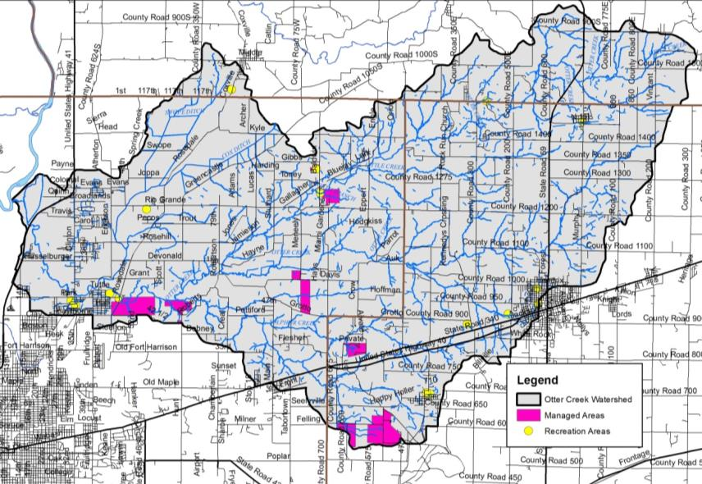
Figure 23. Recreational opportunities and natural areas in the Otter Creek Watershed.

Land Use
Water quality is greatly influenced by land use both past and present. Different land uses contribute different contaminants to surface waters. As water flows across agricultural lands it can pick up pesticides, fertilizers, nutrients, sediment, pathogens, and manure, to name a few. However, when water flows across parking lots or from roof tops it not only picks up motor oil, grease, transmission fluid, sediment, and nutrients, but it reaches a waterbody faster than water flowing over natural or agricultural land. Hard or impervious surfaces present in parking lots or on rooftops create a barrier between surface and groundwater. This barrier limits the infiltration of surface water into the groundwater system resulting in increased rates of transport from the point of impact on the land to the nearest waterbody.

Current Land Use
Today, nearly equal portions of the Otter Creek Watershed are covered by row crop agriculture (41.4%) and deciduous forests (40.9%; Table 9, Figure 24). Nearly 9% of the watershed is covered by developed open space or is in low, medium, or high intensity developed areas. Pasture or hay covers an additional 6% of the watershed, while grassland, evergreen forest, open water, and wetlands cover the remaining 2% of the watershed. Definitions for each land cover type are included in Appendix C.

Table 9. Detailed land use in the Otter Creek Watershed.
Classification | Area (acres) | Percent of Watershed
Row crow | 32,925.0 | 41.4%
Deciduous forest | 32,511.9 | 40.9%
Developed open space | 5,107.6 | 6.4%
Pasture/hay | 4,386.1 | 5.5%
Low intensity developed | 1,686.5 | 2.1%
Grassland | 1,020.0 | 1.3%
Evergreen forest | 767.3 | 1.0%
Open water | 310.7 | 0.4%
Medium intensity developed | 273.3 | 0.3%
Woody wetland | 181.8 | 0.2%
Emergent wetland | 143.3 | 0.2%
High intensity developed | 115.5 | 0.1%
Shrub/scrub | 29.4 | 0.04%
Mixed forest | 20.3 | 0.03%
Barren land | 6.6 | 0.01%
Total | 79,485.2 | 100.0%
Source: USGS, 2011

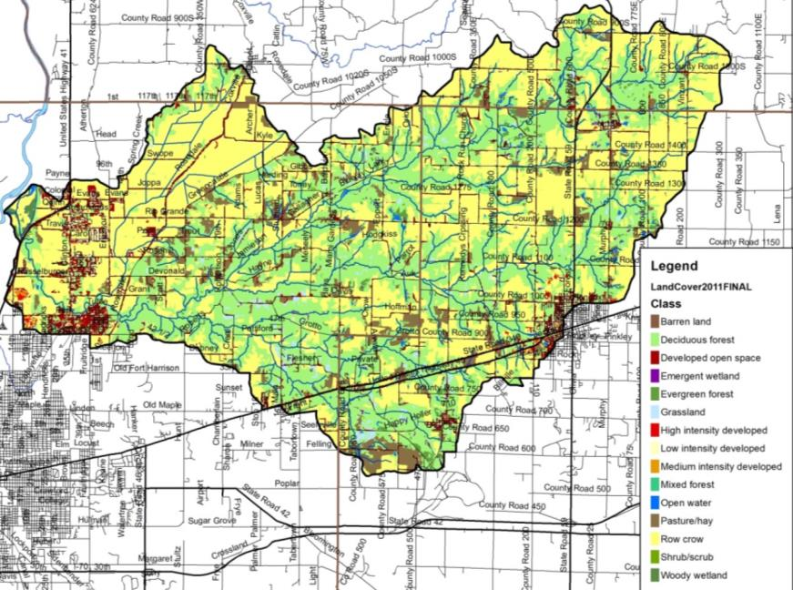
Figure 24. Land use in the Otter Creek Watershed. Source: NLCD, 2011.

Agricultural Land Use
Individuals are concerned about the impact of agricultural practices on water quality. Specifically, the volume of exposed soil entering adjacent waterbodies, the prevalence of tiled fields and thus the transport of chemicals into waterbodies, the use of agricultural chemicals, and the volume of manure applied via small animal farms and through confined animal feeding operations are concerning to local residents. Each of these issues will be discussed in further detail below.

Tillage Transect
Tillage transect information data for Clay, Parke, and Vigo counties was compiled for 2017 (Table 10; ISDA, 2017A-D). As reported by ISDA, members of Indiana’s Conservation Partnership (ICP) conduct a field survey of tillage methods. A tillage transect is an on-the-ground survey that identifies the types of tillage systems farmers are using and long-term trends of conservation tillage adoption using GPS technology, plus a statistically reliable model for estimating farm management and related annual trends. Table 7 provides the number of acres and percent of acres on which conservation tillage was utilized for each county by corn and soybeans. Individuals attending the first public meeting provided their knowledge of tillage type for farm fields throughout the Otter Creek Watershed. Based on their input, some form of conservation tillage (no till, reduced till, strip till) is utilized on approximately 2,950 acres (4%) within the Otter Creek Watershed (Figure 25).

Table 10. Tillage transect data by county for corn and soybeans (ISDA, 2017).
County | Corn (acres) | Corn (%) | Soybeans (acres) | Soybeans (%)
Clay | 18,421 | 27% | 26,328 | 39%
Parke | 16,118 | 35% | 27,754 | 48%
Vigo | 978 | 2% | 11,805 | 21%

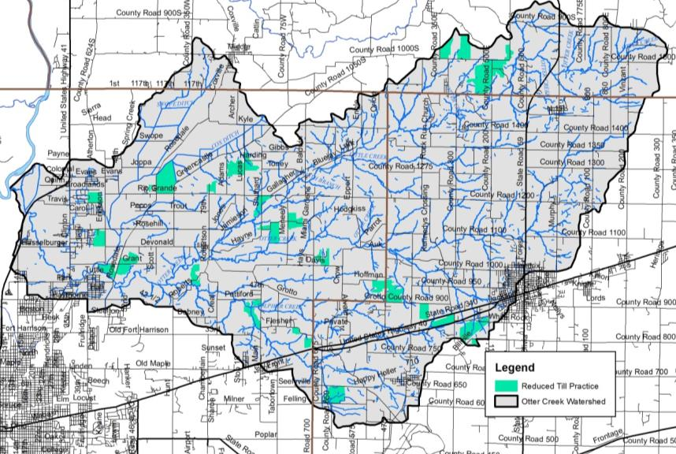
Figure 25. Agricultural fields noted as using reduced practices on Otter Creek Watershed based on input during the December 2017 public meeting.

Agricultural Chemical Usage
Agricultural pesticides and fertilizers are commonly applied to row crops in Indiana. These chemicals can be carried into adjacent waterbodies through surface runoff and via tile drainage. This is especially an issue if a storm occurs prior to the chemicals being broken down and used by the crops.

Data for chemical usage on an individual county or watershed level are not currently collected. Rather, data is collected for the state as a whole in two forms. First, the National Agricultural Statistics Survey (NASS) collects information on chemical usage, number of applications per year, type of chemical applied, and the application rate. These data were last collected in 2006 (NASS, 2006). Additionally, NASS collects farmland data for the number of acres in agricultural production by type (i.e. corn, soybeans, grains) by county (NASS, 2017). These data indicate that corn (170,000acres in Clay, Parke and Vigo counties) and soybeans (189,200 acres in Clay, Parke and Vigo counties) are the two primary crops grown in the watershed.

Nitrogen is more typically applied to corn than to soybeans. Soybeans have symbiotic bacteria on their roots that act as nitrogen fixers, which means that they pull the nitrogen that they need from the atmosphere then convert it into a form which they can use. Corn does not fix nitrogen; therefore nitrogen needs to be applied. Nitrogen is typically applied twice in Indiana – once at or before planting and a second time when corn reaches approximately one foot in height (NASS, 2007). Fall application of nitrogen also occurs, and is particularly problematic. Agricultural data indicate that corn receives 98% of the nitrogen applied in the state and 87% of the phosphorus. For these reasons, nutrient calculations were only completed for corn as applications to soybeans are likely negligible. Based on these data, it is estimated that 12,529 tons of nitrogen and 6,198 tons of phosphorus are applied annually within the Otter Creek Watershed counties (Table 11).

Table 11. Agricultural nutrient usage for corn in the Otter Creek Watershed counties.
Nutrient | Acres of Corn | % of Area Applied | Applications (#/year) | Rate/Application (lb/acre) | Total Applied/Year  (tons)
Nitrogen | 170,000 | 100 | 2.2 | 67 | 12,529
Phosphorus | 170,000 | 93 | 1.4 | 56 | 6,198
Source: NASS, 2007

Pesticides are also used on crops grown in Indiana. The Office of the Indiana State Chemist indicates that the two predominant herbicide active ingredients applied are atrazine and glyphosate. Atrazine is most commonly applied as a corn herbicide, while glyphosate is used on both corn and soybean fields as an herbicide. NASS indicates that in 2005, an average of 1.24 pounds of atrazine and 0.6 pounds of glyphosate were applied per acre of corn, and 0.73 pounds of glyphosate were applied per acre of soybeans (NASS, 2006). Using these rates, we estimated that a little over 105 tons of atrazine and approximately 120 tons of glyphosate are applied to cropland in the Otter Creek Watershed counties annually (Table 13).

Table 12. Agricultural herbicide usage in the Otter Creek Watershed counties.
Crop | Acres | Application Rate  (lb/acre) | Total Applied  (lbs) | Total Applied/Year  (tons)
Corn (Atrazine) | 170,000 | 1.24 | 210,800 | 105.4
Corn (Glyphosate) | 170,000 | 0.60 | 102,000 | 51.0
Soybeans (Glyphosate) | 189,200 | 0.73 | 138,116 | 69.1
Source: NASS, 2006

Confined Feeding Operations and Hobby Farms
A mixture of small, unregulated and larger, regulated livestock operations (confined feeding operations) is found within the Otter Creek Watershed. Small farms are those which house less than 300 animals, while larger farms that house large numbers of animals for longer than 45 days per year are regulated by IDEM. These regulations are based on the number and type of animals present. IDEM requires permit applications which document animal housing, manure storage and disposal, and nutrient management plans for farms which maintain 300 or more cows, 600 or more hogs, or 30,000 or more fowl. These facilities are considered confined feeding operations (CFO). There are two active confined feeding operations located in the watershed, none of which are large enough to be classified as a concentrated animal feeding operation (CAFO) (Figure 26). Both facilities house hogs with a combined total of 129 sows with litters, 750 gestating sows, and 2,200 feeding to finishing hogs. In total, approximately 3,000 animals per year are housed in CFOs in the watershed, generating approximately 12,360,000 pounds of manure per year spread over 3,074 acres in the watershed. This much manure contains nearly 8,200 pounds of nitrogen and 2,620 pounds of phosphorus.

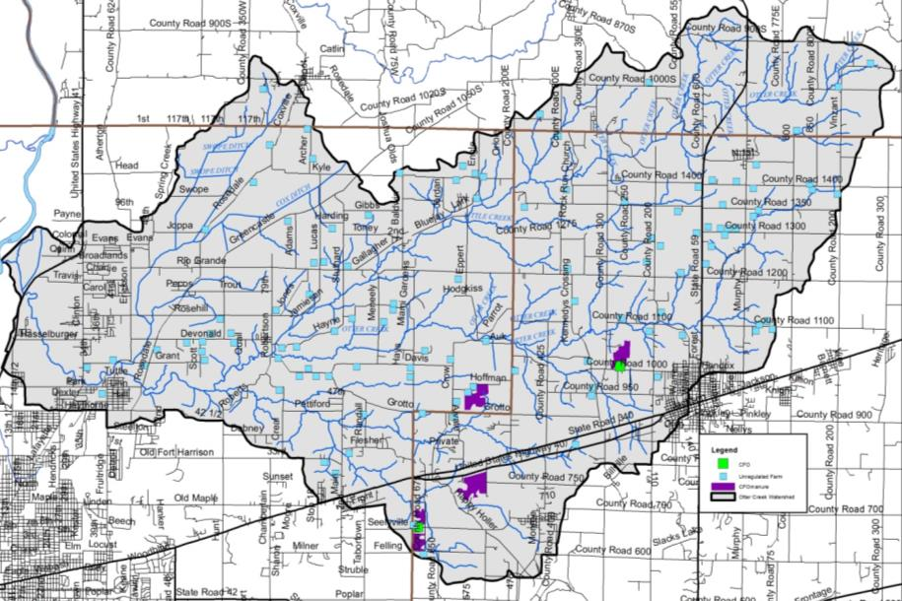
Figure 26. Confined feeding operation and unregulated animal farm locations within the Otter Creek Watershed.
In total, 113 small, unregulated animal farms containing nearly 1,250 animals were identified during the windshield survey, which is most likely an underestimate of the actual number. These small “mini farms” contain small numbers of cattle, horses, llamas, poultry, or goats, which could be sources of nutrients and E. coli as these animals exist on small acreage lots with limited ground cover.

Natural Land Use
Natural land uses including forest, wetlands, and open water cover approximately 42% of the watershed. Individuals are concerned that forested land is being fragmented and would like to see reforestation prioritized. Approximately 33,600 acres or 42% of the watershed are covered by trees. Forest cover occurs adjacent to waterbodies throughout the watershed, with the extent of forests decreasing towards the western end of the watershed where the flatter terrain made it easier to clear for agriculture (Figure 24). Many forested tracts are contiguous and large lengths of the watershed streams contain intact riparian buffers. Nonetheless stakeholders expressed concern that forested tracts continue to decrease in size Specific areas of concern will be discussed in further detail in subsequent sections.

Urban Land Use
Urban land uses cover less nearly 9% of the watershed (Table 9). Although this is only a very small portion of the watershed, there are some significant issues related to the dev areas. Especially troublesome are issues related to failing septic systems, impervious surfaces, flooding, and stormwater runoff that allow untreated sewage and stormwater to flow into the watershed during heavy rain events.

Impervious Surfaces
Impervious surfaces are hard surfaces which limit surface water from infiltrating into the land surface to become groundwater thereby creating high overland flow rates. Hard surfaces include concrete, asphalt, compacted soils, rooftops, and buildings or structures. In developed areas like North Terre Haute, Carbon, Seelyville, and Brazil, land which was once permeable has been covered by hard, impervious surfaces. This results in rain which once absorbed into the soil running off of rooftops and over pavement to enter the stream with not only higher velocity but also higher quantities of pollutants.

Overall, the watershed is covered by low levels of impervious surfaces. However, high impervious densities are present in North Terre Haute, Brazil, Seelyville, Rosedale, Carbon, and Staunton and along roads throughout the watershed. Estimates indicate that 10,475 acres (13%) of the watershed are 25% or more covered by hard surfaces. Elvidge et al. (2004) indicated that streams in watersheds with greater than 10% impervious surfaces clearly exhibited degradation. The Center for Watershed Protection (CWP) identified similar impacts from impervious surface density on water quality. The CWP study indicates that stream ecology degradation begins with only 10% impervious cover in a watershed. Higher impervious surface coverage results in further impairments including water quality problems, increased bacteria concentrations, higher levels of toxic chemicals, high temperatures, and lower dissolved oxygen concentrations (CWP, 2003).

Remediation Sites
Remediation sites including industrial waste, leaking underground storage tanks (LUST), open dumps, and brownfields are present throughout the Otter Creek Watershed (Figure 27). Most of these sites are located within the developed areas of North Terre Haute, Brazil, Carbon and along US Highway 40 and US Highway 41. In total, two industrial waste sites, 40 LUST facilities, one open dump, and five brownfields are present within the watershed. There are no Superfund sites within the watershed.

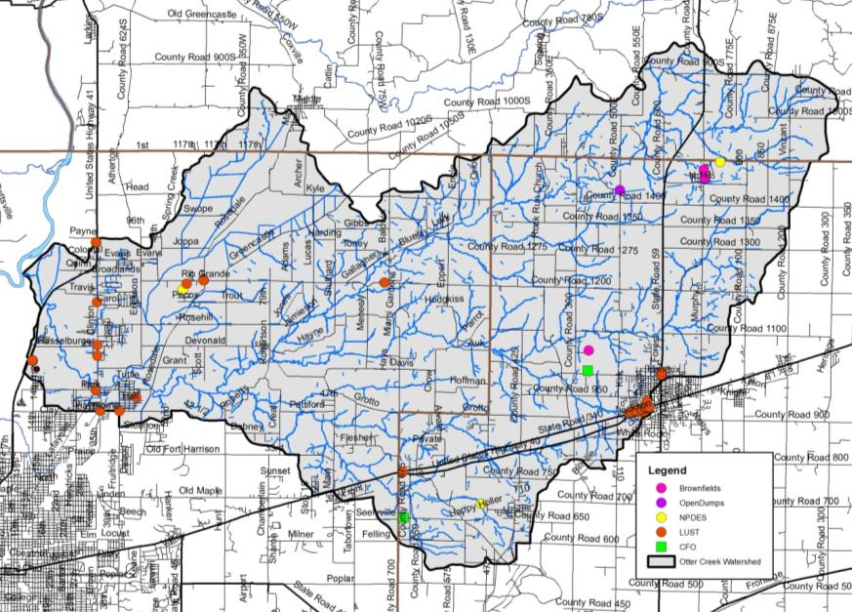
Figure 27. Industrial remediation and waste sites within the Otter Creek Watershed. Source: IDEM.

Mining and Petroleum Impacts
Nearly 100,000 acres of southwest Indiana has been disturbed by strip mining since the early 1920s; nearly 4,800 acres of surface mined land and 12,200 acres of underground mined land occurred in the Otter Creek Watershed (Figure 28). Coal mining played an important role in the development of the Otter Creek Watershed with Seelyville, Fontanet, and Coal Bluff all owing their founding to the Coal Bluff Mining Company or the McKeen Coal Shaft in Lost Creek Township (Oakey, 1908). Much of the disturbed land is due to spoil dumping rather than actual coal removal (Powell, 1972). Most commercial coal mining was restricted to Pennsylvania age out crop along the Eastern Region of the Interior Province with numerous coal beds continuing southwest into the Illinois Basin. Generally, coal was exposed on hillsides and along streams in the Wabash Lowland, Crawford Upland, and Tipton Till Plain (Malott, 1922). Otter Creek and its tributaries lie mainly within the Glaciated Wabash Lowland where strip mining occurred historically. Glacial deposits within the Wabash Lowland generated a more gentle topography allowing for easier access to coal deposits, thus averaging less additional spoil beyond the mined area (Powell, 1972). Additionally, glaciated areas are typically covered by bedrock or glacial drift overburden of uniform depth making them easier to excavate with limited surface cuts. In total, nearly 5.8% of Clay County, 0.2% of Parke County, and 2.7% of Vigo County was disturbed by strip mining (Powell, 1972). The Chinook Mine, now Chinook Fish and Wildlife Area, was historically operated as a strip mine by Ayrshire Coal Company – the long lakes that mark the current reclaimed area are reminders of the former strip mined land (Mined-Land Conservation Conference, 1966).

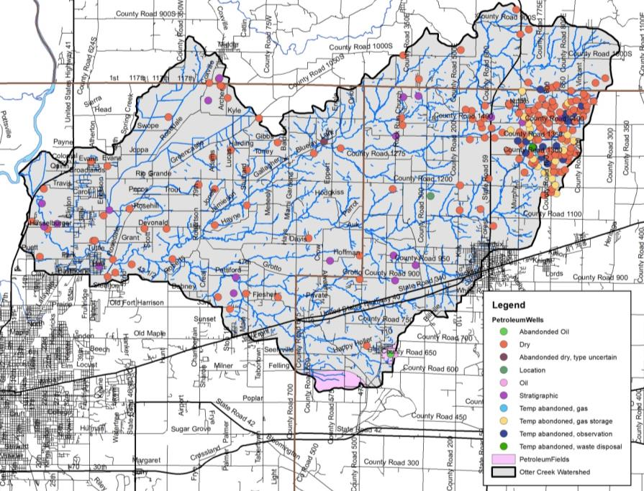
Figure 28. Mining and petroleum production locations within the Otter Creek Watershed.

Two petroleum fields, Staunten and Cherryvale NAS, lie within the Otter Creek Watershed. In total, these fields cover nearly 3,600 acres of which 141 acres of the Staunten Field and 560 acres of the Cherryvale NAS field are within the Otter Creek Watershed (Figure 28). Additionally, 218 petroleum wells are located throughout the Otter Creek Watershed. A majority of petroleum wells (159 of 218) in the Otter Creek Watershed are dry, while an additional 38 wells have been temporarily abandoned. In total, 21 wells are active including 19 stratigraphic wells, one oil well, and one location well.

Population Trends
The Otter Creek Watershed is relatively a sparsely populated area in general portions of Brazil, North Terre Haute, and Seelyville near the boundaries of the watershed. Tracking population changes within a watershed is challenging as data is published by counties and townships rather than watershed boundaries. Estimates of the population of the watershed are derived by calculating percentage of the watershed within a county and extrapolating from county-wide data. The Otter Creek Watershed lies within three counties. It drains nearly 13% of Clay County, 3% of Parke County, and 14% of Vigo County. Population trends for these counties derived from the most recently completed census (2010) are shown in Table 13, while Table 14 displays estimated populations for the portion of each county located within the watershed (StatsIndiana, 2018). These data indicate modest growth in all three counties over the past decade; however most of that growth is associated with Terre Haute and the immediate area.

Table 13. County demographics for counties within Otter Creek Watershed.
County | Area  (acres) | Population (2010) | Population Growth  (2000-2010) | Pop. Density  (#/sq. mi)
Clay | 230,400 | 26,890 | +334 | 74.7
Parke | 294,400 | 17,339 | +98 | 38.5
Vigo | 262,400 | 107,848 | +2,000 | 263.0

Table 14. Estimated watershed demographics for the Otter Creek Watershed.
County | Acres of County  in Watershed | Percent of County  in Watershed | Population
Clay | 31,284 | 13.6% | 3,651
Parke | 9,923 | 3.4% | 584
Vigo | 38,216 | 14.6% | 15,707
Total Estimated Population |  |  | 19,942

Planning Efforts in the Watershed
While no one single plan has been dedicated to the Otter Creek Watershed until the development of this one, several larger plans have encompassed portions of the Otter Creek Watershed or areas which it drains or outlets into. These planning efforts are summarized as follows:

Parke County Area Master Plan
The Parke County Master Plan was updated in 2007 (Parke County Area Plan Commission, 2007). The plan highlights the need to focus on natural resources as attractions, use conservation easements, develop natural resources and environmental education materials for teachers, and maintain agricultural areas. These suggestions will be taken into account for any recommendations in the Otter Creek Watershed that overlap with Parke County.

Vigo County Area Master Plan
In 2006, the Vigo County Area Plan Commission updated the previous county comprehensive plan (Vigo County Area Plan, 2006). The plan, ThriVe, highlights future roadway and thoroughfare plans, long-term development options, neighborhood and urban development options. While development could expand from the City of Terre Haute into the Otter Creek Watershed, most of the plan focuses on urban development and redevelopment within the City of Terre Haute. Based on the plan, there is little overlap in planning area or long-term plans; however, the plan should be consulted prior to any major land use changes, if these are recommended as actions within this watershed planning process.

Clean Water Coalition of the Wabash Valley
In 2015, the Vigo County MS4 communities, including Terre Haute, Vigo County, and Seelyville, developed their Storm Water Master Plan (City of Terre Haute, 2015; Figure 18). The plan describes, evaluates, and/or provides information for the following items:
- An evaluation of the existing storm water program,
- A detailed program description of each minimum control measure (MCM),
- A timetable for future program implementation milestones,
- A schedule for on-going receiving waters characterization,
- A narrative and mapped description of MS4 boundaries,
- An estimate of linear feet of MS4 conveyance systems,
- A summary of structural best management practices (BMPs) allowed in new and redeveloped areas,
- A summary of BMP selection criteria,
- A summary of current storm water budgets and funding sources,
- A summary of measurable goals for the minimum control measures, and
- Identification of programmatic indicators.

The plan includes the following recommendations:
- Consider development and implementation of a water quality and biological monitoring program to better understand watershed conditions and eliminate the limitations of the current data set.
- Clarify the designated use of study are streams and to confirm (or rectify) the current 303(d) list.
- Coordinate with IDEM to establish the designated use status of study area streams.
- Incorporate into the SWQMP an inspection process for the potential pollutant sources
- During public education efforts, the agricultural community should be educated regarding the best management practices to minimize nutrient introduction into watersheds.
- Evaluate/investigate TMDL listings and confirm the categorization of study area streams by IDEM.

Watershed Summary: Parameter Relationships
Several relationships among watershed parameters become apparent when watershed-wide data are examined. These relationships are discussed here in general, while relationships within specific subwatersheds are discussed in more detail in subsequent sections.

Topography, Soils, Septic Suitability, and Hydrology
Much of the topography and terrain characteristics within the Otter Creek Watershed have a direct correlation to water quality. Approximately 40% of the Otter Creek Watershed are mapped in highly erodible or potentially highly erodible soils. Highly erodible and potentially highly erodible soils are very susceptible to erosion. Nutrients, such as phosphorus, and sediment erode easily when these soils are not covered. Sediments and nutrients that reach Otter Creek waterbodies are likely to degrade water quality. Highly erodible and potentially highly erodible soils that are used for animal production or are located on cropland are more susceptible to soil erosion.

Most of the soils in the watershed are rated as very limited for septic system suitability. Sewers are utilized within the City of Terre Haute, City of Brazil, Town of Staunton, and Town of Carbon. All other residences utilize septic systems. This is a concern because adequate filtration may not occur and this water may easily reach water sources and groundwater. With a lack of natural filtration of septic fields to groundwater, degradation of water quality is likely if septic systems are not maintained. Septic maintenance is a concern of Otter Creek Watershed stakeholders.

Development and Population Centers
Much of the watershed’s population is located within incorporated area, including the City of Terre Haute, City of Brazil, Town of Staunton, and Town of Carbon. Unsewered, dense housing areas are located throughout the watershed with small subdivisions and roadside housing developments occurring throughout the watershed. The highest impervious surface densities and highest number of NPDES-regulated facilities occur within these urban population centers and are home to the most urban development issues including brownfields, leaking underground storage tanks (LUST), industrial waste sites, and the watershed’s only superfund site. The concentration of urban pollution issues suggests that within these areas, urban solutions are required to control water quality pollution and improve conditions within the Otter Creek Watershed.

Additionally, as watershed development continues, contiguous forested tracts continue to decline. Otter Creek Watershed stakeholders indicate concern with decreasing forest tract size indicating that smaller forested tracts result in poor forest productivity and poor forest health.

- WATERSHED INVENTORY II-A: WATER QUALITY AND WATERSHED ASSESSMENT
In order to better understand the watershed, an inventory and assessment of the watershed and existing water quality studies conducted within the watershed is necessary. Examining previous efforts allowed the project participants to determine if sufficient data was available or if additional data needed to be collected in order to characterize water quality problems. Once the water quality data assessment occurred, the watershed was then characterized to determine potential sources of any water quality issues identified by the data review. Subsequently, pollutant sources could then be tied to stakeholder concerns and collected data could be used to estimate pollutant loads from each identified source location. The following sections detail the water quality and watershed assessment efforts on both the broad, watershed-wide scale and in a focused manner looking at each subwatershed within the Otter Creek Watershed.

  - Water Quality Targets
Many of the historic water quality assessments occurred using different techniques or goals. Several sites were sampled only one time and for a limited number of parameters. Monitoring committee members were reluctant to draw too many conclusions based on a single sampling event. Nonetheless, the available data are detailed below and compared in general with water quality targets. In order to compare the results of these assessments, the monitoring committee identified a standard suite of parameters and parameter benchmarks. Table 15 details the selected parameters and the benchmark utilized to evaluate collected water quality data.

Table 15. Water quality benchmarks used to assess water quality from historic and current water quality assessments.
Parameter | Water Quality Benchmark | Source
Dissolved oxygen | >4 mg/L | Indiana Administrative Code
pH | <6 or >9 | Indiana Administrative Code
Temperature | Monthly standard | Indiana Administrative Code
E. coli | <235 colonies/100 mL | Indiana Administrative Code
Conductivity | 1050 mos/cm | Indiana Administrative Code
Sulfate | 500 mg/L | Iowa DNR (2009)
Nitrate-nitrogen | <0.5 mg/L | Based on comparison of regional WMPs
Ammonia-nitrogen | 0.o – 0.21 mg/L | Indiana Administrative Code
Total phosphorus | <0.02 mg/L | Based on comparison of regional WMPs
Total suspended solids | <15 mg/L | Waters (1995)
Turbidity | <5.7 NTU | USEPA (2001)
Qualitative Habitat Evaluation Index | >51 points | IDEM (2008)
Index of Biotic Integrity | >36 points | IDEM (2008)
Macroinvertebrate Index of Biotic Integrity | >2.2 (old) >36 (new) points | IDEM (2008)
  - Historic Water Quality Sampling Efforts
A variety of water quality assessment projects have been completed within the Otter Creek Watershed (Figure 29). Statewide assessments and listings include the integrated water monitoring assessment, the impaired waterbodies assessment, and fish consumption advisories. Additionally, the Indiana Department of Environmental Management (IDEM) and Indiana Department of Natural Resources (IDNR) have both completed assessments within the watershed including development of the Otter Creek TMDL which focused on E. coli reductions throughout the watershed. County-wide assessments of the fish community along the length of Otter Creek were completed by Indiana State University. Regional water quality assessments by the ENVI460 students and volunteer-based sampling of water quality through the Hoosier Riverwatch program also provide additional water quality data with which the watershed can be characterized. A summary of each assessment methodology and general results are discussed below. Specific data results are detailed within subwatershed discussions in subsequent section.

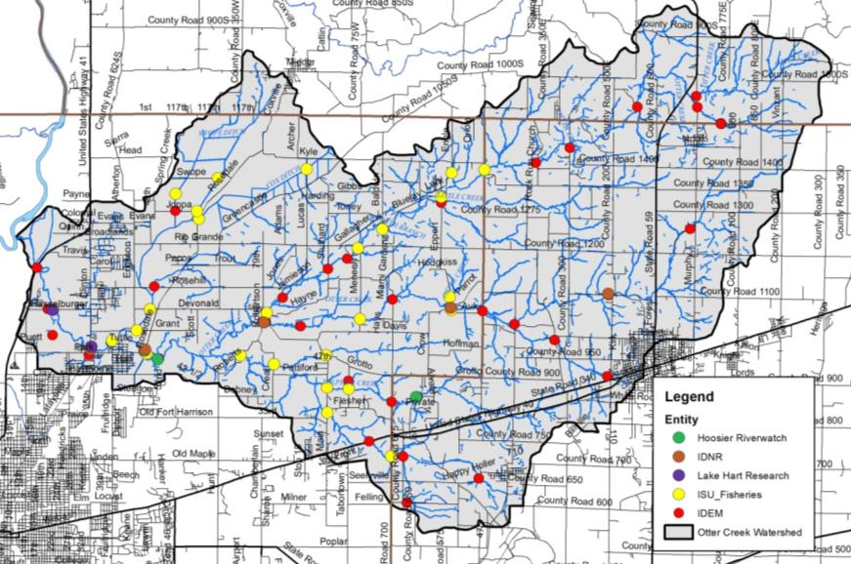
Figure 29. Historic water quality assessment locations.

    - Integrated Water Monitoring Assessment (305(b) Report)
The Indiana Department of Environmental Management (IDEM) is the primary agency tasked with monitoring surface water quality within the state of Indiana. Chapter 305(b) of the Clean Water Act requires that the state report on the quality of waterbodies throughout the state on a biannual basis. These assessments are known as the Integrated Water Monitoring Assessment (IWMA) or the 305(b) Report. The most recent draft report was delivered to the USEPA and underwent public comment in 2016 (IDEM, 2016). To complete this report, the 305(b) coordinator reviews all data collected by IDEM and selected high-quality data collected by other organizations on a waterbody basis. Each assessed waterbody is then assigned a water quality rating based on its ability to meet Indiana’s water quality standards (WQS). WQS are set at a level to protect Indiana waters’ designated uses of swimmable, fishable, and drinkable. Waterbodies that do not meet their designated uses are proposed for listing on the impaired waterbodies list, which is discussed in more detail below. The 2016 IWMA includes 25 waterbody reaches in the Otter Creek Watershed (IDEM, 2016). Listings include the following:
- Five segments of Otter Creek are listed for insufficient data to assess aquatic life use and fish consumption, while these segments are listed for recreational use and E. coli; however, a TMDL which covers these listings has been developed.
- One segment of Otter Creek is listed for pH and a TMDL is required to address this segment.
- Two unnamed tributaries to Otter Creek are listed for recreational use and E. coli; however, a TMDL which covers these listings has been developed.
- Two segments of the North Brand of Otter Creek and four unnamed tributaries to the North Branch Otter Creek are listed for insufficient data for aquatic life use and fish consumption. These segments are listed for recreational use and E. coli; however, a TMDL which covers these listings has been developed.
- Orchard Run, Little Creek and an unnamed tributary, Green Brook-Blue Brook, Ebenezer Creek, Diamond Creek, Sulphur Creek and three unnamed tributaries, and Swope Ditch are listed for insufficient data for aquatic life use and fish consumption. These segments are listed for recreational use and E. coli; however, a TMDL which covers these listings has been developed.
- Branch Cut Creek is listed for insufficient information for recreational use, fish consumption and aquatic life use.

    - Impaired Waterbodies (303(d) List)
Waterbodies in the Otter Creek Watershed which are included on the Impaired Waterbodies list are detailed in section 2.7.3 above.

    - Fish Consumption Advisory (FCA)
Three state agencies collaborate annually to compile the Indiana Fish Consumption Advisory (FCA). The Indiana Department of Natural Resources, Indiana Department of Environmental Management, and Indiana State Department of Health have worked together since 1972 on this effort. Samples are collected through IDEM’s rotating basin assessment for bottom feeding, mid-water column feeding, and top feeding fish. Fish tissue samples are then analyzed for heavy metals, PCBs, and pesticides.

Table 16details the advisories for the Otter Creek Watershed from the 2017 report (ISDH, 2017). Advisories listings are as follows:
- Level 3 – limit consumption to one meal per month for adults with pregnant or breastfeeding women, women who plan to have children, and children under 15 consuming zero volume of these fish.
- Level 4 – limit consumption to one meal every 2 months for adults with women and children detailed above having zero consumption.
- Level 5 – zero consumption or do not eat.

Based on these listings, the following conclusions can be drawn:
- Otter Creek is under a fish consumption advisory along their entire length for spotted bass and black redhorse.
- The Wabash River is under a fish consumption advisory for selected fish of select size within the length of the river in Parke and Vigo counties.
- No carp should be consumed from any waterbody within the watershed.

Table 16. Fish Consumption Advisory listing for the Otter Creek Watershed.
Waterbody | Fish Species | Fish Size | Advisory
All | Carp | 15-20 inches | 3
 |  | 20-25 inches | 4
 |  | 25+ inches | 5
Otter Creek | Black Redhorse | 14+ inches | 3
 | Spotted bass | 8+ inches | 3
Wabash River | Bigmouth buffalo | 21-24 inches | 3
 |  | 24+ inches | 4
 | Blue sucker | 21-26 inches | 3
 |  | 26+ inches | 4
 | Carpsuckers | 17+ inches | 3
 | Channel catfish | 19+ inches | 3
 | Flathead catfish | <16 inches | Unrestricted
 | Freshwater drum | 21+ inches | 3
 | Sauger | 17+ inches | 3
 | Shovelnose sturgeon | 30+ inches | 3
 | Striped bass | 10-12 inches | 3
 |  | 12+ inches | 4
 | Wiper | 10-12 inches | 3
 |  | 12+ inches | 4

    - IDEM Rotational Basin Assessments
In 1991, 1992, 1999, 2000, 2004, 2009, 2013, 2015, and 2016, IDEM sampled water chemistry at several locations in the Otter Creek Watershed via their rotational basin, watershed assessment and source ID assessment programs. Sampling occurred in Otter Creek and the North Branch of Otter Creek in 1991, Waterworks Lake and sediment from Otter Creek was assessed in 1992. Five Otter Creek reaches were assessed in 1999, while Sulphur Creek and tributaries, Ebenezer Creek and tributaries, North Branch Otter Creek and tributaries, Gundy Ditch, Little Creek, Otter Creek and unnamed tributaries, and No End Creek were assessed in 2000. Only the North Branch Otter Creek was assessed in 2004, while 19 sites were sampled as part of the Otter Creek TMDL assessment in 2009. Two sites along North Branch Otter Creek and one on Otter Creek were assessed in 2015 and 2016, respectively.

A few of the assessments which occurred via various IDEM assessment program included a single sample event with most assessments including three sample events and a few assessments including up to 12 events. Based on the rotational basin water chemistry assessments, the following conclusions can be drawn:
- E. coli concentrations exceeded the state standard Otter Creek at Rosedale Road, Miami Gardnens, 35 North Road, 1025 North, Lafayette Avenue, Hendrix Avenue and Hasselburger Road; North Branch Otter Creek at 700 East, Rock Road, Blue Jay Road, Hayne Road, Rosedale, and Fontanet Road; Ebenezer Creek at 1500 North; Waterworks Creek at Kennedy Crossing; Gundy Ditch at Grant Avenue and Rosedale Road; Sulphur Creek at Roberts Road and Main Street; Swope Ditch at Joppa Road; No End Creek at Grotto Road during at least one assessment. Most sites included one or two of five samples in excess of the target E. coli concentration (235 colonies/100 mL).
- Nitrate-nitrogen concentrations measured relatively low with only one sample (North Branch Otter Creek at Fontanet Road) exceeding target concentrations.
- Total phosphorus concentrations exceeded the recommended criteria in Little Creek, Otter Creek at Penn Central Railroad and 14 West; Ebenezer Creek at and downstream of the Carbon wastewater treatment plant outlet, and North Branch Otter Creek at Fontanet Road.
- Turbidity levels and total suspended solids concentrations routinely exceed the state standard with North Branch Otter Creek at Fontanet and Rock roads and Otter Creek at Rosedale Road routinely exhibiting elevated sediment levels.

    - Otter Creek TMDL
Water quality data collected by IDEM within the Otter Creek Watershed in 2009 indicated that 17 of 19 sites violated the E. coli state standard. Required E. coli reductions range from 0 to 84.5%. Based on these determinations, segments covering nearly 97% of Otter Creek Watershed streams have been included on the state’s 303(d) list. The Otter Creek Watershed TMDL (IDEM, 2013) addressed E. coli throughout the Otter Creek Watershed.

Data collected by IDEM and used for TMDL calculation generate the following conclusions:
- A 63% reduction in E. coli is required in the Headwaters Otter Creek Subwatershed.
- A 49% reduction in E. coli is required in the North Branch Otter Creek Subwatershed.
- A 52% reduction in E. coli is required in the Little Creek-North Branch Otter Creek Subwatershed.
- A 67% reduction in E. coli is needed in the Sulphur Creek Subwatershed.
- An 84% reduction in E. coli is needed in the Gundy Ditch Subwatershed.
- A 58% reduction in E. coli is needed in the Wastewaters Creek-Otter Creek Subwatershed.

IDEM recommended addressing he following contributing sources:
- Wastewater treatment plants, livestock access to streams, wildlife access to streams, onsite wastewater/unsewered areas, an abandoned mines under very low conditions.
- The above areas as well as impervious surfaces and riparian areas during dry conditions.
- The above areas as well as Combined Sewer Overflows, field drainage and upland stormwater issues during mid-range flows.
- The above as well as natural condition field drainage and bank erosion during moist conditions.
- On-site wastewater, abandoned mines, combined sewer overflows, stormwater inputs, field drainage from tiled and non-tiled files and bank erosion during high flow conditions.

Specific waste load allocations indicate that the Staunton and Carbon WWTPs contribute about 0.15% of the E. coli load during normal flow in the Otter Creek Watershed or approximately 0.12 billion E. coli/day for Carbon WWTP and 0.37 billion E. coli/day for the Staunton WWTP. The Seelyville and Terre Haute MS4s contribute 11.83 billion E.coli/day and 116.1 billion E. coli/day, respectively. Under wet weather conditions, the TMDL prioritizes E. coli reductions for the Wastewaters Creek-Otter Creek Subwatershed over the Sulphur Creek, North Branch Otter Creek, Gundy Ditch, Little Creek-North Branch Otter Creek and Headwater Otter Creek in that order. IDEM indicates that this ranking should be considered when determining critical areas as part of this planning process (IDEM, 2013).

    - Indiana State Fish Assessments (1962-2010)
From 1962 through 2010, Indiana State University students under the direction of John Whitaker assessed the fish community at 29 sites throughout the Vigo County portion of the Otter Creek Watershed (Jordan, 1877; Hay, 1894; Jenkins, 1887; Jordan, 1890; Blatchley, 1938; Gerking, 1945; Whitaker and Wallace, 1973; Whitaker, 1976; Grossman et al., 1982; Grossman et al., 1985; Simon et al., 2014). The following conclusions can be drawn from these collections:
- Markle Mill Dam greatly influences the fish community in Otter Creek. Upstream of the dam, 25 fish species were collected, while 47 species were collected below the dam. On average, 209 species were collected at the dam with 15.7 collected below the dame and 9.9 collected above the dam. The variable habitat present below the dam provides unique, high quality habitat for a variety of fish species (Whitaker and Wallace, 1973).
- Over a 12 year period (1962-1974), 21,029 fish representing 57 fish species were identified at the Markle Mill Dam. Of these, 36 species occurred regularly during annual collections and 21 species representing 0.27% of the total number of individuals were considered accidentals or those that occurred sporadically (Whitaker, 1976).
- Otter Creek fish assemblages observed at Markle Mill Dam is likely related to both timing and severity of floods during previous springs, summers and falls. If flooding occurred during the species’ reproductive period, it likely did not appear during the following years’ collection (Grossman et al., 1982).
- Over the 50 year study period, cumulatively 76 fish species were observed with an average of 49 species identified per decade. In general, species richness declined over the 50 year observation period. The 1970s showed the most significant decline in species diversity (Simon et al., 2014). Common carp were collected for the first time in the 1970s. Gizzard shad comprised 15% of the population during the 1980s increasing from its previous <1% dominance during the 1960s and 1970s collections. Invasive species, including the mottled sculpin and steelcolor shiner, were collected for the first time in the 2000s.
- Habitat quality at Markle Mill Dam is high scoring a mean of 88.5 from 1990 through 2010 (Simon et al., 2014).

    - Indiana DNR Fish Assessment (2006)
The Indiana Department of Natural Resources (IDNR) assessed the fish community in Otter Creek at four locations in 1995 and at five locations along the mainstem in 2006 (Weiman, 2006). Fish habitat was assessed using the QHEI and the Index of Biotic Integrity (IBI) was calculated for each sites’ fish community. General chemistry parameters were also measured at each reach. The following conclusions can be drawn:
- Dissolved oxygen, temperature, and transparency measured within targets. pH concentrations were elevated measuring 9.0-9.5 suggesting that algal production may have been elevated during the assessment period.
- Fishing was rated as fair to good during the 1995 assessment within the lower 10 miles of Otter Creek with spotted bass, smallmouth bass, largemouth bass, and rock bass being the most abundant game fish. In total, 1,760 individuals including 51 species representing 11 families were collected during the 2006 assessment.
- River miles 4.0, 10.3 and 14.5 rated IBI scores of good to excellent, while river mile 18 was classified as good. The highest species richness (32 species) occurred at river mile 4.0. River mile 18 contained the lowest richness (22).
- Habitat scores averaged 62 with habitat scores increasing from headwaters to mouth sites. In general, IBI scores increased as QHEI scores decreased likely due to the presence of large river species migrating into Otter Creek from the Wabash River along its lower reaches.

    - BioBlitz Results - Aquatic Species (2005)
On October 7, 2005, the Rivers Institute in partnership with the Biodiversity and Natural Areas Committee of the Indiana Academy of Science hosted a one day BioBlitz on Otter Creek (Karns et al., 2005). While the event focused on both terrestrial and aquatic diversity, only the aquatic results are summarized here. Sample collection of fish, mussels, clams and crayfish occurred at two locations along Otter Creek: 1) at U.S. 41 and at Markle Mill Dam. Conclusions that can be drawn are as follows:
- In total, 40 and 44 fish species were identified at the respective sites.
- Two crayfish species was represented at both sites as well as 8 mussel species were represented in the assessment.

    - Cox Ditch and Otter Creek LARE Biomonitoring Report (1991-1994)
Lake Hart Research assessed the appropriateness of funding a watershed land treatment project in Cox Ditch in 1995. As part of this assessment, Lake Hart Research reviewed existing water quality data, established biological and habitat baselines and evaluated the potential for project success. Two Otter Creek locations, one upstream and one downstream of Gundy Ditch, were assessed as part of the project. The following conclusions can be drawn:
- Mayfly, stonefly, and caddisfly (EPT) species were present in low density. This resulted in relatively high ratios of EPT taxa to chironmidae taxa.
- HBI results indicate that relatively diverse and pollution intolerant species are present within these reaches of Otter Creek.

    - Indiana State ENVI460 E.coli and Geochemistry Analysis
Indiana State University students in ENVI460 collected water and soil samples from five locations along Otter Creek to assess the presence of E. coli and assess the potential for heavy metal contamination (Montanez et al., unpublished). The following conclusion can be drawn:
- E. coli testing tablets indicate that all Otter Creek samples contain E. coli.
- Soil heavy metal tests indicate elevated concentrations for iron, zircon, manganese, strontium, zinc, and rubidium. Concentrations were not elevated at one particular site over another and concentrations did not exceed EPA published values for critical continuous concentration levels.

    - Hoosier Riverwatch Sampling (2002-2017)
From 2002-2006 and again in 2017, volunteers trained through the Hoosier Riverwatch program assessed two sites in the Otter Creek Watershed: Sulphur Creek at CR 650 West and Otter Creek at Haythorne Road. Assessments typically occurred monthly during the growing season. Volunteers monitored stream stage, flow rate, and discharge; collected water chemistry samples for analysis using HACH test kits; assessed instream habitat using the Citizen’s QHEI; and surveyed the stream’s macroinvertebrate community. Using the chemical data, the Water Quality Index (WQI) was calculated. Volunteers calculated a Pollution Tolerance Index (PTI) using the biological data. Based on these data, the following conclusions can be drawn:
- In Sulphur Creek, nitrate-nitrogen concentrations were elevated measuring as high at 8.8 mg/L. Dissolved phosphorus concentrations typically measured low while pH, dissolved oxygen and temperature concentrations measured within state standards.
- Otter Creek samples measure within target concentrations for pH, temperature, dissolved oxygen, nitrate, and dissolved phosphorus.

    - Wabash River Total Maximum Daily Load (TMDL) Study
Water quality data collected from the Wabash River indicated that the Wabash River did not consistently comply with the state’s water quality standards. Based on these determinations, segments of the Wabash River have been included on the state’s 303(d) list since its inception. The 2002 listing included segments of the Wabash River in non-compliance for pathogens (E. coli and fecal coliform), nutrients, pH, dissolved oxygen, and impaired biotic communities. Subsequent lists prepared in 2004, 2006, and 2008 replicate these listings. In order to cohesively address impairments, one TMDL was written for the entire length of the Wabash River including the 30 miles in Ohio and the 475 miles in Indiana and Illinois (Tetra Tech, 2006). While not part of the Otter Creek Watershed, the TMDL addresses nutrient, dissolved oxygen, and E. coli impairments to its receiving body, the Wabash River, and should therefore be considered when setting project goals.

Data collected by several agencies was obtained for water quality model development and TMDL calculation. The following conclusions were drawn with regards to water quality in the Wabash River:
- Nitrate+nitrite concentrations routinely exceeded the Indiana benchmark (10 mg/L); however, median concentrations measured 5 mg/L.
- Median dissolved oxygen concentrations generally exceeded 8 mg/L with only a few stations measuring below the minimum benchmark (4 mg/L
- Phosphorus concentrations routinely exceeded the phosphorus benchmark (0.3 m).g/L) used for impaired waterbody listing by the IDEM.
- Most station impairments resulted from a combination of phosphorus and nitrate+nitrite or dissolved oxygen exceedences.

Due to the routine nature of the listings, one TMDL was developed for the entire Wabash River. The TMDL was calibrated at six locations along the river where sufficient data was available for calculation. The location relevant to the Otter Creek Watershed is the Wabash River at its confluence with the Vermillion River. Although this station does not specifically identify inputs from Otter Creek, it contains the watershed and is therefore used as the base assessment regarding necessary reductions (Figure 30). Based on the Wabash River TMDL, the following conclusions have been drawn:
- A monthly reduction in E. coli from nonpoint sources from April to October of 87-88% is needed in the Wabash River at its confluence with the Vermillion River. No reduction in point source generated E. coli is necessary (TetraTech, 2007).
- Monthly reductions of total phosphorus from point sources ranging from 69 to 97% are needed in the Wabash River at its confluence with the Vermillion River; while a 4-5% reduction from nonpoint sources is necessary.
- According to the TMDL, no nitrate reductions are required within this reach from either point or nonpoint sources.

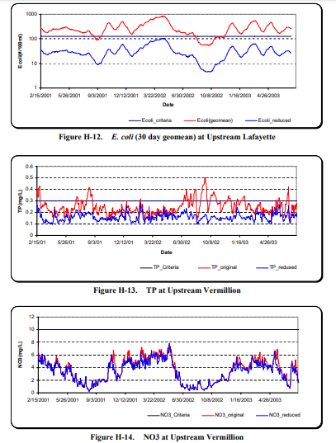
Figure 30. Total phosphorus (TP), nitrate (NO3), and E. coli load reductions identified in the Wabash River TMDL for the confluence with the Vermilion River reach of the Wabash River. Source: TetraTech, 2007.

    - Wabash River IDNR Fisheries Assessment (1999)
In July 1999, the Indiana Department of Natural Resources (IDNR) surveyed the length of the Wabash River in 48 one-half to one mile segments. Habitat and general chemistry data were collected concurrent with the fish community assessment. Four segments were located within the watershed. During the assessment, between 17 and 36 species and 133 and 225 individuals were collected. In total, 117 species were identified during the assessment. Based on these data, the following conclusions can be drawn:
- Habitat may be limited within these reaches. Water clarity was also low measuring 10 to 14 inches. Dissolved oxygen concentrations were elevated measuring greater than 11.5 mg/L in each reach.
- Stefanavage (2007) indicated that distribution of species was most explained by individual species biology and its habitat preference rather than any impact from upstream dams or water quality impacts.

    - Wabash River Fishery Assessments: DePauw University (1967-1994)
Assessment and study of the Wabash River began in 1967. Initial studies focused on thermal effects on the fish community near Terre Haute and Cayuga. Research efforts extended to longer stretches of the river in 1973 and expanded north to include the river from Delphi (RM 330) downstream to Merom (RM 161). Extensive data collected via IDEM’s fixed monitoring station network are also reported as part of Gammon’s efforts (Gammon, 1995). Based on Gammon (1995), the following conclusions have been drawn:
- The average suspended sediment concentration in the Wabash River from 1977-1987 measured 87 mg/L which resulted in 714 tons of suspended sediments moving through the river per day. During high flow events, clay particles accounted for 68% of suspended sediments, while silt and sand represented 27% and 6%, respectively. Based on these data, a reduction in suspended sediments is necessary.
- Mean nutrient concentrations calculated from measurements occurring from 1977-1987 indicate that nitrate-nitrogen (3.3 mg/L) and phosphate (0.170 mg/L) concentrations were elevated and need to be reduced.
- In Gammon’s 1994 assessment of riparian condition, bare banks were observed on 1.9 km, while banks with few trees occurred on 2.8 km. These data indicate that in 1994, the banks of the Wabash River were relatively well protected. However, areas which were denuded likely represent former riparian wetland locations, thus indicating that floodplain storage may have been lost due to these conversions.

    - Wabash River Fishery Assessment: Ball State University (2001-2008)
Ball State University continued Jim Gammon’s Wabash River assessment efforts starting in 2001 and continuing with an annual assessment through present day (Pyron and Lauer, 2009). The most recently reported effort included assessment of the fish community and field water chemistry in 500 feet reaches throughout the Middle Wabash. Data collected throughout the Middle Wabash indicate relatively similar numbers of individuals (115 in 2008; 116.2 average) and numbers of species per collection (2001 to 2008). Based on these data, the following conclusions can be drawn:
- pH and dissolved oxygen concentrations were elevated along the Wabash River; however, none of the concentrations exceeded the target value.
- The highest species diversity occurred in the below Lafayette and below Granville Bridge sampling reaches with these same reaches containing the highest density.
- The lowest diversity occurred in the Granville bridge reach while the lowest density occurred within the Attica reach. Pyron and Lauer (2004) noted that habitat is likely a contributing factor to both high and low densities and diversities.
- All sites possessed IBI scores which exceeded the score at which IDEM indicates streams are not meeting their aquatic life use designation; however, the Granville bridge reach only scored one point above the ALUS. Despite its low density and diversity, the Attica reach scored the highest IBI (61).

    - The Nature Conservancy Wabash River Study
The Nature Conservancy compiled a database of biological, stressor, and threat data for the Wabash River and its tributaries (Armitage and Rankin, 2009). The data were then used to analyze water quality and fish community information on an 11-digit watershed level. Although no new data were collected as part of this study, their analysis methods allow conclusions to be drawn which can be used to compare this watershed with others along the length of the Wabash River. Based on data collected, the following conclusions can be drawn:
- An ideal habitat (QHEI) score for this portion of the Wabash River based on 1800s conditions is 93.5. At that time, habitat would have rated as excellent to near maximum scores for most metrics.
- The fish community in this reach is generally lacking in sensitive species with common carp and freshwater drum dominating the population.
- Total phosphorus and nitrate-nitrogen concentrations are elevated within both the mainstem and tributaries in this reach. The elevated nutrient concentrations present in the tributaries, coupled with the lack of buffers, increased delivery of nutrients via drainage systems and tile drains, and degradation of instream habitat due to altered hydrology.

  - Current Water Quality Assessment
    - Water Quality Sampling Methodologies
As part of the current project, the Otter Creek Project implemented a one year professional water quality monitoring program. The program included water chemistry and habitat assessments. Additionally, the project implemented a volunteer monitoring program to assess water chemistry and macroinvertebrate communities. Indiana State University also assessed metal concentrations in soil, augmented E. coli monitoring throughout the watershed, and assessed macroinvertebrate communities using the RBP. The program is detailed below and in the Quality Assurance Project Plan for Otter Creek Watershed Management Plan approved on January 8, 2018. Sites sampled through this program are displayed in Figure 31. Sample sites were selected based on land use and watershed drainage and correspond with sites sampled by IDEM as part of TMDL development. The biweekly sampling regimen was enacted to create a baseline of water quality data.

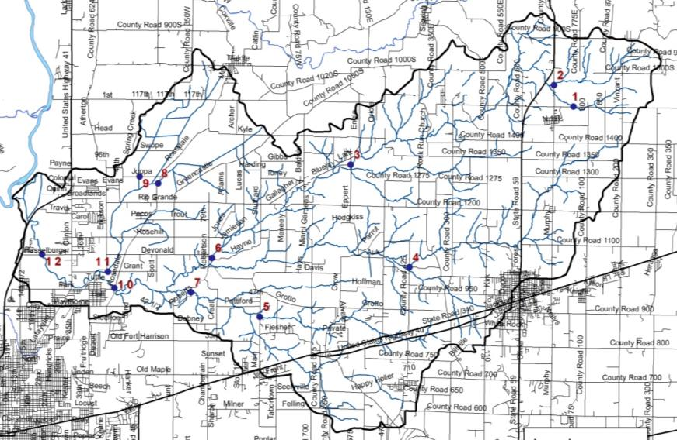
Figure 31. Sites sampled as part of the Otter Creek Watershed Management Plan.

Stream Flow
Stream flow was measured in situ when grab samples were collected. Stream flow was calculated by scaling stream flow measured at the U.S. Geological Survey (USGS) Big Raccoon Creek near Ferndale (USGS Gage 03340900) to subwatershed drainage area during high flow events.

Field Chemistry Parameters
The Otter Creek Project established twelve chemistry monitoring stations as part of the monitoring program. Stations are located on Ebenezer Creek (CR 1500 N), Otter Creek (CR1025 N, Rosedale Road, Hasselberger Road), North Branch Otter Creek (CR 700 E, Bluejay Road), Sulphur Creek (main Streeet, Roberts Road), Gundy Ditch (21 East and Rosedale Road), Swope Ditch (Joppa Road). Dissolved oxygen, temperature, pH, turbidity, conductivity, nitrate-nitrogen and ammonia-nitrogen were measured biweekly at the sampling stations from January to December 2018. Appendix D details the parameters measured and potential impacts to particular parameters.

Laboratory Chemistry Parameters
Like the field parameters, biweekly laboratory sample collection and analysis occurred throughout the one year sampling program. Samples were analyzed for total phosphorus, total suspended solids, sulfate, and E. coli. Appendix D details the parameters measured and potential impacts to particular parameters.

Habitat
The physical habitat at each of the biological sample sites was evaluated using the Qualitative Habitat Evaluation Index (QHEI). The Ohio EPA developed the QHEI for streams and rivers in Ohio (Rankin, 1989, 1995) and the IDEM adapted the QHEI for use in Indiana. Arion Consultants assessed habitat at all twelve sites in the summer of 2018. Appendix D details the QHEI and its individual metrics.

Sediment and Water Metals Samples
Indiana State University students collected one sediment and one water chemistry sample at each of the twelve sample sites. Samples were collected biweekly for eight weeks. Sediment samples were sieved with a 106 µm sieve, and 0.5 g was weighed into crucibles. Samples were dry-ashed at 550°C for 2 hours in a muffle furnace. Ashed samples were transferred to 50 mL centrifuge tubes with 20 mL of hydrochloric acid and shaken for 16 hours. After shaking, samples were centrifuged and diluted (1:10 and 1:100) in ICP tubes to measure minor and major metals on an ICP-OES. Water samples were analyzed as collected using an ICP-OES.

Field Chemistry Results
Figure 32 through Figure 36 display results for non-nutrient field chemistry data collected biweekly at the twelve sample sites. At each of the stream sites, a multi parameter probe is deployed. The probe collects data for temperature, dissolved oxygen, specific conductivity, pH and turbidity.

Temperature
Figure 32 illustrates the biweekly temperature measurements in Otter Creek Watershed stream. As shown, temperatures measure approximately the same at each of the stream sites with seasonal changes in temperature creating major differences in temperature throughout the sampling period. Temperatures measured near 0 ºC in all streams from January through March and again in November and December sampling events. The highest temperatures occurred during the June, July and August assessments depending on riparian cover and stream depth present at each location.

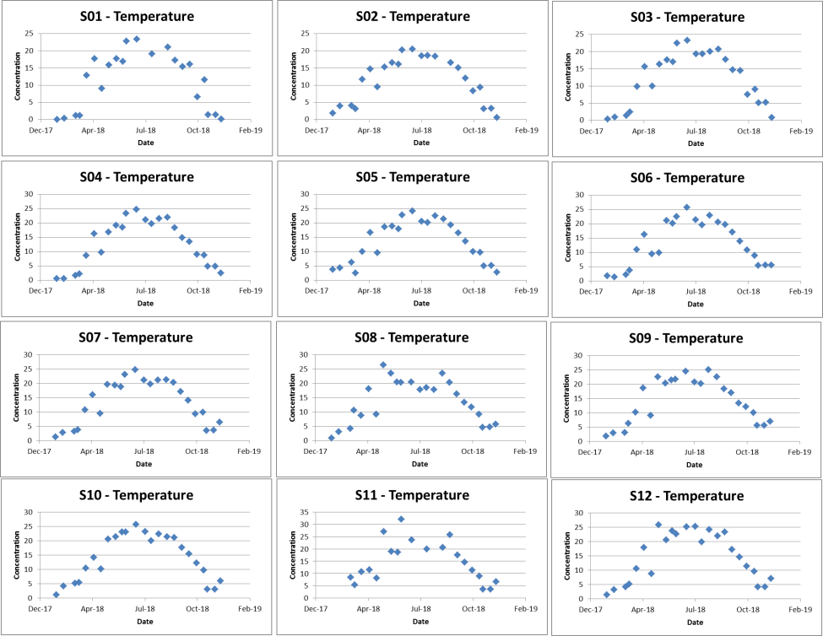
Figure 32. Temperature measurements in Otter Creek samples sites from January-December, 2018.

Dissolved Oxygen
Dissolved oxygen concentrations also display seasonal changes like those observed for temperature. However, as shown in Figure 33, dissolved oxygen concentrations are opposite those measured for temperature. This is as expected as colder water holds more dissolved oxygen than warmer water; therefore, when water temperatures are low, dissolved oxygen concentrations are high and vice-versa. As such, the dissolved oxygen graph shows a general pattern where dissolved oxygen concentrations are higher in winter and lower in summer. All streams display variation in dissolved oxygen concentration due to individual conditions present within each system. The lowest dissolved oxygen concentrations occurred at Site 8 during June 2018. None of the streams contained dissolved oxygen concentrations which measured below the state standard (5 mg/L).

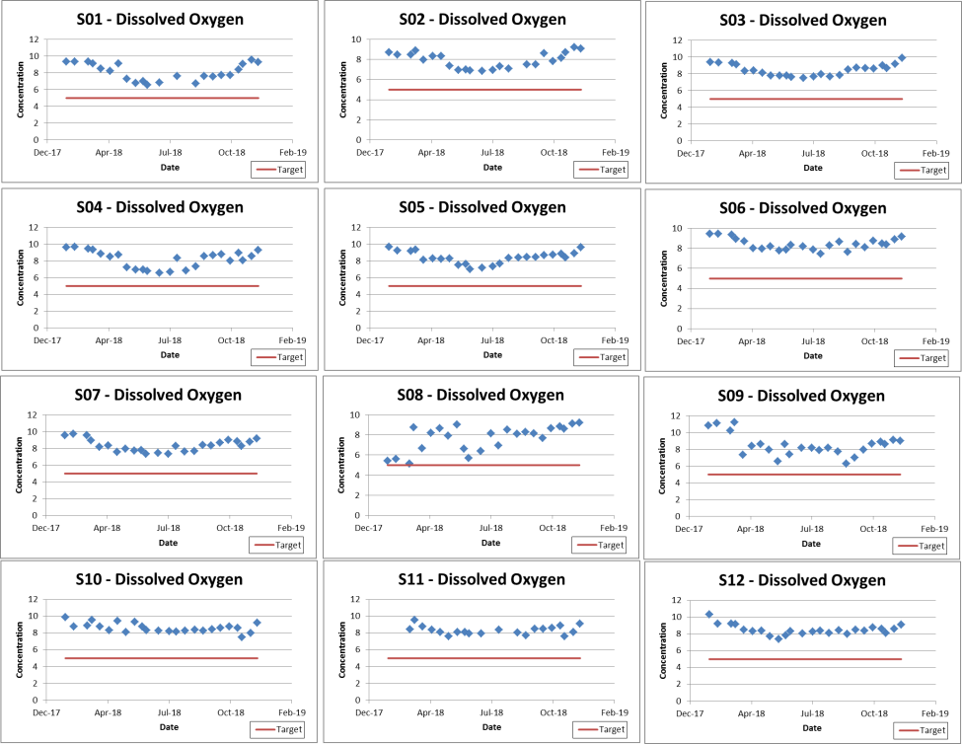
Figure 33. Dissolved oxygen measurements in Otter Creek samples sites from January-December, 2018.

pH
Throughout the sampling period, pH generally remained in an acceptable range in all watershed streams. No discernible pattern can be found in pH levels in any of the monitored streams (Figure 34). In March and April, pH levels measured below the lower pH target (6.0), while pH never measured above the upper pH target (9.0). Low pH levels typically occurred in the headwaters streams (S1 and S2) where more wetland drainages and strip pit lakes are present. Low pH levels also occurred under high flow conditions.

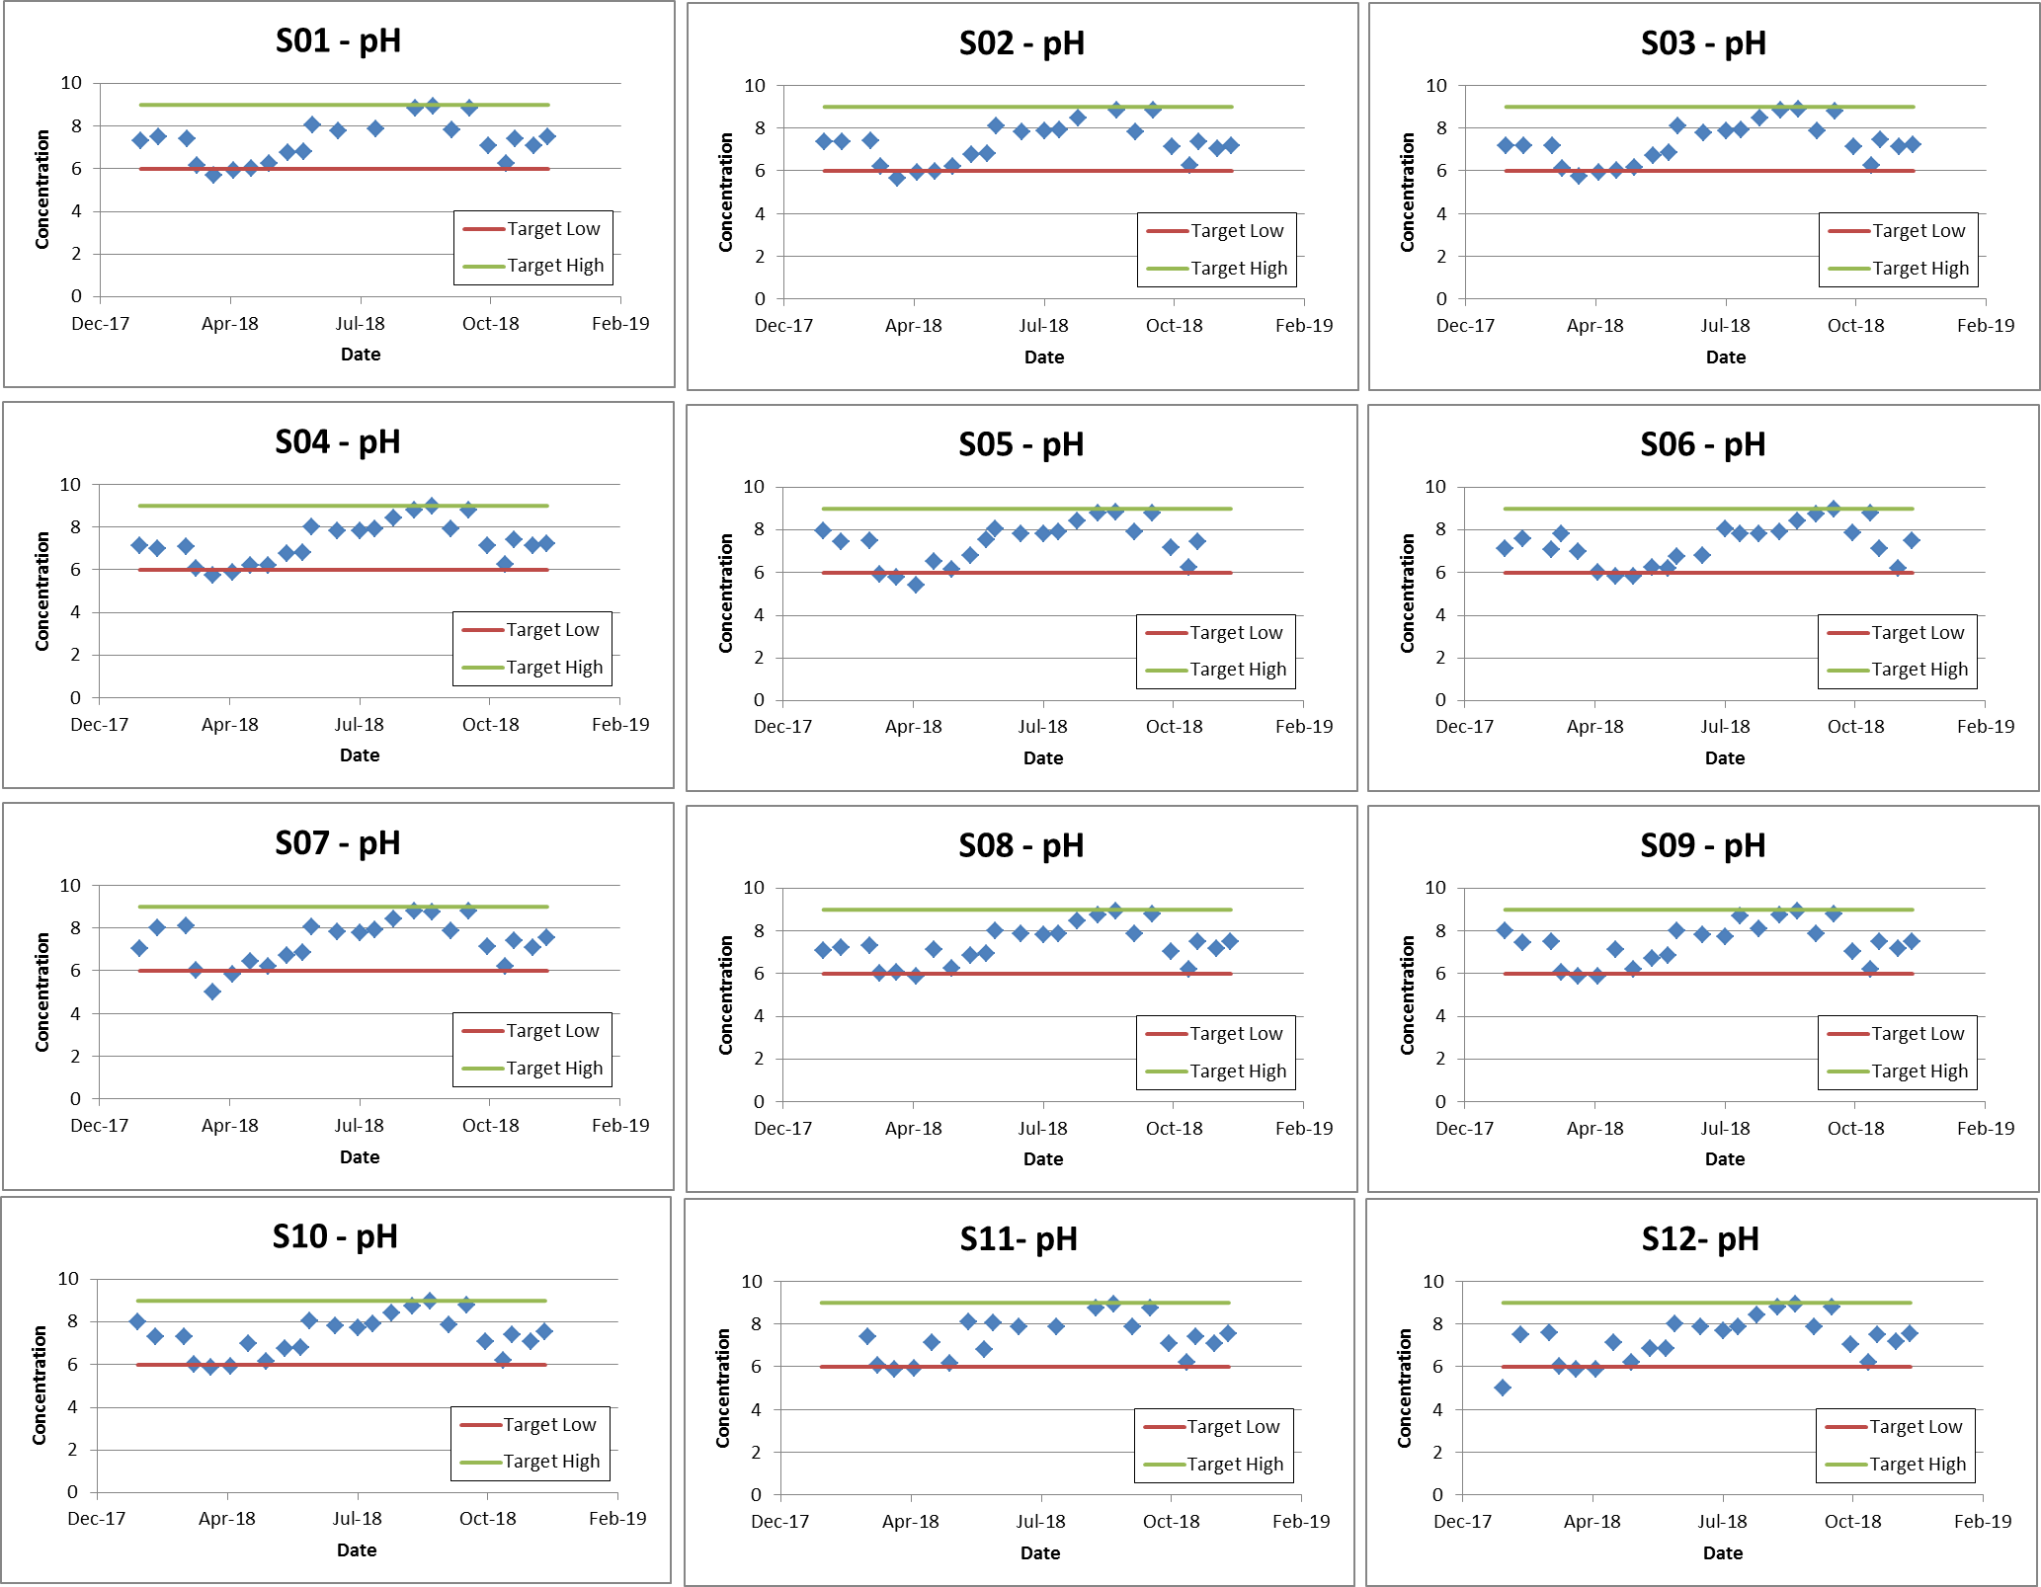
Figure 34. pH measurements in Otter Creek samples sites from January-December, 2018.

Specific Conductivity
Figure 35 displays conductivity measurements in Otter Creek Watershed streams. Conductivity measurements varied greatly over the sampling period. Conductivity exceeded state standards in Sulfur Creek (Site 07) in 11 of 24 samples (46%). Conductivity did not exceed state standards at any other sites.

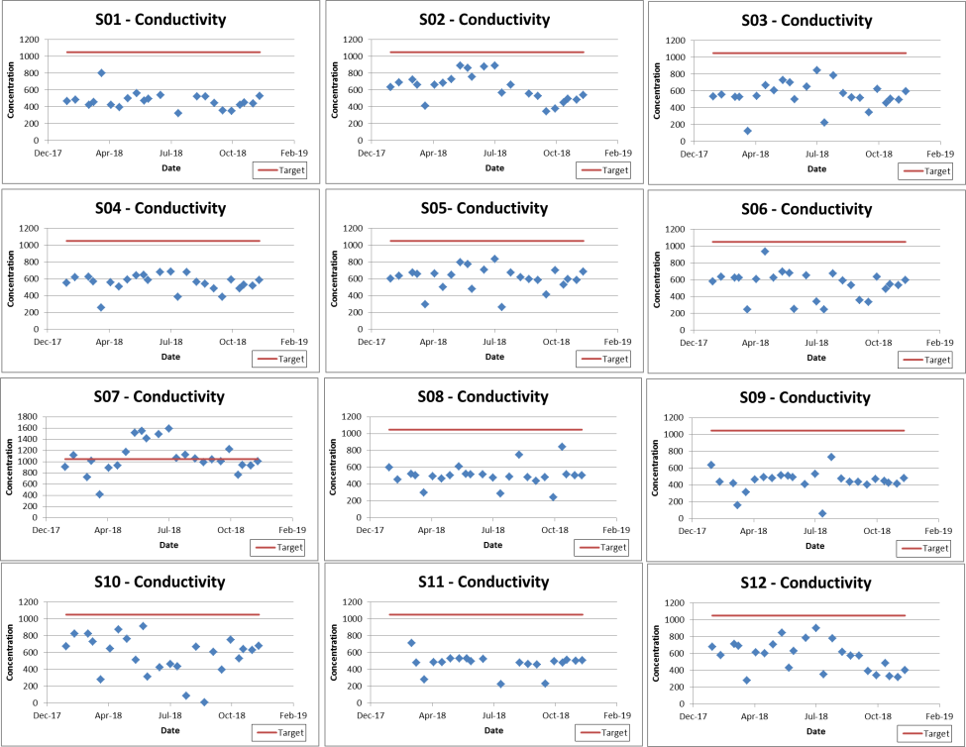
Figure 35. Conductivity measurements in Otter Creek samples sites from January-December, 2018.

Turbidity
Turbidity measurements for Otter Creek watershed streams are displayed in Figure 36. Turbidity concentrations exceeded the target in 32% of collected samples. Turbidity tends to spike during high flow events and this can be observed at several sites throughout the sampling season. Most exceedances in the Otter Creek Watershed measured just above the target (5.7 NTU). The highest turbidity levels occurred in Otter Creek (S06) with turbidities as high at 144 NTU observed in March 2018.

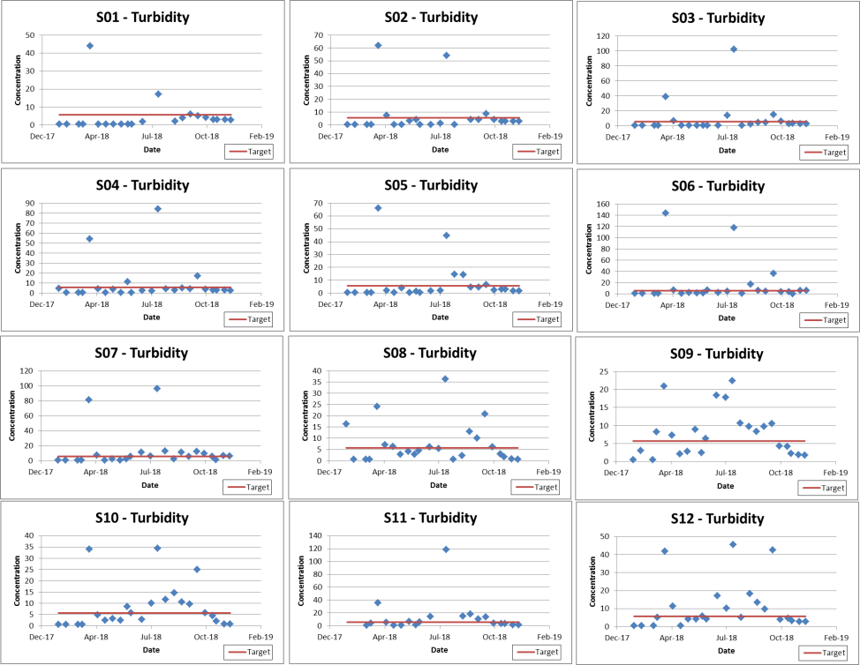
Figure 36. Turbidity measurements in Otter Creek samples sites from January-December, 2018.

Water Chemistry Results
Figure 37 to Figure 45 display results for nitrate-nitrogen, total phosphorus, total suspended solids, and E. coli collected biweekly from twelve locations in the Otter Creek Watershed. Data are displayed in comparison to target concentration and on load duration curves during the sample period. Appendix D details individual measurements collected throughout the sampling period.

Nitrate-nitrogen
Figure 37 displays nitrate-nitrogen concentrations compared to target levels (0.5 mg/L). As shown below, nitrate-nitrogen concentrations measured in 2018 always exceeded target levels. Nitrate-nitrogen concentrations measured the highest during the spring, falling throughout the summer and increasing again in the fall. The highest concentrations occurred in January and December 2018. The fact that nitrate-nitrogen concentrations exceeded targets in 100% of collected samples suggesting that flow condition does not impact sources of nitrate-nitrogen in the Otter Creek Watershed. The highest average concentrations occurred in S01 and S05 with average concentrations measuring 4.5 mg/L. All sites averaged nitrate-nitrogen concentrations higher than the median concentration at which biological communities are impaired.
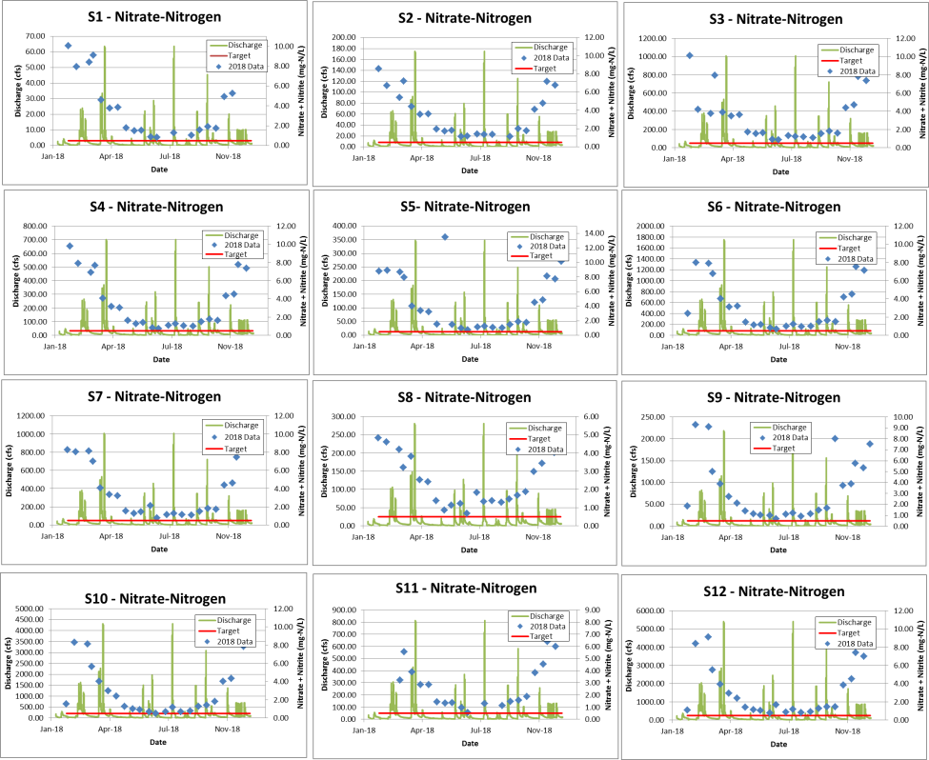
Figure 37. Nitrate-nitrogen concentrations measured in Otter Creek sample sites January to December 2018.

Total Phosphorus
Total phosphorus concentrations exceed target concentrations in 100% of samples (Figure 38). The highest concentrations occurred during the March 28, 2018 monitoring event, which coincided with the highest flow event monitored during the annual monitoring program. Concentrations measured in excess of 25 times that target concentration (0.03 mg/L). Concentrations measured throughout the watershed measured in excess of the level at which total phosphorus concentrations impair biological communities (0.08 mg/L) with most exceedances occurring in concert with high flow events. Sites 03, 06, and 11 contain the highest average concentration (0.11 mg/L). All sites contain average total phosphorus concentrations in excess of the level at which biological impairments occur (0.08 mg/L).

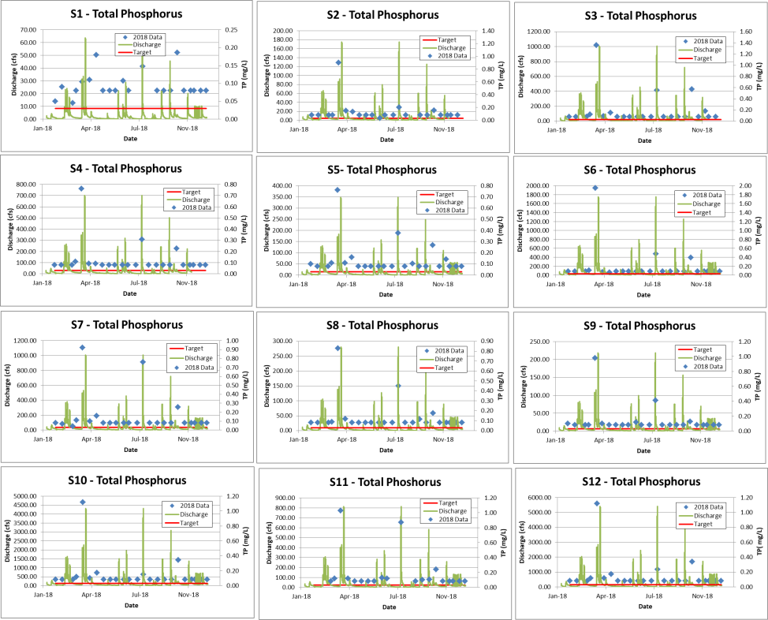
Figure 38. Total phosphorus concentrations measured in Otter Creek samples sites from January-December, 2018.

Total Suspended Solids
Total suspended solids (TSS) levels measured above target levels during high flow events (Figure 39) with 21% of samples exceeding target concentrations. Sites 11 and 07 contained the highest average concentrations measuring 34.2 and 33.2 mg/L, respectively. Sites 11, 12, and 07 contained the highest percentage of exceedances with each exceeding targets in 29% or more collected samples. TSS concentrations exceeded 300 mg/L in Site 03, 07 and 11 during the July 31, 2018 sampling event.
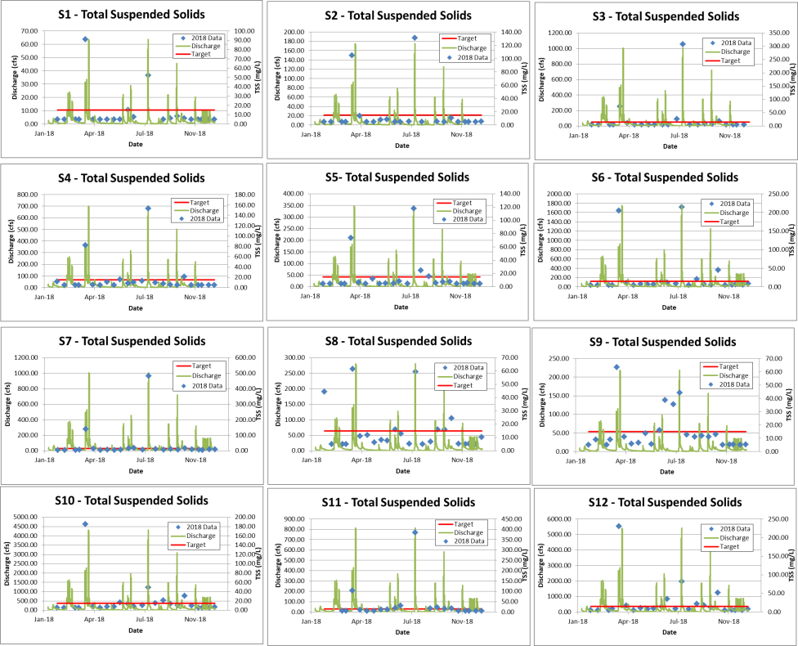
Figure 39. Total suspended solids concentrations measured in Otter Creek samples sites from January-December, 2018.

E. coli
E. coli concentrations observed at Otter Creek Watershed sites are shown in Figure 40. E. coli concentrations exceed state standards in 33% of collected samples. Site 05, 06, 10, 11 and 12 contained E. coli concentrations where were elevated during various flow conditions. Sites 11 and 05 contained the highest average E. coli concentrations, respectively. All Otter Creek Watershed sites possessed average E. coli concentrations in excess of state standards (235 col/100 mL). Sites 08 and 09 contained the lowest average E. coli concentrations with concentrations greater than 300 col/100 mL. E. coli exceedances at Sites 01-03 and 07-09 appear to coincide with flow conditions with many sites containing elevated E. coli concentrations under elevated flow conditions.

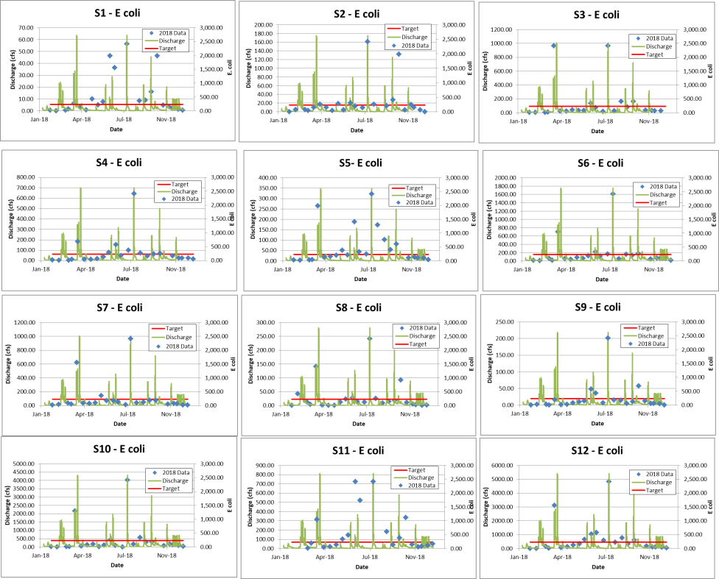
Figure 40. E. coli concentrations measured in Otter Creek samples sites from January-December, 2018.

Sulfate
Sulfate levels measured above target levels in 2% of collected samples (Figure 39). Only Site 07 contained sulfate samples which measured above the target concentration (300 mg/L). Based on high conductivity measurements recorded at this site, it is possible that a point source located within this drainage may be the source of elevated sulfate and conductivity levels. In total, 21% of samples exceed targets at Site 07.

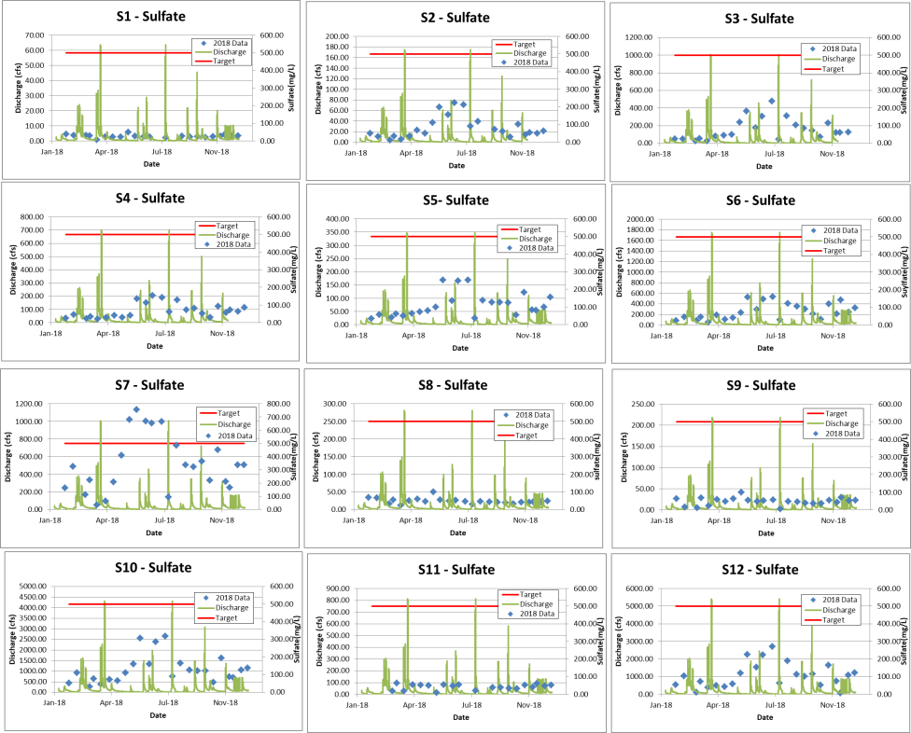
Figure 41. Sulfate concentrations measured in Otter Creek samples sites from January-December, 2018.

Load Duration Curves
Load duration curves allows for comparison of instream loading with stream flow so that conditions of concern can be identified. The load duration curves present the flow characteristics for the twelve systems during the time of study from January to December 2018. Data used for the curves were calculated by scaling flow measured at Big Raccoon Creek near Fincastle, Indiana. Big Raccoon Creek stream flow measured at the U.S. Geological Survey gauge was scaled to watershed size for each of the twelve monitoring stations as follow:

observed flow (cfs)) x (conversion factor) x (target concentration or state criteria) = total load /day

The individual load duration curves, also known as the allowable load curves, are displayed below (Figure 42 to Figure 45). In the graphs, the total daily load of each contaminant sample result (points) is plotted against the “percent time exceeded” for the day of sampling (curve). Those points above the curve exceed the state criterion or target concentration. Values on a load duration curve can be grouped by hydrologic condition to help identify possible sources and conditions that result in the material being present in the system under those flow conditions. Most often, the flow ranges fall in High (0 to 10), Moist (10-40), Mid-Range (40-60), Wet (60-90), and Low (90-100). Exceedances falling in the moist range (10-40) are typically associated surface runoff or stormwater loads, while exceedances associated with the dry zone are most often associated with dry conditions. These exceedances are suggested to result from point sources that are the most likely source.

Nitrate + Nitrite-nitrogen Load Duration Curves
Nitrate + Nitrite loads tend to measure higher than target concentrations at most sites during all conditions (Figure 42). S04, S10, and S12 nitrate-nitrogen loading rates measured above target levels more than 90% of the time. This suggests that a steady stream of nitrate-nitrogen is available within these subwatersheds. S03 typically contain elevated nitrate-nitrogen during high flow conditions only. This suggests that under normal flow conditions, nitrogen is washed into the stream and that it may enter when sediment enters.

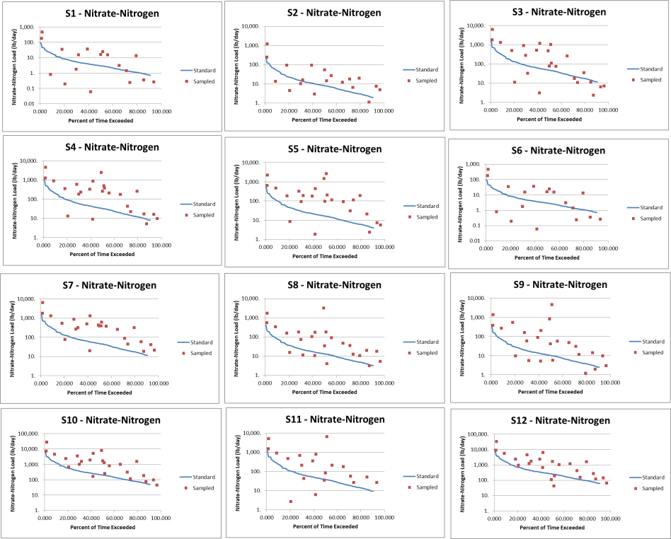
Figure 42. Nitrate-nitrogen load duration curves for Otter Creek samples sites from January-December, 2018.
Total Phosphorus Load Duration Curves
Total phosphorus (TP) levels generally measured above target levels under all flow conditions (Figure 43). This is somewhat surprising considering that most total phosphorus enters streams attached to suspended solids. Exceedances of the target levels occurred under storm flow conditions in Sites S01, S02, and S03 suggesting erosion or runoff is the cause of these values. All other sites, S04 to S12, exceeded target levels under both low flow conditions and high flow conditions. This suggests that a steady stream of total phosphorus is present in much of the Otter Creek Watershed under all conditions.

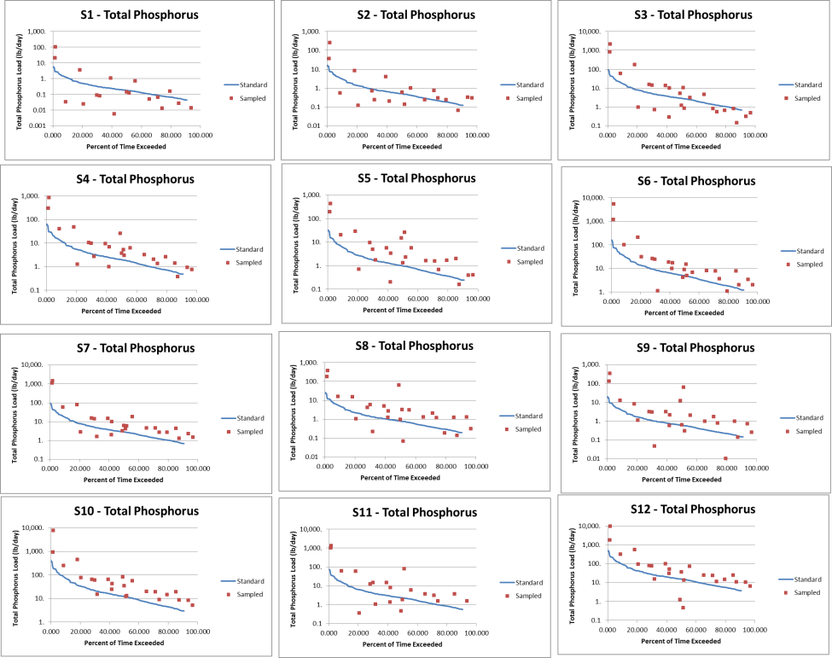
Figure 43. Total phosphorus load duration curves for Otter Creek samples sites from January-December, 2018.

Total Suspended Solids Load Duration Curves
Total suspended solids (TSS) levels generally measured below target levels during most flow events (Figure 44). Most exceedances occurred in the Otter Creek Watershed during storm flow events suggesting erosion or runoff is the cause of these values. Site 05, 07, and 11 exhibited several exceedances during lower flow conditions as well. Possible sources of total suspended solids include the livestock access or stream bank erosion, both of which can provide a continuous source of total suspended solids.

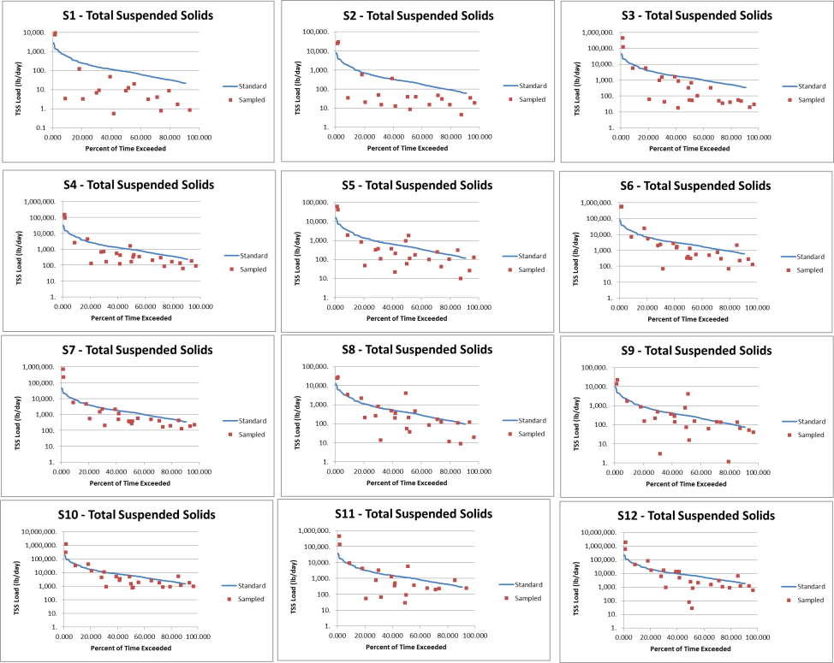
Figure 44. Total suspended solids load curves for Otter Creek samples sites from January-December, 2018.

E. coli Load Duration Curves
E. coli load duration curves display completely different conditions than those presented by nitrate-nitrogen, total phosphorus and total suspended solids curves (Figure 45). E. coli curves indicate that E. coli level exceed targets in Site 05, 08, 09, 11, and 12 during all flow conditions. These data suggest a nearly continuous source of E. coli within these streams. When flows are at their lowest, most of these sites contain E. coli concentrations below target levels suggesting that during wet or low exceedance conditions (60-100), there are limited sources of E. coli within these streams. Site 01 through 04, 96, and 10 load duration curves indicate that E. coli concentrations exceed targets only during high flow conditions.

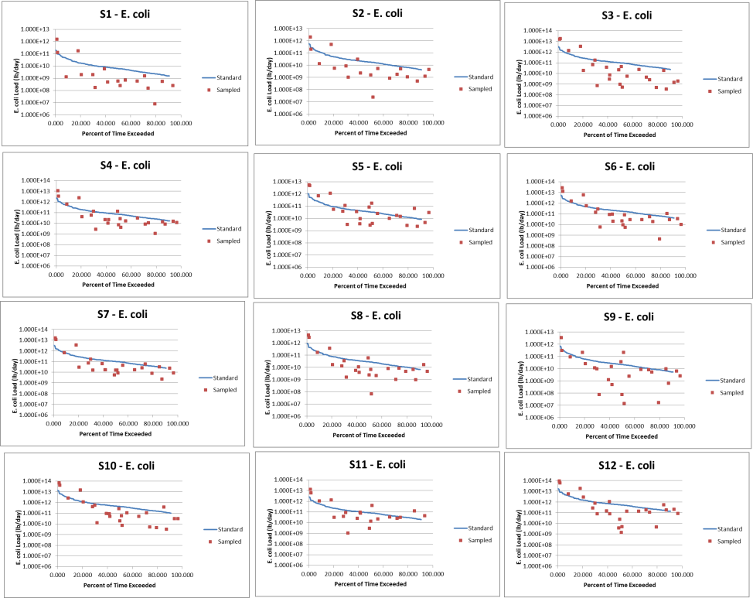
Figure 45. E. coli concentrations load duration curves for Otter Creek samples sites from January-December, 2018.

Habitat Results
Stream water quality and available habitat influence the quality of a biological community in a stream, and it is necessary to assess both factors when reviewing biological data. Table 17 presents the results of QHEI assessments at each of the 12 stream sites sampled in the Otter Creek Watershed during the summer of 2018. Figure 46 details metric and total scores for all sites. Among all the sites except Otter Creek at Mill Dam (S10) and Otter Creek at its outlet (S12), pool/riffle development scores and gradient were relatively low contributing to overall lower QHEI scores. The lowest scores occurred in the Gundy Ditch subwatershed including Sites 11, 09 and 09. These sites were representative of ditched streams present throughout Indiana. With high banks, narrow riparian zones, and limited pool and riffle development, it is not surprising that these sites scored poorly relative to other stream sites. The highest scores occurred along the mainstem of Otter Creek, specifically Otter Creek at Mill Dam (Site 10) and Otter Creek at its outlet (S12) where comparatively high amounts of instream cover, intact riparian buffers, and larger substrates contributed strongly to the higher scores at these sites.

Table 17. Qualitative Habitat Evaluation Index (QHEI) scores measured in the Otter Creek Watershed.
Site | Substrate | Cover | Channel | Riparian | Pool | Riffle/Run | Gradient | Total
1 | 13 | 6 | 6 | 8 | -1 | 0 | 2 | 34
2 | 15 | 6 | 6 | 8 | 5 | 4 | 2 | 46
3 | 13 | 11 | 11 | 9 | 7 | 6 | 4 | 61
4 | 15 | 9 | 11 | 9 | 7 | 6 | 4 | 61
5 | 13 | 8 | 12 | 9 | 5 | 4 | 4 | 55
6 | 11 | 8 | 8 | 7 | 4 | 4 | 4 | 46
7 | 11 | 8 | 8 | 7 | 4 | 4 | 4 | 46
8 | 11 | 6 | 4 | 4 | 3 | 0 | 4 | 32
9 | 11 | 6 | 4 | 4 | 2 | 0 | 4 | 31
10 | 14 | 16 | 7 | 8 | 7 | 6 | 4 | 62
11 | 4.5 | 4 | 6 | 1 | 4 | 0 | 4 | 23.5
12 | 14 | 10 | 6 | 4 | 6 | 4 | 4 | 48

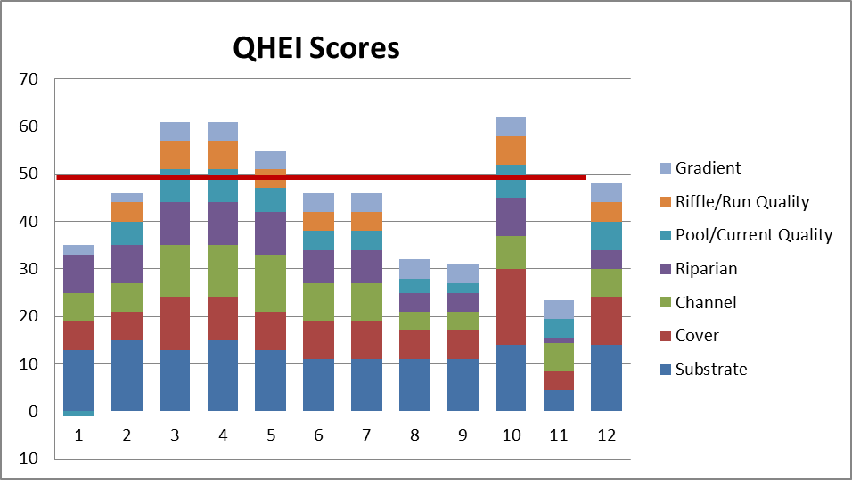
Figure 46. Qualitative Habitat Evaluation Index (QHEI) total and component scores measured for stream sites in the Otter Creek Watershed.

Sediment and Stream Metals Data
None of the major or minor metals analyzed exceeded target concentrations in any sediment or water samples (Matthews et al., 2018).

Summary and Conclusions
Nutrient levels are elevated at all sites in the Otter Creek Watershed under various conditions. Total suspended solids concentrations are elevated under storm flow conditions, while E. coli levels are elevated at different sites under varied conditions. These data suggest that there are sources of E. coli and nutrients readily available within the Otter Creek Watershed, while sediment is only available under storm flow conditions. While the steering committee noted concerns from remnant mining activities within the Otter Creek Watershed, metal concentrations in sediment and water measured below target levels with many measuring below detection levels. Sulfate and conductivity concentrations were elevated exceeding state standards and target concentration at one site and given the propensity for these exceedances to occur in concert, these elevated concentrations may be attributable to a point source.

  - Watershed Inventory Assessment
    - Watershed Inventory Methodologies
Volunteers completed windshield surveys throughout the Otter Creek Watershed in spring 2018. Volunteers conducted surveys by driving all accessible roads throughout the watershed. Large maps with aerial photographs, road and stream names, and public property labels were provided to each volunteer group. Volunteers recorded observations on the provided maps and data sheets, documented field conditions with photographs, and provided all notes to the Project Coordinator for review. The windshield surveys were also used to confirm GIS map layer data throughout the watershed. Items targeted during the surveys included, but were not limited to the following:
- Aerial land use category
- Field or gully erosion
- Pasture locations and condition
- Livestock access and impact to streams
- Buffer condition and width
- Bank erosion or head-cutting
- Logjams located within the stream
- Dumping areas or areas where trash or debris accumulate
- Abandoned mines or mine shafts
- Small, unregulated farms
- Environmental site confirmation (NPDES, CFO, open dump, Superfund, etc.)

    - Watershed Inventory Results
More than 300 individual road-stream crossings were inventoried by watershed volunteers. A majority of issues identified fall into four categories: stream buffers limited in width or lacking altogether, streambank erosion, dumping areas, and unregulated farms. Figure 47 details locations throughout the Otter Creek Watershed where problems were identified. Additional assessments will be on-going; therefore, those identified in Figure 47 should not be considered exhaustive. More than 6.4 miles of streams possessed limited buffers, nearly 66.6 miles of streambank were eroded, and livestock had access to nearly 6.6 miles of streams. Additionally, 44 dumping areas, 8 logjams, and 10 abandoned mine shafts were identified.

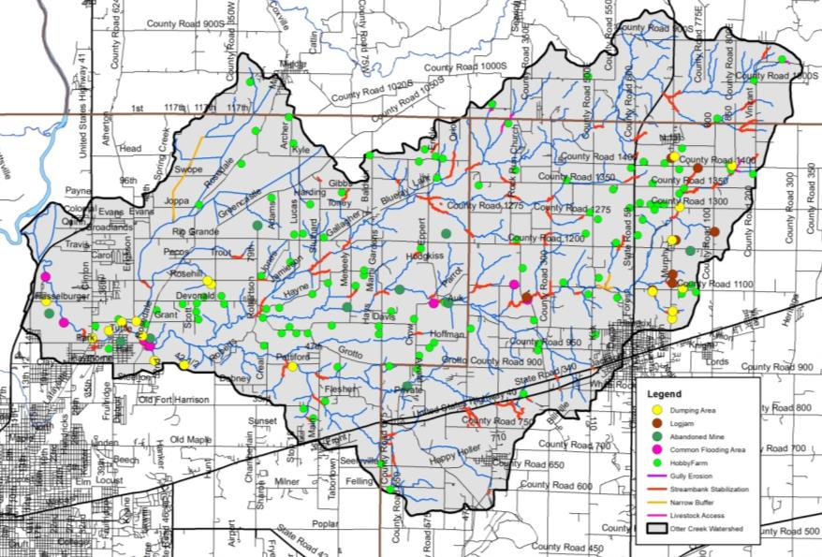
Figure 47. Stream-related watershed concerns identified during watershed inventory efforts.

WATERSHED INVENTORY II-B: SUBWATERSHED DISCUSSIONS
To gather more specific, localized data, the Otter Creek Watershed was divided into six subwatersheds with each subwatershed reflecting one 12-digit Hydrologic Unite Code (HUC; Figure 48). These subwatersheds reflect specific tributary drainages and similar land uses and hydrology. Land uses, point and non-point watershed concern areas, and historic water quality sampling locations and results are discussed in detail below for each subwatershed.

Figure 48. 12-digit Hydrologic Unit Codes in the Otter Creek Watershed.

Headwaters Otter Creek Subwatershed
The Headwaters Otter Creek Subwatershed forms the eastern boundary of the Otter Creek Watershed including portions of the City of Brazil and lies completely within Clay County (Figure 49). It encompasses one 12-digit HUC watershed: 051201110401. The headwaters drain 10,098 acres or 15.8 square miles. There are 47.1 miles of stream. IDEM has classified 25.3 miles of stream as impaired for E. coli.

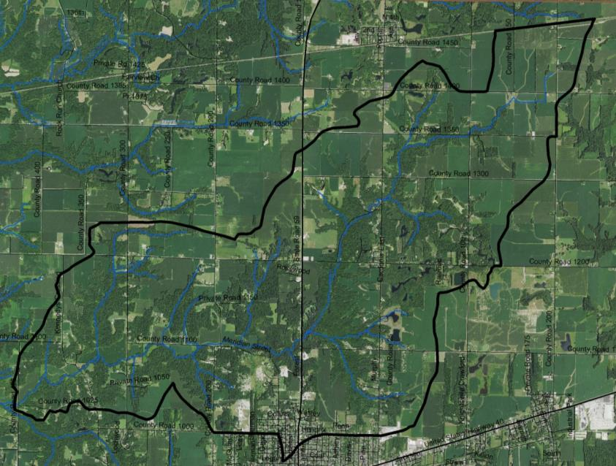
Figure 49. Headwaters Otter Creek Subwatershed.

Soils
Soils in the Headwaters Otter Creek Subwatershed are dominated by Hosmer-Stoy-Hickory soils or those that lie on uplands. This association is characterized by relatively strong relief with abrupt changes. Streams within this association are commonly dendritic with well-developed drainage patterns. The soils along Otter Creek Ditch are Miami-Strawn-Hennepin soils, are found in areas of sandy loam till. These soils are typically found on slopes of 25-50% and cover should be maintained to manage these soils. Hydric soils cover 4,215 acres (42%) of the subwatershed, indicating that nearly half of the subwatershed was historically wetlands. The greatest concentration of hydric soils is in the Parke County portion of the subwatershed and are also located on wide, flat plains away from subwatershed streams. Wetlands currently cover 2% (228.1 acres) of the subwatershed, representing a loss of 95% of historic wetlands. Highly erodible and potentially highly erodible soils are prevalent throughout the subwatershed, covering 23% and 16% of the subwatershed, respectively. Nearly the entire subwatershed (99%) has soils which are severely limited for septic use.

Land Use
Agricultural and forested land uses dominate the Headwaters Otter Creek subwatershed with 47% (4,767 acres) in agricultural land uses, including row crop and pasture and 44% (4,451 acres) in forested land use. The 2012 NASS statistics suggest that a majority of row crop agriculture in the Headwaters Otter Creek Subwatershed is in corn or soybeans with a small percentage in winter wheat. Wetlands, open water, and grassland cover just over 182 acres, or 2%, of the subwatershed. The northern portion of the City of Brazil lies within and the State Road 59 corridor bisects the Headwaters Otter Creek Subwatershed accounting for much of the urban land use within the subwatershed. In total, 698 acres or 7% of the subwatershed are in urban land uses.

Point Source Water Quality Issues
There are few point sources of water pollution in the subwatershed. There is one brownfield, located near the intersection of County Road 1000 North and County Road 300 West, and three leaking underground storage tanks (LUST) located near State Road 59 on the north side of Brazil (Figure 50). No industrial waste facilities, open dumps or NPDES-permitted facilities are located within the Headwaters Otter Creek Subwatershed.

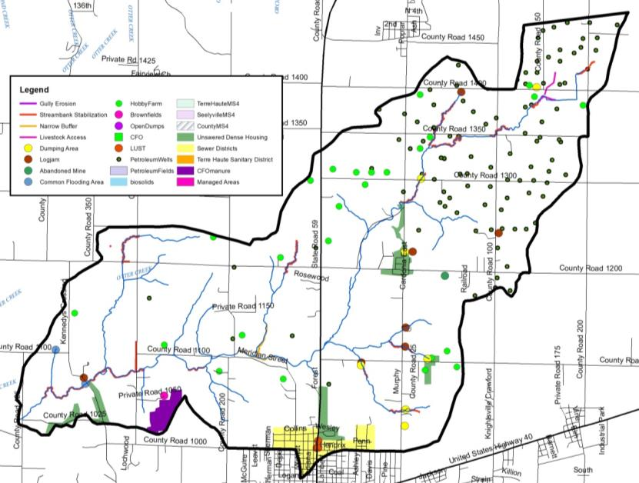
Figure 50. Point and non-point sources of pollution and suggested solutions in the Headwaters Otter Creek Subwatershed.

Non-Point Source Water Quality Issues
Agricultural and forested land uses are co-dominate the Headwaters Otter Creek Subwatershed. Additionally, a number of small animal operations and pastures are also present. Twenty-five unregulated animal operations housing more than 325 cows, horses, goats, hogs, and poultry were identified during the windshield survey. Observations are lower than estimates produced using county-wide NASS data, which suggest 765 animals in the Headwaters Otter Creek Subwatershed. Livestock have access to 3.5 miles of Headwaters Otter Creek streams. No active confined feeding operations are located within the Headwaters Otter Creek Subwatershed. A dairy CFO is located outside the watershed to the south, but 67% of the land it uses for manure is located within the Headwaters Otter Creek Subwatershed, manure is spread on 60 acres in the Headwaters Otter Creek Subwatershed. In total, manure from small animal operations and CFO total over 2,236 tons per year, which contains almost 5,629 pounds of nitrogen and almost 3,713 pounds of phosphorus. Additionally, the Otter Creek TMDL estimated the rural population density in the Headwaters Otter Creek Subwatershed as 91 persons/square mile. The TMDL also estimates impacts from 510 dogs and 660 cats spread across 300 households within the Headwaters Otter Creek Subwatershed. Streambank erosion and lack of buffers are a concern in the subwatershed. Approximately 1.8 miles of insufficient stream buffers and 13.8 miles of streambank erosion were identified within the subwatershed. There were 4,360 acres of fields identified during the windshield survey that could benefit from the installation of soil health practices, including reduced tillage and/or cover crops. Additionally, seven logjams, seven dumping areas, one abandoned mine and two areas that are commonly flooded were identified within the Headwaters Otter Creek Subwatershed.

Water Quality Assessment
Waterbodies within the Headwaters Otter Creek Subwatershed have been sampled at 3 locations (Figure 51). Assessments include collection of water chemistry data by IDEM (3 sites) and as part of the current project (1 site). Fish and macroinvertebrate communities have not been sampled in this subwatershed. No stream gages are located in the Headwaters Otter Creek Subwatershed. pH levels measured below the lower state standards twice during the current assessment, turbidity and total suspended solids exceed target concentrations during four sampling events, while E. coli concentrations exceed the state standard during nine sampling events and nitrate-nitrogen and total phosphorus concentrations exceed targets during all sampling events.

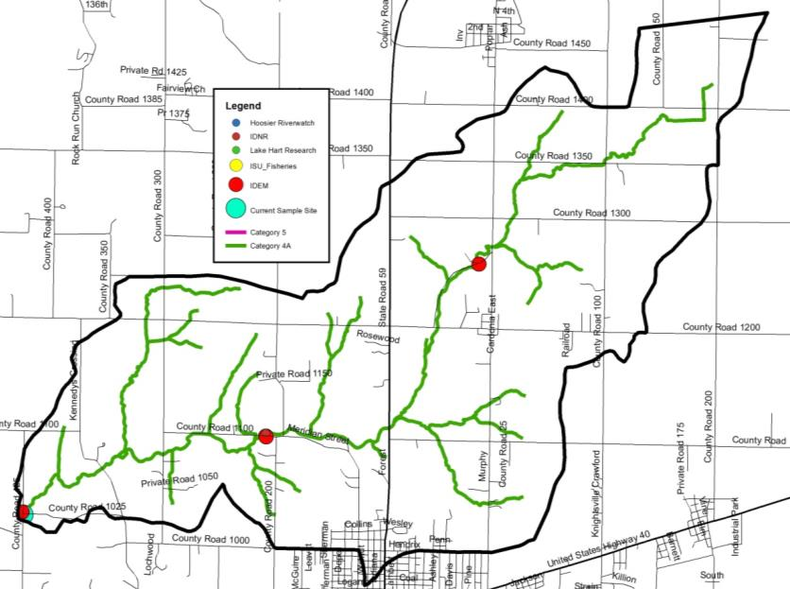
Figure 51. Locations of current and historic water quality data collection and impairments in the Headwaters Otter Creek Subwatershed.

Table 18. Water quality data collected in the Headwaters Otter Creek Subwatershed, January to December 2018.
Site |  | DO  (mg/L) | Temp  (deg C) | pH | Cond  (mg/L) | Turb  (NTU) | Nitrate  (mg/L) | Ammon (mg/L) | Sulfate  (mg/L) | TP  (mg/L) | TSS (mg/L) | Ecoli\ (col/100 mL)
4 | Average | 8.19 | 12.64 | 7.27 | 551.37 | 9.11 | 3.83 | 0.02 | 67.86 | 0.13 | 17.03 | 366.67
 | Max | 9.66 | 24.78 | 8.98 | 685.5 | 84.2 | 10.24 | 0.07 | 153 | 0.76 | 153 | 2419.6
 | Min | 6.55 | 0.59 | 5.74 | 256.6 | 0.5 | 0.74 | 0.02 | 21 | 0.08 | 5 | 7.4
 | #Samples | 24 | 24 | 24 | 24 | 24 | 24 | 24 | 24 | 24 | 24 | 24
 | #Exceed | 0 | 0 | 2 | 0 | 4 | 24 | 0 | 0 | 24 | 4 | 9

North Branch Otter Creek Subwatershed
The North Branch Otter Creek Subwatershed is the northern-most subwatershed, stretching from northwest Clay County into northeast Vigo County and including a portion of southern Parke County (Figure 52). It encompasses one 12-digit HUC watershed: 051201110402. The North Branch Otter Creek Subwatershed drains 14,500 acres or 22.7 square miles. There are 77.6 miles of stream, of which 43.7 miles are impaired for E. coli.

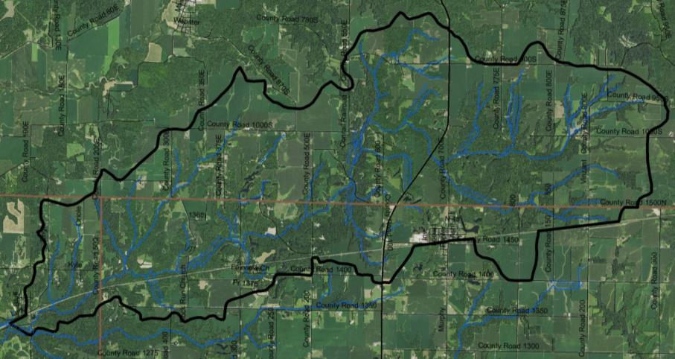
Figure 52. North Branch Otter Creek Subwatershed.

Soils
Soils in the North Branch Otter Creek Subwatershed are dominated by Miami-Strawn-Hennepin soils, are found in areas of sandy loam till. These soils are typically found on slopes of 25-50% and cover should be maintained to manage these soils. Hosmer-Stoy-Hickory soils lie on uplands along the eastern border of the subwatershed. The northern subwatershed boundary is covered by Reesville-Ragsdale-Uniontown soils. These soils are very poorly drained, gleyed soils which formed under wetland conditions. Hydric soils cover 7,339.5 acres (51%) of the subwatershed, indicating that more than half of the subwatershed was historically wetlands. The greatest concentration of hydric soils is located along the County Road 1200 North/Rio Grande Road corridor and along the northern bank of the North Branch Otter Creek. Wetlands currently cover 4% (527.1 acres) of the subwatershed, representing a loss of 93% of historic wetlands. Highly erodible and potentially highly erodible soils are prevalent throughout the subwatershed, covering 24% and 16% of the land, respectively. Nearly the entire subwatershed (96%) has soils which are severely limited for septic use.

Land Use
Agricultural and forested land uses are equally dominant within the North Branch Otter Creek Subwatershed. In total 6,682.6 acres (46%) of the subwatershed is in row crop agriculture or pasture, while 6,674.8 acres (46%) of the subwatershed is in forested land use. Wetlands, open water, and grassland cover 238.5 acres or 2% of the subwatershed. Nearly 900 acres (6%) of the North Branch Otter Creek Subwatershed is in urban land uses including the City of Carbon and portion of the State Road 59 corridor, which bisects the subwatershed.

Point Source Water Quality Issues
There are few point sources of water pollution in the subwatershed. There is one open dump, located on County Road 200 West in northern Clay County (Figure 53). There are two brownfields located within and north of the Town of Carbon. There is one active, NPDES-permitted facility - the Carbon wastewater treatment plant - located in the North Branch Otter Creek Subwatershed. The Carbon Wastewater Treatment Plant uses waste stabilization lagoons with a 90 day detention time. When discharge occurs, effluent is discharged at a 10:1 dilution ratio to Ebenezer Creek at a maximum designed flow of 0.0242 MGD. During the five year period ending 2012, the Carbon WWTP reported no E. coli violations, one quarter of pH violation, and six quarters of nitrogen violations.

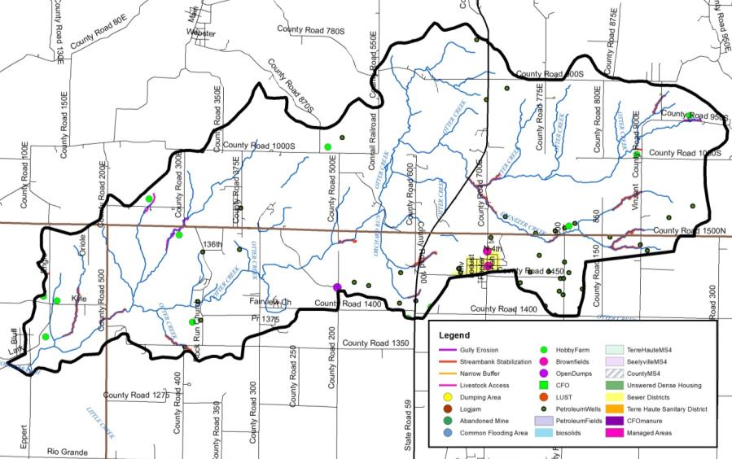
Figure 53. Point and non-point sources of pollution and suggested solutions in the North Branch Otter Creek Subwatershed.

Non-Point Source Water Quality Issues
Agricultural and forested land uses are co-dominate within the North Branch Otter Creek Subwatershed. Additionally, a number of small animal operations and pastures are also present. Ten unregulated animal operations were identified during the windshield survey, which house approximately 100 animals. NASS county-wide statistics suggest a higher animal density of 614 animals within the North Branch Otter Creek Subwatershed. Livestock had access to the stream impacting 3.5 miles of streambank. No active confined feeding operations are located within the North Branch Otter Creek Subwatershed. Manure from small animal operations totals over 1,034 tons per year. This contains almost 1,336 pounds of nitrogen and almost 755 pounds of phosphorus. Additionally, the Otter Creek TMDL estimated the rural population density in the North Branch Otter Creek Subwatershed as 89 persons/square mile. The TMDL also estimates impacts from 105 dogs and 231 cats spread across 1679 households within the Headwaters Otter Creek Subwatershed. Streambank erosion is a concern in the subwatershed. Approximately 14.2 miles of streambank erosion were identified within the subwatershed. There were 0.2 miles of gully erosion identified in the North Branch Otter Creek Subwatershed. There were 5,630 acres of fields identified during the windshield survey that could benefit from the installation of soil health practices, including reduced tillage and/or cover crops.

Water Quality Assessment
Waterbodies within the North Branch Otter Creek Subwatershed have been sampled at 9 locations (Figure 54). Assessments include collection of water chemistry data by IDEM (8 sites), as part of the current project (3 sites), and fish community assessments via Indiana State University (3 sites). Macroinvertebrates have not been sampled in this subwatershed. No stream gages are located in the North Branch Otter Creek Subwatershed. pH levels measured below the lower state standards seven times during the current assessment, turbidity and total suspended solids exceed target concentrations during 13 and eight sampling events, respectively; while E. coli concentrations exceed the state standard during 24 sampling events and nitrate-nitrogen and total phosphorus concentrations exceed targets during all but three sampling events.

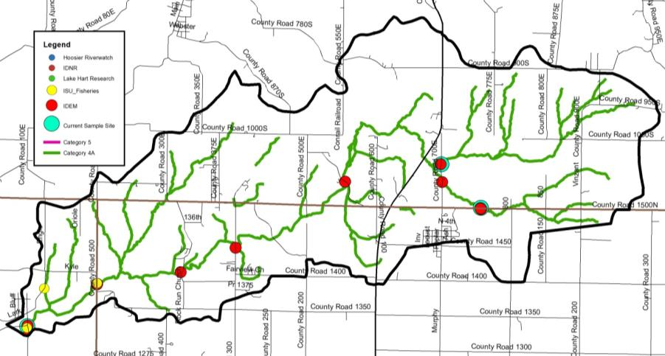
Figure 54. Locations of current and historic water quality data collection and impairments in the North Branch Otter Creek Subwatershed.

Table 19. Water quality data collected in the North Branch Otter Creek Subwatershed, January to December 2018.
Site |  | DO  (mg/L) | Temp  (deg C) | pH | Cond  (mg/L) | Turb  (NTU) | Nitrate  (mg/L) | Ammon (mg/L) | Sulfate  (mg/L) | TP  (mg/L) | TSS (mg/L) | Ecoli\ (col/100 mL)
1 | Average | 8.12 | 11.31 | 7.24 | 471.86 | 4.60 | 4.50 | 0.02 | 26.75 | 0.14 | 11.87 | 521.65
 | Max | 9.56 | 23.34 | 8.93 | 802 | 44 | 10.11 | 0.04 | 50 | 1.04 | 91 | 2419.6
 | Min | 6.54 | 0.05 | 5.71 | 322.9 | 0.5 | 0.84 | 0.02 | 7 | 0.045 | 5 | 1
 | #Samples | 22 | 22 | 22 | 22 | 22 | 22 | 22 | 22 | 22 | 22 | 22
 | #Exceed | 0 | 0 | 2 | 0 | 3 | 22 | 0 | 0 | 22 | 2 | 10
2 | Average | 7.92 | 11.36 | 7.23 | 628.84 | 7.38 | 3.87 | 0.03 | 81.62 | 0.18 | 15.77 | 331.63
 | Max | 9.22 | 20.45 | 8.84 | 891.7 | 62 | 9.81 | 0.2 | 223 | 1.2 | 131 | 2419.6
 | Min | 6.84 | 0.56 | 5.66 | 343.6 | 0.5 | 1.13 | 0.02 | 12 | 0.03 | 5 | 3
 | #Samples | 23 | 23 | 23 | 23 | 23 | 23 | 23 | 23 | 23 | 23 | 23
 | #Exceed | 0 | 0 | 3 | 0 | 4 | 23 | 0 | 0 | 22 | 2 | 8
3 | Average | 8.45 | 12.14 | 7.28 | 547.19 | 8.84 | 3.65 | 0.02 | 79.23 | 0.18 | 22.60 | 403.93
 | Max | 9.88 | 23.24 | 8.9 | 843.2 | 102.1 | 10.11 | 0.06 | 240 | 1.36 | 308 | 2419.6
 | Min | 7.51 | 0.32 | 5.72 | 121 | 0.5 | 0.86 | 0.02 | 14 | 0.08 | 5 | 11
 | #Samples | 24 | 24 | 24 | 24 | 24 | 24 | 24 | 24 | 24 | 24 | 24
 | #Exceed | 0 | 0 | 2 | 0 | 6 | 24 | 0 | 0 | 24 | 4 | 6

Little Creek-North Branch Otter Creek Subwatershed
The Little Creek-North Branch Otter Creek Subwatershed is located in north central Vigo County and drains water from the North Branch Otter Creek Subwatershed (Figure 55). It includes on 12-digit HUC: 051201110403. The Little Creek-North Branch Otter Creek Subwatershed drain 10,669 acres or 16.7 square miles. There are 67.4 miles of stream, of which IDEM has classified 31.6 miles of stream as impaired for E. coli.

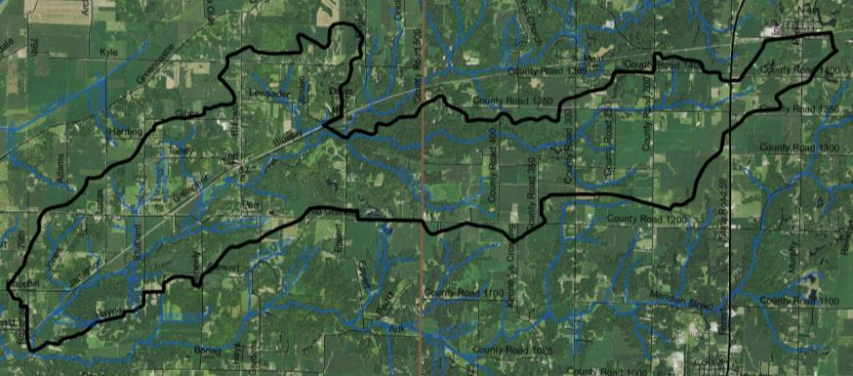
Figure 55. Little Creek-North Branch Otter Creek Subwatershed.

Soils
Soils in the Little Creek-North Branch Otter Creek Subwatershed are dominated by Hosmer-Stoy-Hickory soils, which lie on uplands along the eastern border of the subwatershed. Miami-Strawn-Hennepin soils, are found in areas of sandy loam till along the North Branch Otter Creek channel. These soils are typically found on slopes of 25-50% and cover should be maintained to manage these soils. The northern subwatershed boundary is covered by Bloomfield-Princeton-Ayrshire soils. These soils are excessively drained and found on gentle to strong slopes. Hydric soils cover 3697 acres (35%) of the subwatershed, indicating that much of the land was historically wetlands. Wetlands currently cover 5% (572.1 acres) of the subwatershed, representing a loss of 85% of historic wetlands. Highly erodible and potentially highly erodible soils are prevalent throughout the subwatershed, covering 23% and 19% of the land, respectively. Nearly the entire subwatershed (96%) has soils which are severely limited for septic use.

Land Use
Agricultural land uses cover the largest percentage of the Little Creek-North Branch Otter Creek Subwatershed, with 48% (5,174.2 acres) in row crops and hay/pasture. Forest covers just over 4,700 acres, or 44%, of the subwatershed. Open water, wetlands, and grasslands account for 174 acre or 2% of the subwatershed. There are no incorporated towns in the Little Creek-North Branch Otter Creek Subwatershed, thus urban lands cover 6% or 613 acres of the subwatershed.

Point Source Water Quality Issues
There are few point sources of water pollution in the subwatershed. There is one leaking underground storage tank (LUST) located near Coal Bluff (Figure 56). There are no NPDES-permitted facilities, brownfields, or open dumps in this subwatershed.

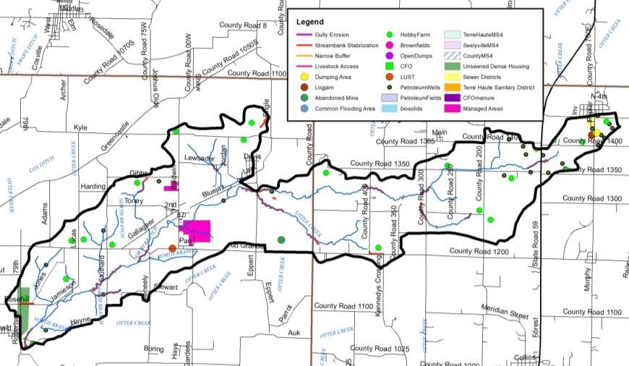
Figure 56. Point and non-point sources of pollution and suggested solutions in the Little Creek-North Branch Otter Creek Subwatershed.

Non-Point Source Water Quality Issues
Agricultural land uses dominate the Little Creek-North Branch Otter Creek Subwatershed. A number of small animal operations and pastures are also present (Figure 65). In total, 21 unregulated animal operations were identified during the windshield survey, which house more than 200 animals. NASS county-wide livestock estimates generate a slightly higher density of 416 animals. Livestock access was observed to impact nearly 12 miles of Little Creek-North Branch Otter Creek Subwatershed streams. No active confined feeding operations are located within the subwatershed. In total, small animal operations generate 2,097 tons of manure. This manure contains almost 2,721 pounds of nitrogen and almost 1,473 pounds of phosphorus. Additionally, the Otter Creek TMDL estimated the rural population density in the Little Creek-North Branch Otter Creek Subwatershed as 143 persons/square mile. The TMDL also estimates impacts from 20 dogs and 44 cats spread across 34 households in cities and towns within the Little Creek-North Branch Otter Creek Subwatershed. Approximately 15.1 miles of streambank erosion were identified within the subwatershed. There were 4,240 acres of fields identified during the windshield survey that could benefit from the installation of soil health practices, including reduced tillage and/or cover crops. Additionally, one logjam, one dumping areas, and one abandoned mine were identified within the Little Creek-North Branch Otter Creek Subwatershed.

Water Quality Assessment
Waterbodies within the Little Creek-North Branch Otter Creek Subwatershed have been sampled at 7 locations (Figure 58). Assessments include collection of water chemistry data by IDEM (6 sites) and during the current assessment (1 site). The fish community has been assessed by Indiana State University at 3 sites. Macroinvertebrates have not been sampled in this subwatershed. No stream gages are located in the Little Creek-North Branch Otter Creek Subwatershed. pH levels measured below the lower state standards twice during the current assessment, turbidity and total suspended solids exceed target concentrations during eight and four sampling events, respectively; while E. coli concentrations exceed the state standard during seven sampling events and nitrate-nitrogen and total phosphorus concentrations exceed targets during all sampling events.

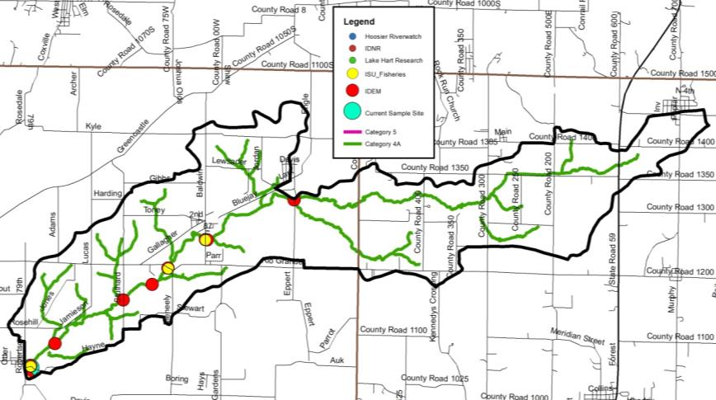
Figure 57. Locations of historic water quality data collection and impairments in the Little Creek-North Branch Subwatershed.

Table 20. Water quality data collected in the Little Creek-North Branch Otter Creek Subwatershed, January to December 2018.
Site |  | DO  (mg/L) | Temp  (deg C) | pH | Cond  (mg/L) | Turb  (NTU) | Nitrate  (mg/L) | Ammon (mg/L) | Sulfate  (mg/L) | TP  (mg/L) | TSS (mg/L) | Ecoli\ (col/100 mL)
6 | Average | 8.43 | 13.20 | 7.32 | 541.95 | 15.62 | 3.46 | 0.02 | 77.03 | 0.19 | 26.08 | 353.19
 | Max | 9.44 | 25.66 | 8.98 | 932 | 144 | 10.3 | 0.02 | 160 | 1.95 | 214 | 2419.6
 | Min | 7.46 | 1.41 | 5.84 | 244.8 | 0 | 0.7 | 0.02 | 15 | 0.06 | 5 | 7.4
 | #Samples | 24 | 24 | 24 | 24 | 24 | 24 | 24 | 24 | 24 | 24 | 24
 | #Exceed | 0 | 0 | 2 | 0 | 8 | 24 | 0 | 0 | 24 | 4 | 7

Sulfur Creek Subwatershed
The Sulfur Creek Subwatershed is the southern-most subwatershed, including portions of Seelyville, all of Staunton and most of the U.S. Highly 40 corridor located within the Otter Creek Watershed (Figure 58). The Sulfur Creek Subwatershed drains 14,787.5 acres or 23.1 square miles. There are 43.4 miles of stream. IDEM has classified 28.7 miles of stream as impaired for E. coli.

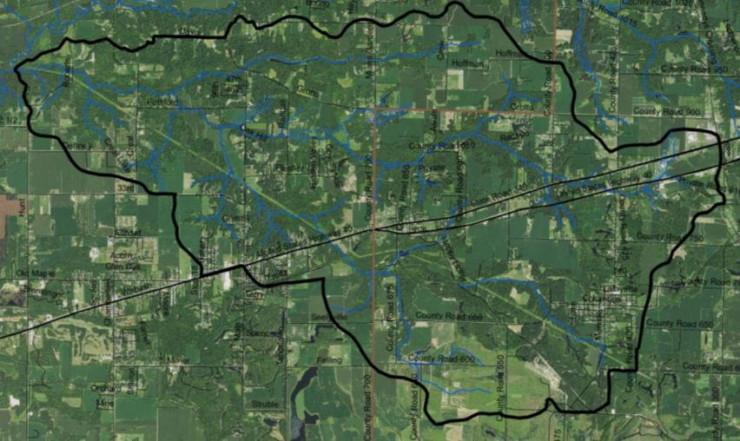
Figure 58. Sulfur Creek Subwatershed.

Soils
Soils in the Sulfur Creek Subwatershed are dominated by Hosmer-Stoy-Hickory soils, which lie on uplands along the eastern border of the subwatershed. Miami-Strawn-Hennepin soils are found in areas of sandy loam till along the Sulfure Creek channel. These soils are typically found on slopes of 25-50% and cover should be maintained to manage these soils. The lower subwatershed is covered by Bloomfield-Princeton-Ayrshire soils. These soils are excessively drained and found on gentle to strong slopes. Hydric soils cover 4,797 acres (32%) of the subwatershed, indicating that much of the land was historically wetlands. The greatest concentration of hydric soils is in the southern watershed boundary. Wetlands currently cover 5% (800.7 acres) of the subwatershed, representing a loss of 83% of historic wetlands. Highly erodible and potentially highly erodible soils are prevalent throughout the subwatershed, covering 24% and 27% of the land, respectively. Nearly the entire subwatershed (92%) has soils which are severely limited for septic use.

Land Use
Forested land use dominates the Sulfur Creek Subwatershed cover 7,991.3 acres (54%) of the drainage. Agricultural land uses, including row crop and pasture, account for 5,189.6 acre (35%) of the subwatershed land use. The Sulfur Creek Subwatershed contains the second highest density of urban land use with nearly 7% (1,035.9 acres) covered by developed lands. These include the Cities of Seelyville and Staunton as well as a portion of the U.S. Highway 40 and State Road 340 corridor. Wetland, open water, and grasslands account for just 4% (570.7 acres) of the Sulfur Creek Subwatershed.

Point Source Water Quality Issues
There are few point sources of water pollution in the subwatershed. There is one leaking underground storage tank (LUST) located near the western confluence of U.S. Highway 40 and State Road 340 (Figure 59). There are no industrial waste facilities or open dumps in this subwatershed. Staunton operates the only NPDES-permitted facility within the Sulfur Creek Subwatershed. The Staunton WWTP is a Class I, 0.1 MGD extended aeration treatment facility which consists of a flow meter, communicator, splitter box, two aeration tanks, two clarifies, a parshall flume, two polishing lagoons, a chlorine tank, step aeration and dechlorination. The collection system is 100% separated from sanitary sewer which no designed overflow of bypass points. The facility discharges to Sulfur Creek northwest of Staunton. In May 2000, IDEM imposed a sewer connection ban on the Staunton WWTP. In 2007 the Town of Staunton completed construction of its sewage collection system and wastewater plant which reduced the wet weather flows to the treatment plant. The connection ban was listed in February 2012. For the five-year period ending 2012, the Staunton WWTP possessed no E. coli violations and one quarter of nitrogen violation. Additionally, the 0.54 square miles of the Seelyville MS4 lies within the Sulfur Creek watershed.

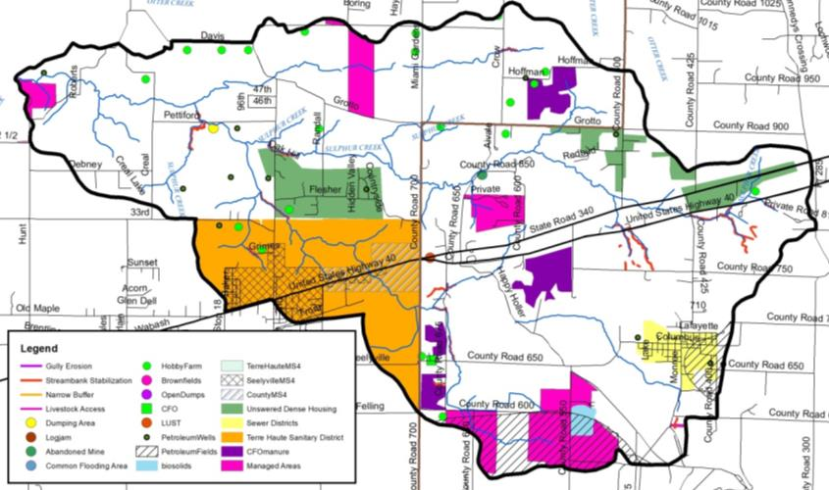
Figure 59. Point and non-point sources of pollution and suggested solutions in the Sulfur Creek Subwatershed.

Non-Point Source Water Quality Issues
Forested land uses dominate the Sulfur Creek Subwatershed. Agricultural land is primarily in a corn-soybean rotation. A number of small animal operations and pastures are also present (Figure 65). Twenty unregulated animal operations housing approximately 90 animals were identified during the windshield survey. NASS county-wide statistics provide a higher estimated density of 2,435 animals in the Sulfur Creek Subwatershed. Pastures where livestock have access to the stream were not identified as an issue in the Sulfur Creek Subwatershed. One active confined feeding operation is located near the western edge of Clay County south of north of Seelyville housing a total of 1,400 swine per year. Manure from this CFO is spread on 335 acres in the Sulfur Creek Subwatershed. In total, approximately 8,702 tons of manure is generated annually from CFO and small animal operations. This contains almost 22,977 pounds of nitrogen and almost 17,124 pounds of phosphorus. Additionally, the Otter Creek TMDL estimated the rural population density in the Headwaters Otter Creek Subwatershed as 130 persons/square mile. The TMDL also estimates impacts from 837 dogs and 1,083 cats spread across 492 households within Staunton and Seelyville in the Sulfur Creek Subwatershed. Municipal biosolids are applied to 46.4 acres within the subwatershed. Streambank erosion impacts 12.2 miles of stream throughout the Sulfur Creek Subwatershed. One dumping location and one abandoned mine were identified within the Sulfur Creek Subwatershed. There were 3,270 acres of fields identified during the windshield survey that could benefit from the installation of soil health practices, including reduced tillage and/or cover crops.

Water Quality Assessment
Waterbodies within the Sulfur Creek Subwatershed have been sampled at 14 locations (Figure 60). Assessments include collection of water chemistry data by IDEM (12 sites), during the current project (2 sites), and via volunteer monitors through the Hoosier Riverwatch program (1 site). The fish community has been assessed by Indiana State University at 7 sites. Macroinvertebrates have not been sampled in this subwatershed. No stream gages are located in the Sulfur Creek Subwatershed. pH levels measured below the lower state standards five times during the current assessment. Conductivity levels exceed targets during 11 sampling events, while sulfate concentrations measure above targets during five sampling events. Turbidity and total suspended solids exceed target concentrations during 17 and eight sampling events, respectively; while E. coli concentrations exceed the state standard during 15 sampling events and nitrate-nitrogen and total phosphorus concentrations exceed targets during all sampling events.

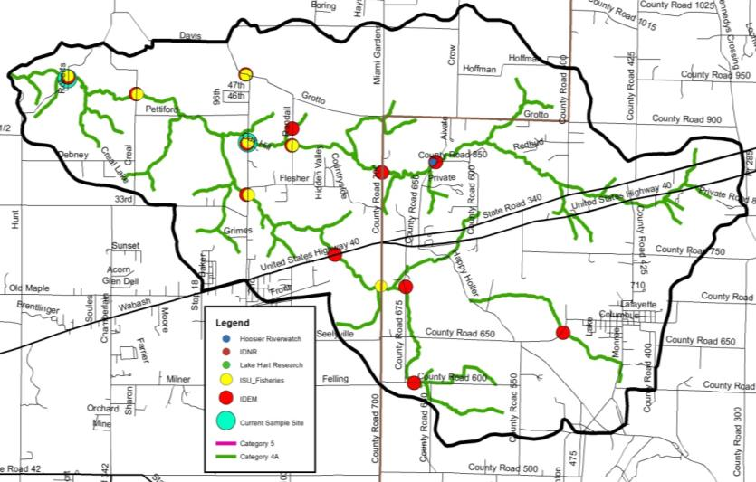
Figure 60. Locations of historic water quality data collection and impairments in the Sulfur Creek Subwatershed.

Table 21. Water quality data collected in the Sulfur Creek Subwatershed, January to December 2018.
Site |  | DO  (mg/L) | Temp  (deg C) | pH | Cond  (mg/L) | Turb  (NTU) | Nitrate  (mg/L) | Ammon (mg/L) | Sulfate  (mg/L) | TP  (mg/L) | TSS (mg/L) | Ecoli\ (col/100 mL)
5 | Average | 8.39 | 13.42 | 7.37 | 603.31 | 7.55 | 4.51 | 0.02 | 110.90 | 0.14 | 14.74 | 569.63
 | Max | 9.66 | 24.21 | 8.85 | 831.2 | 66 | 13.5 | 0.02 | 253 | 0.76 | 118 | 2419.6
 | Min | 7.03 | 2.49 | 5.41 | 261.8 | 0.5 | 0.74 | 0.02 | 34 | 0.08 | 5 | 27.2
 | #Samples | 24 | 24 | 24 | 24 | 24 | 24 | 24 | 24 | 24 | 24 | 24
 | #Exceed | 0 | 0 | 3 | 0 | 5 | 24 | 0 | 0 | 24 | 4 | 11
7 | Average | 8.39 | 12.61 | 7.33 | 1082.20 | 12.26 | 4.02 | 0.02 | 345.26 | 0.15 | 34.17 | 361.05
 | Max | 9.71 | 24.71 | 8.8 | 1588 | 96.1 | 10.56 | 0.02 | 755 | 0.92 | 484 | 2419.6
 | Min | 7.31 | 1.27 | 5.01 | 415.3 | 0.5 | 0.78 | 0.02 | 32 | 0.04 | 5 | 24.3
 | #Samples | 24 | 24 | 24 | 24 | 24 | 24 | 24 | 24 | 24 | 24 | 24
 | #Exceed | 0 | 0 | 2 | 11 | 12 | 24 | 0 | 5 | 24 | 4 | 4

Gundy Ditch Subwatershed
The Gundy Ditch Subwatershed carries water from the northwestern portion of the Otter Creek Watershed draining much of the channelized portion of the watershed (Figure 61). It encompasses one 12-digit HUC watersheds: 051201110405. The headwaters drain 11,717 acres or 18.3 square miles. There are 43.4 miles of stream, of which 28.7 mile are impaired for E. coli.

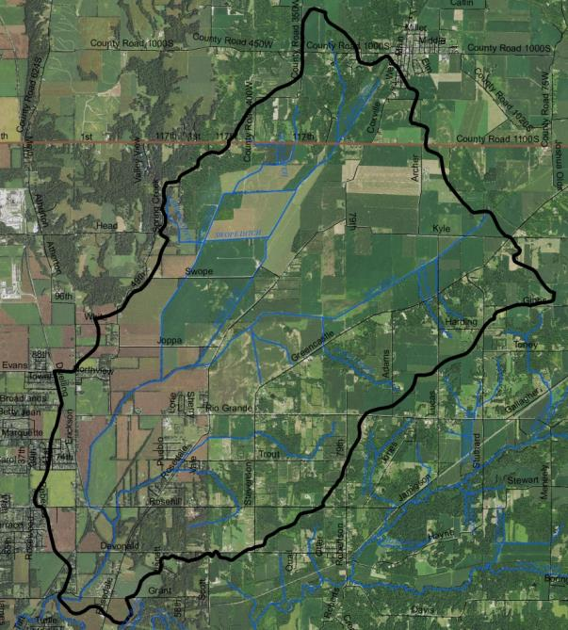
Figure 61. Gundy Ditch Subwatershed.

Soils
The eastern portion of the Gundy Ditch Subwatershed is dominated Bloomfield-Princeton-Ayrshire soils. These soils are excessively drained and found on gentle to strong slopes. Elston-Warsaw-Shipshe soils dominate the western portion of the Gundy Ditch Subwatershed. These deep, well-drained soils formed on outwash materials. These soils are moderately rapidly permeable and easily wind and water eroded. Hydric soils cover 987 acres (8%) of the subwatershed, indicating that only a small portion of the Gundy Ditch Subwatershed was historically wetlands. Small areas of historic wetland are concentrated nearly Rockville in Parke County. In total, 127.1 acres (1% of the watershed) of wetlands remain in the Gundy Ditch Subwatershed representing an 87% wetland loss. Highly erodible and potentially highly erodible soils are prevalent throughout the subwatershed, covering 6% and 23% of the land, respectively. Nearly the entire Gundy Ditch Subwatershed (98%) has soils which are severely limited for septic use.

Land Use
Agricultural land uses dominate the Gundy Ditch Subwatershed with 74% in row crops and hay/pasture. Nearly 8,637 acres of row crop and pasture land is located within the Gundy Ditch Subwatershed covering the largest percentage of any of the Otter Creek drainages. Forest covers the smallest percentage of any Otter Creek Subwatershed accounting for just 2,011.6 acre (17%) of the Gundy Ditch Subwatershed. The smallest area (1% or 90.8 acres) of wetlands, open water, and grassland are also found within the Gundy Ditch Subwatershed. Nearly 977.5 acres (8%) of the Gundy Ditch Subwatershed is in urban land uses with most of this located in Rockville or unincorporated towns.

Point Source Water Quality Issues
There are few point sources of water pollution in the subwatershed. There are two leaking underground storage tank (LUST) located near sand Cut (Figure 62). There are no industrial waste facilities, open dump sites or NPDES-permitted facilities in this subwatershed. In total, 0.61 square miles of the Terre Haute MS4 is located within the Gundy Ditch Subwatershed.

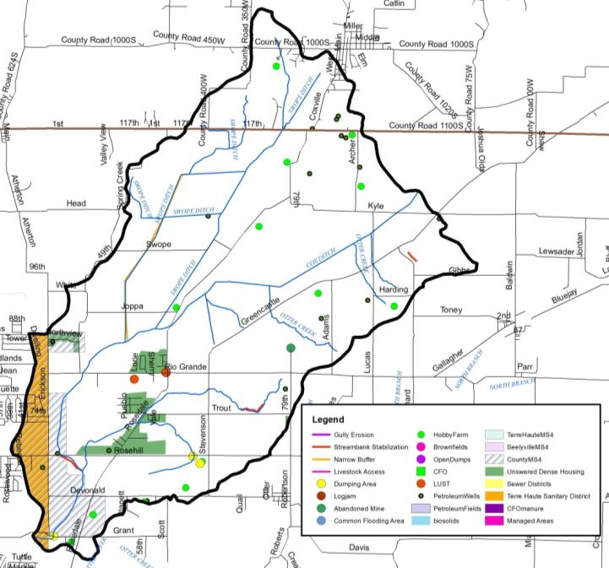
Figure 62. Point and non-point sources of pollution and suggested solutions in the Gundy Ditch Subwatershed.

Non-Point Source Water Quality Issues
Agricultural land uses dominate the Gundy Ditch Subwatershed, primarily in a corn-soybean rotation. Thirteen unregulated animal operations were identified during the windshield survey housing approximately 225 animals. County-wide NASS statistics suggest a higher animal density of 330. No areas where livestock have access to the stream were identified in the Gundy Ditch Subwatershed. No active confined feeding operations are located within the Gundy Ditch Subwatershed. Overall, small animal operations produce over 2,180 tons per year. This contains almost 2,449 pounds of nitrogen and almost 1,314 pounds of phosphorus. Additionally, the Otter Creek TMDL estimated the rural population density in the Headwaters Otter Creek Subwatershed as 156 persons/square mile. The TMDL also estimates impacts from 391 dogs and 506 cats spread across 230 households within Rosedale and North Terre Haute in the Gundy Ditch Subwatershed. Streambank erosion and lack of buffers are a concern in the subwatershed. Approximately 4.6 miles of insufficient stream buffers and 1.8 miles of streambank erosion were identified within the subwatershed. There were 7,225 acres of fields identified during the windshield survey that could benefit from the installation of soil health practices, including reduced tillage and/or cover crops. Additionally, three dumping areas and one abandoned mine were identified within the Gundy Ditch Subwatershed.

Water Quality Assessment
Waterbodies within the Gundy Ditch Subwatershed have been sampled at 9 locations (Figure 63). Assessments include collection of water chemistry data by IDEM (4 sites), during the current project (3 sites), and via Lake Hart Research (2 sites). The fish community has been assessed by Indiana State University at 7 sites. Macroinvertebrates have not been sampled in this subwatershed. No stream gages are located in the Gundy Ditch Subwatershed. pH levels measured below the lower state standards five times during the current assessment. Turbidity and total suspended solids exceed target concentrations during 22 and 19 sampling events, respectively; while E. coli concentrations exceed the state standard during 19 sampling events and nitrate-nitrogen and total phosphorus concentrations exceed targets during all b7t four sampling events.

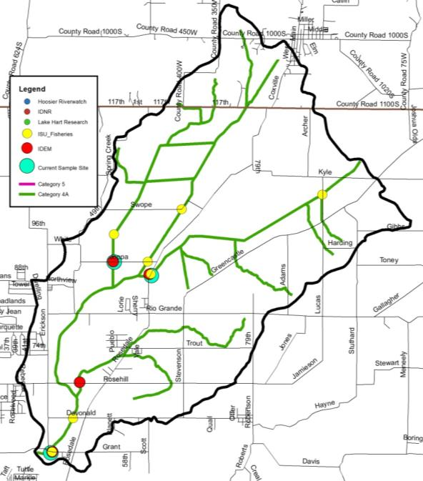
Figure 63. Locations of historic water quality data collection and impairments in the Gundy Ditch Subwatershed.

Table 22. Water quality data collected in the Gundy Creek Subwatershed, January to December 2018.
Site |  | DO  (mg/L) | Temp  (deg C) | pH | Cond  (mg/L) | Turb  (NTU) | Nitrate  (mg/L) | Ammon (mg/L) | Sulfate  (mg/L) | TP  (mg/L) | TSS (mg/L) | Ecoli\ (col/100 mL)
8 | Average | 7.68 | 13.72 | 7.35 | 502.16 | 7.33 | 2.58 | 0.02 | 47.70 | 0.13 | 14.98 | 303.27
 | Max | 9.23 | 26.33 | 8.94 | 846.3 | 36.3 | 5.2 | 0.11 | 100 | 0.83 | 61.6 | 2419.6
 | Min | 5.12 | 0.88 | 5.88 | 242.8 | 0.5 | 0.69 | 0.02 | 23 | 0.08 | 5 | 8.4
 | #Samples | 24 | 24 | 24 | 24 | 24 | 24 | 24 | 24 | 24 | 24 | 24
 | #Exceed | 0 | 0 | 1 | 0 | 10 | 24 | 0 | 0 | 24 | 7 | 7
9 | Average | 8.49 | 14.14 | 7.41 | 446.33 | 7.70 | 3.37 | 0.02 | 47.76 | 0.14 | 14.77 | 236.23
 | Max | 11.22 | 24.961 | 8.94 | 733.1 | 22.4 | 9.3 | 0.02 | 100 | 0.98 | 63.4 | 2419.6
 | Min | 6.26 | 1.78 | 5.87 | 60.8 | 0.5 | 0.69 | 0.02 | 5 | 0.08 | 5 | 1
 | #Samples | 24 | 24 | 24 | 24 | 24 | 24 | 24 | 24 | 24 | 24 | 24
 | #Exceed | 0 | 0 | 2 | 0 | 13 | 24 | 0 | 0 | 24 | 5 | 4
11 | Median | 8.33 | 14.85 | 7.34 | 468.49 | 13.18 | 3.00 | 0.02 | 42.01 | 0.19 | 34.40 | 587.49
 | Max | 9.53 | 32.07 | 8.92 | 711 | 118.4 | 7.95 | 0.02 | 64 | 1.03 | 385 | 2419.6
 | Min | 7.62 | 3.55 | 5.9 | 222.4 | 0.5 | 0.53 | 0.02 | 10 | 0.08 | 5 | 17.1
 | #Samples | 20 | 20 | 20 | 20 | 20 | 20 | 20 | 20 | 20 | 20 | 20
 | #Exceed | 0 | 0 | 2 | 0 | 9 | 20 | 0 | 0 | 20 | 7 | 9

Wastewaters Creek-Otter Creek Subwatershed
The Wastewaters Creek-Otter Creek Subwatershed stretches across the southern portion of the Otter Creek Watershed covering portions of Clay and Vigo Counties and includes 12-digit HUC watershed: 051201110406 (Figure 64). The Wastewaters Creek-Otter Creek Subwatershed drains 17.714 acres or 27.7 square miles. There are 86.9 miles of stream, of which 46.3 miles are impaired for E. coli and 8.2 mile are impaired for pH.

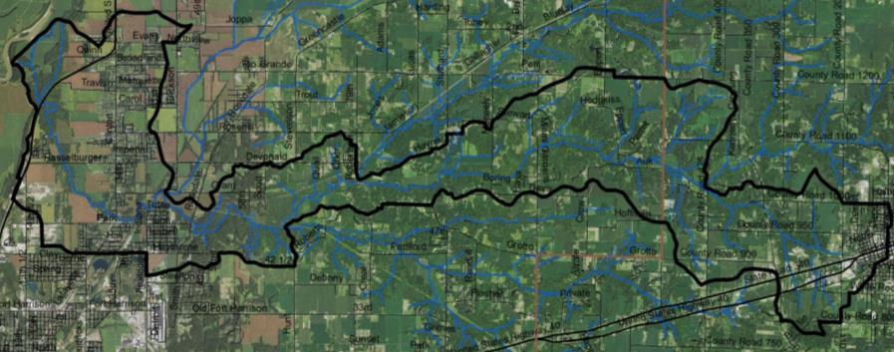
Figure 64. Wastewaters Creek-Otter Creek Subwatershed.

Soils
Soils in the Wastewaters Creek-Otter Creek Subwatershed transition from Hosmer-Stoy-Hickory soils, which lie on uplands along the eastern border of the subwatershed and Miami-Strawn-Hennepin soils, which are found in areas of sandy loam till along the Otter Creek channel into Bloomfield-Princeton-Ayrshire soils along the lower portion of the subwatershed. These soils are excessively drained and found on gentle to strong slopes. Elston-Warsaw-Shipshe soils dominate the western portion of the Wastewaters Creek-Otter Creek Subwatershed transitioning into Sawmill-Lawson-Genessee soils at the confluence with the Wabash River. These deep, well-drained Elston-Warsaw-Shipshe soils formed on outwash materials. These soils are moderately rapidly permeable and easily wind and water eroded, while the Elston-Warsaw-Shipshe soils formed under wetland conditions that are commonly inundated by floodwaters. Hydric soils cover 4,735 acres (27%) of the subwatershed, indicating that much of the land was historically wetlands. The greatest concentration of hydric soils is in the eastern portion of the subwatershed north and west of Brazil in Clay County. Wetlands currently cover 7% (1,232.1) of the subwatershed, representing a loss of 74% of historic wetlands. This represents both the highest wetland acreage and lowest wetland loss of any of the Otter Creek Subwatersheds. Highly erodible and potentially highly erodible soils are prevalent throughout the subwatershed, covering 19% and 18% of the land, respectively. Nearly the entire subwatershed (97%) has soils which are severely limited for septic use.

Land Use
The Wastewaters Creek-Otter Creek subwatershed contains the highest density of urban land uses of any Otter Creek subwatershed. In total, 2,961.2 acres (17%) of the watershed is in urban land uses including the western edge of the City of Brazil, North Terre Haute, and the corridors along U.S Highway 40 and State Road 340. Forested and agricultural land uses are nearly equally dominant within the Wastewaters Creek-Otter Creek Subwatershed accounting for 42% (7,462.9 acres) and 39% (6,860.7 acres), respectively. Wetlands, open water, and grasslands account for the remaining 2% (429.2 acres) of land within the subwatershed.

Point Source Water Quality Issues
As the Wastewaters Creek-Otter Creek Subwatershed includes both the western portion of Brazil and all of North Terre Haute, the largest number of point sources of water pollution in the Otter Creek Watershed are found within this subwatershed. More than 30 leaking underground storage tank (LUST) are located within the watershed with most concentrated along U.S Highly 40/State Road 340 west of Brazil (Figure 65). There are no industrial waste facilities, open dumps, or NPDES-permitted facilities in this subwatershed. More than 3.5 square miles of the Terre Haute MS4 falls within the Wastewaters Creek-Otter Creek Subwatershed.

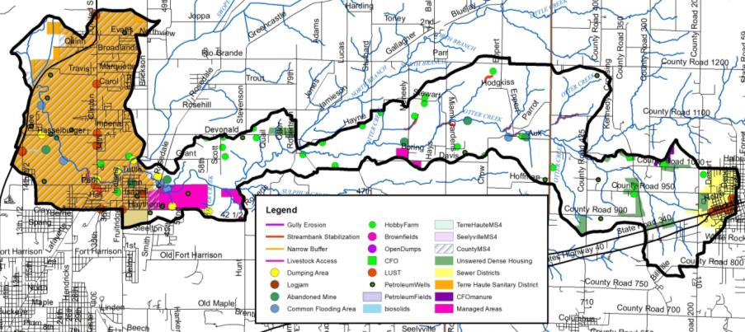
Figure 65. Point and non-point sources of pollution and suggested solutions in the Wastewaters Creek-Otter Creek Subwatershed.

Non-Point Source Water Quality Issues
Agricultural land uses dominate the Wastewaters Creek-Otter Creek Subwatershed, primarily in a corn-soybean rotation. Approximately 25 small animal operations housing nearly 300 animals are present (Figure 65). Areas where livestock have access to the streamwere not identified in the subwatershed. One active confined feeding operations housing a total of 3,046 swine per year is located in the Wastewaters Creek-Otter Creek Subwatershed. In total, manure is spread on 30 acres in the Wastewaters Creek-Otter Creek Subwatershed. Manure from the one CFO and 25 small animal operations produce more than 10,282 tons per year. This contains almost 28,893 pounds of nitrogen and almost 21,184 pounds of phosphorus. Additionally, the Otter Creek TMDL estimated the rural population density in the Headwaters Otter Creek Subwatershed as 78 persons/square mile. The TMDL also estimates impacts from 4,099 dogs and 5,304 cats spread across 2,411 households within the within Brazil and North Terre Haute in the Wastewaters Creek- Otter Creek Subwatershed. Municipal biosolids are applied to 4.1 acres within the subwatershed. Streambank erosion affects 9.6 miles of streams within the subwatershed. There were 5,275 acres of fields identified during the windshield survey that could benefit from the installation of soil health practices, including reduced tillage and/or cover crops. Additionally, seven dumping areas, five abandoned mines, and five areas that are commonly flooded were identified within the Wastewaters Creek-Otter Creek Subwatershed.

Water Quality Assessment
Waterbodies within the Wastewaters Creek-Otter Creek Subwatershed have been sampled at 17 locations (Figure 66). Assessments include collection of water chemistry data by IDEM (12 sites), during the current assessment (2 sites), and via volunteer monitors through the Hoosier Riverwatch program (1 site). The fish community has been assessed by IDNR at 5 sites and via Indiana State University at 8 sites. Macroinvertebrates have not been sampled in this subwatershed. No stream gages are located in the Wastewaters Creek-Otter Creek Subwatershed. pH levels measured below the lower state standards five times during the current assessment. Turbidity and total suspended solids exceed target concentrations during 18 and 13 sampling events, respectively; while E. coli concentrations exceed the state standard during 14 sampling events and nitrate-nitrogen and total phosphorus concentrations exceed targets during all sampling events.

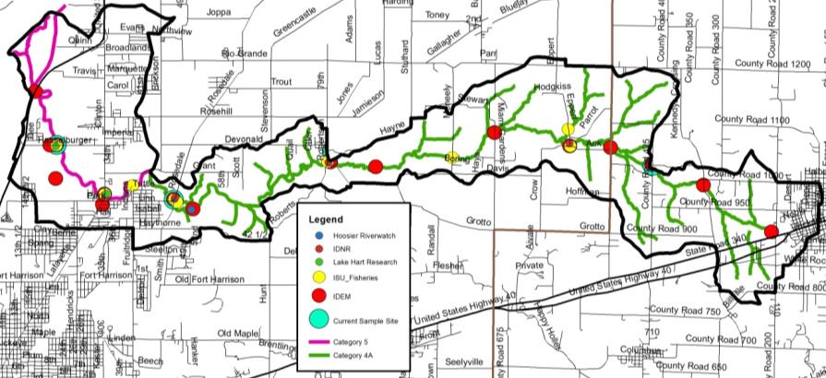
Figure 66. Locations of historic water quality data collection and impairments in the Wastewaters Creek-Otter Creek Subwatershed.

Table 23. Water quality data collected in the Headwaters Otter Creek Subwatershed, January to December 2018.
Site |  | DO  (mg/L) | Temp  (deg C) | pH | Cond  (mg/L) | Turb  (NTU) | Nitrate  (mg/L) | Ammon (mg/L) | Sulfate  (mg/L) | TP  (mg/L) | TSS (mg/L) | Ecoli\ (col/100 mL)
10 | Average | 8.63 | 14.17 | 7.37 | 568.47 | 8.16 | 3.31 | 0.02 | 129.61 | 0.14 | 19.00 | 329.25
 | Max | 9.9 | 25.75 | 8.97 | 913.8 | 34.4 | 9.61 | 0.02 | 319 | 1.12 | 185 | 2419.6
 | Min | 7.49 | 1.15 | 5.89 | 6.9 | 0.5 | 0.52 | 0.02 | 32 | 0.08 | 5 | 5.2
 | #Samples | 24 | 24 | 24 | 24 | 24 | 24 | 24 | 24 | 24 | 24 | 24
 | #Exceed | 0 | 0 | 2 | 0 | 9 | 24 | 0 | 0 | 24 | 6 | 5
12 | Average | 8.49 | 13.84 | 7.27 | 565.44 | 10.75 | 3.33 | 0.02 | 105.85 | 0.15 | 24.28 | 415.82
 | Max | 10.33 | 25.8 | 8.92 | 901.1 | 45.5 | 9.7 | 0.02 | 271 | 1.12 | 230 | 2419.6
 | Min | 7.38 | 1.43 | 4.99 | 278.3 | 0.5 | 0.79 | 0.02 | 7.8 | 0.08 | 5 | 5.2
 | #Samples | 24 | 24 | 24 | 24 | 24 | 24 | 24 | 24 | 24 | 24 | 24
 | #Exceed | 0 | 0 | 3 | 0 | 9 | 24 | 0 | 0 | 24 | 7 | 9

WATERSHED INVENTORY III: WATERSHED INVENTORY SUMMARY
Several important factors and relationships become apparent when the Otter Creek Watershed is observed both as a whole and in part. Many of these were discussed in the individual subwatershed discussions above. An overall summary of water quality impairments and a review of stakeholder concerns and any data which support these concerns are included below.

Water Quality Summary
Several water quality impairments were identified during the watershed inventory process, based on historic data collected from IDEM, IDNR LARE/Lake Hart Research, Indiana State University Fisheries, and Hoosier Riverwatch as well as current water quality assessments completed as through the professional and Hoosier Riverwatch monitoring programs conducted during the current project. These include elevated nitrate-nitrogen, total phosphorus, total suspended solids or turbidity, and E. coli concentrations; pH concentrations outside of target ranges; site specific conductivity and sulfate concentrations higher than targets; and limited habitat and/or fish and macroinvertebrate communities at some sites.

Based on historic data, Table 24 highlights those locations within the Otter Creek Watershed where concentrations of these parameters measured higher than the target concentrations, those locations where impaired waterbodies were identified by IDEM, or where poor IBI and QHEI scores were recorded. Sample sites are mapped only if 50% or more of samples collected at those sites were outside the target values. Table 24 summarizes where historic samples were outside the target values and are grouped by subwatershed.

Table 24. Percent of samples historically collected in Otter Creek Subwatersheds which measured outside target values.
Subwatershed | pH | P | N | TSS | E. coli | Poor IBI | Poor Habitat*
Headwaters Otter Creek | 0% | 33% | 33% | 0% | 31% | 0% | 0%
North Branch Otter Creek | 0% | 0% | 83% | 9% | 29% | N/A | N/A
Little Creek-North Branch Otter Creek | 0% | 17% | 40% | 0% | 23% | N/A | N/A
Sulfur Creek | 0% | 50% | 100% | 8% | 40% | N/A | N/A
Gundy Ditch | 0% | 0% | 100% | 0% | 55% | N/A | N/A
Wastewaters Creek- Otter Creek | 4% | 63% | 91% | 27% | 40% | 0% | 0%
*Includes QHEI scores from fish IBI sampling and cQHEI scores from Hoosier Riverwatch monitoring.
NOTE: N/A indicates no data available.

Table 25 summarizes current samples which measured outside the target values during the current assessment. Elevated nitrate-nitrogen concentrations were observed at all sample sites with concentrations exceeding targets during 100% of sampling events throughout the Otter Creek Watershed. Elevated total phosphorus concentrations were observed at all sample sites with concentrations exceeding total phosphorus targets during 99% of collected samples at all sample sites. Elevated total suspended solids concentrations were observed at multiple sites with 20% of all samples exceeding targets; however, no site contained elevated TSS concentrations in more than 35% of samples. Turbidity concentrations exceeded targets in 32% of collected samples at each site with one site in the Gundy Ditch Subwatershed (Site 09) exceeding targets in 54% of collected samples. E. coli concentrations that exceeded the state grab sample standard were measured at all sites with 32% of samples exceeding state standards. Indiana State University collected five E. coli samples in 30 days in May and June 2018. In total, eight sample sites exceeded the E. coli geometric mean target concentrations. Sulfate samples exceeded targets at one site during 21% of sample events, while conductivity exceeded targets at the same site during 46% of sample events. pH concentrations measured outside of targets in 9% of collected samples or between 9 and 13% at each site.

Table 25. Percent of samples collected in the Otter Creek Watershed during the 2018 which measured outside target values.
ID | DO | Temp | pH | Cond | Turbidity | Nitrate | Ammonia | Sulfate | TP | TSS | E coli
1 | 0% | 0% | 9% | 0% | 14% | 100% | 0% | 0% | 100% | 9% | 45%
2 | 0% | 0% | 13% | 0% | 17% | 100% | 0% | 0% | 96% | 9% | 35%
3 | 0% | 0% | 8% | 0% | 25% | 100% | 0% | 0% | 100% | 17% | 25%
4 | 0% | 0% | 8% | 0% | 17% | 100% | 0% | 0% | 100% | 17% | 38%
5 | 0% | 0% | 13% | 0% | 21% | 100% | 0% | 0% | 100% | 17% | 46%
6 | 0% | 0% | 8% | 0% | 33% | 100% | 0% | 0% | 100% | 17% | 29%
7 | 0% | 0% | 8% | 46% | 50% | 100% | 0% | 21% | 100% | 17% | 17%
8 | 0% | 0% | 4% | 0% | 42% | 100% | 0% | 0% | 100% | 29% | 29%
9 | 0% | 0% | 8% | 0% | 54% | 100% | 0% | 0% | 100% | 21% | 17%
10 | 0% | 0% | 8% | 0% | 38% | 100% | 0% | 0% | 100% | 25% | 21%
11 | 0% | 0% | 10% | 0% | 45% | 100% | 0% | 0% | 100% | 35% | 45%
12 | 0% | 0% | 13% | 0% | 38% | 100% | 0% | 0% | 100% | 29% | 38%
*WQI= water quality index from Hoosier Riverwatch monitoring.

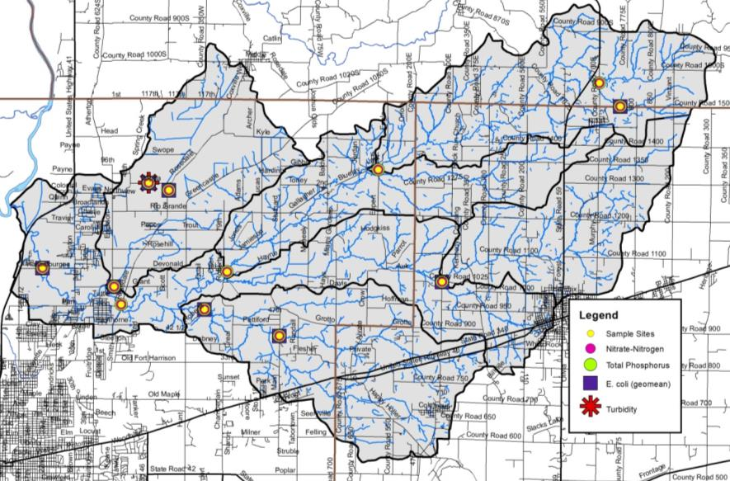
Figure 67. Sample sites with poor water quality, biological communities, and/or habitat (50% or more of samples collected during current or historic water quality monitoring were outside the target values).

In general, Otter Creek contains high quality habitat and fish communities rate as good to excellent. Macroinvertebrate communities score moderate to high water quality index scores. There is little correlation with fish IBI and macroinvertebrate WQI scores to habitat assessments.

Stakeholder Concern Analysis
All of the identified concerns generated both from stakeholder input and through water quality and watershed inventory efforts are detailed in Table 26. This list represents a work in progress and additional concerns may be added as the steering and monitoring committees work through data analysis. The steering committee rated each concern as to whether it is supported by watershed-based data, what evidence does or does not support the concern, whether the concern is quantifiable, whether it is in the scope of the watershed management plan, and if it is something on which the committee wants to focus. Nearly all concerns were quantifiable and many were rated as being within the scope and items on which the committee wants to focus.

Table 26. Analysis of stakeholder concerns identified in the Otter Creek Watershed.
Concern | Supported by our data? | Evidence | Able to Quantify? | Outside Scope? | Group wants to focus on?
E. coli concentrations are elevated | Yes | 32% of samples collected during the Otter WMP monitoring exceed water quality targets. 8 of 12 sites’ geometric mean exceed the state standard for 05/24-06/21 samples. Otter Creek TMDL indicates 23 assessment units covering 212 stream miles are impaired for E.coli. | Yes | No | Yes
Septic soils – too many residences are sited on unsuitable soils | Yes | 95% of the watershed is covered by soils which rate as very limited for septic use. 16 areas where 25+ houses/square mile utilize septic treatment were documented (464 houses total). Anecdotal information suggests that straight pipes and facility maintenance is an issue in the watershed | Yes | No | Yes, education
Septic system inputs to stream – straight pipes, abandoned facilities and limited maintenance | Unknown | 95% of the watershed is covered by soils which rate as very limited for septic use. Anecdotal information suggests that straight pipes and facility maintenance is an issue in the watershed. | No | No | Yes - education
Is it safe to swim at Mill Dam Park | Yes | Only 5 of 24 E. coli samples collected during the WMP process exceed the state standard. Mill Dam is a low head dam– there is both a dangerous drop in water level and undercurrents around the base of the dam. | Yes | No- E.coli;  Yes- LHD | Yes- E.coli;  Yes-education – LHD
Heavy use of tile drainage on agricultural lands | Yes | Tile drainage occurs on an estimated 28% of the watershed (22,884 acres) | Yes | No | Maybe – for targeting
Wastewater isn’t treated in/near Carbon | No | The Town of Carbon operates a wastewater system which collects effluent from approximately 160 septic tanks which flow to a lift station for pumping to treatment lagoons. The tanks are pumped on a rotational basis. Two lagoons are used for treatment with 90 days storage and the third is used for polishing and storage. Once cleaned to a 10:1 dilution ration, the plant discharges a maximum of 0.0252 MGD of wastewater to Ebenezer Creek. | Yes | Yes | No
Impacts of effluent inputs from wastewater plants | No – effluent levels are set by IDEM; with the exception of Carbon all effluent concentrations are meeting required permit requirements | Two wastewater treatment facilities located within and discharging to Otter Creek or a tributary, the Staunten Wastewater Plant and the Carbon Municipal Sewage Treatment Plant, as well as two wastewater treatment facilities which treat portions of the watershed but discharge outside of the watershed, the City of Terre Haute and City of Brazil. Only the Town of Carbon has reported effluent violations – one quarter for pH and six quarters for nitrogen. | No | Yes | No
Sand inputs throughout the watershed | Yes anecdotally | More than 90% of the watershed is covered by soil associations in which sand is the predominant component. Anecdotal observations of sand moving through Otter Creek. Surveyors indicate 22 ton of material removed from legal drains over the last 10 years. | Maybe | No | Yes
Stream cleaning/log jam removal needed from Mill Dam to Wabash River | Yes | 8 logjams were identified during the windshield inventory. OLC video documented additional logjams in the spring 2018. | Yes | Yes | No
Heavy use of tile drainage on agricultural lands | Yes | Tile drainage occurs on an estimated 28% of the watershed (22,884 acres). | Yes | No | Maybe – for targeting
Heavy use of tile drainage on agricultural lands | Yes | Tile drainage occurs on an estimated 28% of the watershed (22,884 acres). | Yes | No | Maybe – for targeting practices
Runoff from new subdivisions (Grants Way, others) | Yes | 9% of the watershed is covered by developed areas with 10,475 acres (13%) of the watershed are 25% or more covered by hard surfaces. 16 SWMPPs have been issued in the watershed in the last 12 months. Anecdotal evidence of standing water in/near new subdivisions following rain events. | Yes | No | Yes
Highly erodible /potentially highly erodible soils density | Yes | HES and PHES cover 40% of the watershed. | Yes | No | Yes – for targeting practices
Stormwater infiltration – slowing the flow of water is required to increase water infiltration | Yes | Storm drain systems are present in most urban areas throughout the watershed. In total, more than 80 miles of storm drain pipe are present within the watershed. The Vigo County, Terre Haute, and Seelyville MS4s work to mitigate stormwater impacts to Otter Creek and its tributaries via the Clean Water Coalition. Photographic evidence of standing water following storm events of 0.25 inches of rain or more. | Yes | No | Yes
Agricultural producers are not sufficiently utilizing cover crops or conservation tillage | Yes | Anecdotal information indicates that cover crops are utilized on no less than 2950 acres of agricultural land (4% total or 10% of ag land). Tillage transect data indicate 2-35% ag land uses conservation tillage on corn and 21-48% of ag land on soybeans in all 3 watershed counties. | Yes | No | Yes
Dividing forest land into smaller parcels/increasing fragmentation– current ordinance allows for 10 acre parcels | Yes | 41% of the watershed is forested. Forested parcel data is not available; however, NLCD data indicate 2,552 acres of forest land converted to urban or agricultural use from 1992 to 2011 (3.2% loss) | Maybe | No | Yes – ordinance based; education
Nutrient management on cropland needed | Yes | 42% of watershed is cultivated crops. N and P levels exceeded targets at 100% of sample sites. | Yes | No | Yes
Seelyville Water wellhead protection area | Yes | The Seelyville Water wellhead protection area is 100% located within the Otter Creek Watershed. | Yes | Yes | Yes – education
Poor water quality | Yes | 303(d) impairments for pH (8.2 miles) and E. coli (212 miles) in the watershed. | Yes | No | Yes
Nitrogen inputs from manure | Yes – anecdotal | 0% of ammonia samples and 100% of nitrate samples exceed targets; manure application is anecdotal with at least 12,360,000 lb of manure generated by CFO and small, unregulated farms annually. | No as we cannot assume N originates from manure | No | Yes
Riparian impacts that increase rate of stream flow/flashiness | Yes – anecdotal | Stream flow is not continuously measured with a stream gage; however, anecdotal information and photographs indicate large flow increases in Otter Creek following small precipitation events. | Not really | No | Yes
Trash needs to be kept out of creek | Yes | Individual observations during the watershed inventory indicate trash accumulation is a problem. | Yes - anecdotal | No | Yes
Streambank and bed erosion as a source of instream sediment and erosion | Yes | 66.6 miles of streambank were identified as eroding during the windshield survey. 32% of turbidity and 20% of TSS samples exceed targets. | Yes where stream banks are visible | No | Yes
Livestock access to the stream | Yes | Livestock access was documented at 12 locations covering 6.6 miles of Otter Creek streams. | Yes | No | Yes
Heavy use pads are not prevalent enough | Unknown | Data are not reported but anecdotal information suggestions that additional heavy use pads are likely needed. | No | No | No – livestock population is not sufficient to promote this practice
Protection of high quality areas – Forest Park Bayou Area, others – should be encouraged | Yes | Fontanet Woods, Little Bluestem Prairie, Mill Dam Park, George N Craig and Babe Wheeler Parks, Chinook FWA, Forest Park and the Isaac Walton property offer current protection for high quality areas. | Yes | No | Yes - education
High quality forest land preservation | Yes | 41% of the watershed is forested. Historically 62% of the watershed was mapped in forest land. Acreage of classified forest mapped in Otter Creek has not changed in the last 25 years. | Yes | No | Yes
Historic planning efforts – 800 acre lake planned by conservation club/potential to dam Otter Creek | Yes – historic knowledge | The Army Corps investigated the potential to create the “Otter Creek Reservoir” to control flooding in 1964. While the area was deemed a good option for flood control, the lake never came to fruition. | Yes | Yes | No
Flooding in North Terre Haute/lower Otter Creek, levee area, upstream of Hasselburger Road | Yes | Floodplain covers 6,675 acres of the watershed. 85% of historic wetlands have been modified or lost. There is anecdotal evidence of historic flooding near the confluence with the Wabash River. 14 flooded locations were noted during the windshield survey. | Yes | No | Yes
New developments are impacting wetlands | Yes | 85% of historic wetlands have been modified or lost. 12 permits totaling 3.22 acres of wetland impacts were issued in the last 12 months. | Yes | No | Yes – education
High quality areas/parks are not connected to provide wildlife corridors | Yes | Fontanet Woods, Little Bluestem Prairie, Mill Dam Park, George Craig & Babe Wheeler Parks, Chinook FWA, Forest Park & the IWLA property are not contiguous. | Yes | No | Yes
Biodiversity is limited across the watershed | No | Biodiversity data have not been compiled. | Fish /macros–yes; other species - no | No – use as a metric | Yes – instream only
Invasive plant impacts to native species including quail and other native plants | Yes | There are 25 documented invasive plant species in the 3 counties covered by the watershed. Several invasive species were observed in riparian areas during the windshield survey; however, few studies show significant impacts to biodiversity or water quality beyond the site level scale. |  | No | Yes
Invasive species impacts– especially Asian bush honeysuckle – impacts on forested land | Yes |  |  | No | Yes
General public needs educated about agricultural practice use | Yes - anecdotal | Anecdotal evidence based on communication with stakeholders. | No | No | Yes
Education needed – watershed concept, elevated nutrients, etc – for the general public | Yes - anecdotal | Anecdotal evidence based on communication with stakeholders. | No | No | Yes
Urban residents are unaware of their impacts to Otter Creek | Yes - anecdotal | Anecdotal evidence based on communication with stakeholders | No | No | Yes
Abandoned strip and surface mines; open mine shafts are impacting water quality | Yes present; No observable impact | There are nearly 4,800 acres of surface mined land and 12,200 acres of underground mined land within the watershed. | Yes | No – continued monitoring | Yes – education only
Heavy metal contamination from previous mining efforts are impacting water quality | No | Initial soil sample metals analysis indicate low metal concentrations are currently present. Two sulfate samples exceed targets. | Yes | No – continued monitoring | Yes – education only
Animal manure storage and spreading is negatively impacting water quality | Yes | More than 5,000 animals are housed in CFO or on small, unregulated farms producing more than 26,530 tons of manure annually. | Yes | No | Yes
Wetland preservation required | Yes | 85% of historic wetlands have been modified or lost. | Yes | No | Yes - education

Following a review of the stakeholder concerns, the steering committee determined the following concerns identified by the public to be outside of this project’s approach: wastewater treatment and wastewater treatment plants, logjam removal, heavy use pads, and the historic fact that a lake was planned within the Otter Creek Watershed. Therefore, these concerns will not be addressed in this watershed management plan.

PROBLEM AND CAUSE IDENTIFICATION
After evaluation of stakeholder concerns and completion of the watershed inventory, watershed problems can be summarized as shown in Table 27. Problems represent the condition that exists due to a particular concern or group of concerns. Table 28 details potential causes of problems identified in Table 27.

Table 27. Problems identified for the Otter Creek watershed based on stakeholder and inventory concerns.
Concern(s) | Problem
- E coli concentrations are elevated  - Manure spreading and storage  - Septic soils – too many residences are sited on unsuitable soils  - Septic system inputs to streams from straight pipes and abandoned facilities, poor maintenance | Area streams are impaired for recreational contact by IDEM’s 303(d) list (high E. coli)
- Streambed erosion is a source of instream sediment and causes erosion  - Highly erodible/potentially highly erodible soils density  - Sand inputs to watershed streams  - Runoff from subdivisions needs to be slowed and treated  - Riparian impacts increase the rate of stream flow/flashiness  - Flooding  - Agricultural producers are underutilizing cover crops or conservation tillage  - Stormwater infiltration is required to increase water infiltration | Area streams are very cloudy and turbid
- Septic soils – too many residences are sited on unsuitable soils  - Septic system inputs to streams from straight pipes and abandoned facilities, poor maintenance  - Runoff from subdivisions needs to be slowed and treated  - Flooding  - Nitrogen inputs from animal manure  - Manure spreading and storage  - Heavy use pad prevalence  - Wetland preservation is required  - Wetlands are impacted by new developments  - Riparian impacts increase the rate of stream flow/flashiness  - Agricultural producers are underutilizing cover crops or conservation tillage  - Stormwater infiltration is required to increase water infiltration | Area streams have nutrient levels exceeding the target set by this project
- Biodiversity is limited in the watershed  - General public needs educated about agricultural practice use  - Heavy use of tile drainage on agricultural lands  - Education is needed on watershed concepts, elevated nutrients, etc  - It is unsafe to swim at Mill Dam Park due to the low head dam  - Urban residents are unaware of their impacts to Otter Creek  - Heavy metal impacts from previous mining  - Abandoned strip mines impact water quality | A unified education program for entire watershed does not currently exist
- Invasive species, especially Asian bush honeysuckle, impacts forest land  - Invasive plants impact native species and habitat  - Forests are divided into smaller parcels  - Protection of high quality areas is needed  - High quality forest preservation is needed  - High quality areas/parks are not contiguous | High quality, non-invasive species impacted forests are limited

Table 28. Potential causes of identified problems in the Otter Creek watershed.
Problem | Potential Cause(s)
Area streams are very cloudy and turbid | Total Suspended Sediment concentrations and turbidity levels exceed the targets set by this project
Area streams have nutrient levels exceeding the targets set by this project | Nutrient levels exceed the target set by this project
Areas streams are impaired by IDEM for recreational contact | E.coli levels exceed the water quality standard
A unified education program for entire watershed does not currently exist | Educational efforts targeting funders, local agencies, and the public are lacking.
High quality, non-invasive species impacted forests are limited | Forest land is impacted by competing land uses and invasive species

SOURCE IDENTIFICATION AND LOAD CALCULATION

Source Identification: Key Pollutants of Concern
Nonpoint pollution sources are varied, yet common throughout almost any watershed. Several earlier sections of this document identify potential sources of the pollutants of concern in the Otter Creek Watershed. These and other potential sources of these causes are discussed in further detail in subsequent sections. A summary of potential sources identified in the Otter Creek Watershed for each of our concerns is listed below:

Nutrients (Nitrogen and Phosphorus):
- Conventional tillage cropping practice
- Wastewater treatment discharges
- Gully or ephemeral erosion
- Agricultural and residential fertilizer
- Poor riparian buffers
- Poor forest management
- Streambank and bed erosion
- Animal waste (livestock in streams, poor manure management, domestic and wildlife runoff)
- Confined feeding operations
- Human waste (failing septic systems, package plants, inadequately treated wastewater)

Sediment:
- Conventional tillage cropping practice
- Streambank and bed erosion
- Poor riparian buffers
- Gully or ephemeral erosion
- Cropped floodplains
- Livestock access to streams
- Altered hydrology (ditching and draining, altered stream courses)

E. coli:
- Human waste (failing septic systems, package plants, inadequately treated wastewater)
- Animal waste (livestock in streams, poor manure management, domestic and wildlife runoff)
- Combined Sewer Overflows

Forest land management:
- Gully or ephemeral erosion
- Lack of fence rows, windbreaks and field borders
- Invasive species impacts
- Reduced forest plot size

Potential Sources of Pollution
The steering committee used GIS data, water quality data, watershed inventory observations and anecdotal information as available to evaluate the potential sources of nonpoint pollution in the Otter Creek Watershed. Appendix E contains tables detailing each potential source within each subwatershed. Table 29 through Table 33 summarizes the magnitude of potential sources of pollution for each problem identified in the Otter Creek Watershed.

Table 29. Potential sources causing nutrient problems.
Problems: | Nutrient concentrations threaten the health of Otter Creek and its tributaries.
Potential Causes: | Nutrient concentrations exceed target values set by this project.
Potential Sources:  Potential Sources: | - 16 livestock access areas (115,104 linear feet of streams) were observed throughout the watershed. The highest percent of stream miles accessed by livestock were found in the Little Creek-North Branch Otter Creek (27%), Headwaters Otter Creek (7%) and North Branch Otter Creek (4%) subwatersheds.  - 113 unregulated animal operations were observed housing nearly 1,250 animals throughout the watershed. The highest number of operations was observed in the Headwaters Otter Creek (25), Little Creek-North Branch Otter Creek (21) and Sulfur Creek (20) subwatersheds. These operations can be sources due to livestock defecating in or near streams, soil compaction, streambank erosion, and improper manure storage and spreading.  - 6.4 miles of stream lack adequate buffers. The highest percent of stream miles needing buffers were found in Gundy Ditch (11%) and Headwaters Otter Creek (4%) subwatersheds.  - 128 acres of fields exhibit active gully erosion.  - 51.6 miles of stream lack adequate stabilization, with the highest percent of stream miles lacking stabilization found in Headwaters Otter Creek (29%), North Branch Otter Creek (18%) and Sulfur Creek (18%) subwatersheds.  - Manure from confined feeding operations is applied in the Wastewaters Creek-Otter Creek and Sulfur Creek subwatersheds.  - Manure from small animal operations is applied across the Otter Creek Watershed with more than 26,530 tons produced annually. More than 64,000 lb of N and 45,600 lb of P are delivered annually with this manure.  - Failing septic systems add nutrients to the system within the rural portion of the watershed and in areas of dense unsewered housing.  - 0.54 square miles of Seelyville MS4 and 4.11 square miles of the Terre Haute MS4 lie within the Otter Creek Watershed in the Sulfur Creek and Wastewaters Creek-Otter Creek subwatersheds, respectively.  - 80 miles of pipe carry stormwater within developed portions of the watershed.  - More than 8,380 cats and 6,115 dogs are located within urban areas of the Otter Creek Watershed.

Table 30. Potential sources causing sediment problems.
Problems: | Area streams are cloudy and turbid.
Potential Causes: | Suspended sediments and/or turbidity exceed target values set by this project.
Potential Sources: | - 16 livestock access areas (115,104 linear feet of streams) were observed throughout the watershed. The highest percent of stream miles accessed by livestock were found in the Little Creek-North Branch Otter Creek (27%), Headwaters Otter Creek (7%) and North Branch Otter Creek (4%).  - 6.4 miles of stream lack adequate buffers. The highest percent of stream miles needing buffers were found in Gundy Ditch (11%) and Headwaters Otter Creek (4%) subwatersheds.  - 128 acres of fields exhibit active gully erosion.  - 60% of corn fields and 14% of soybean fields are under conventional tillage.  - 51.6 miles of stream lack adequate stabilization, with the highest percent of stream miles lacking stabilization found in Headwaters Otter Creek (29%), North Branch Otter Creek (18%) and Sulfur Creek (18%) subwatersheds.  - 113 unregulated animal operations were observed housing nearly 1,250 animals throughout the watershed. The highest number of operations was observed in the Headwaters Otter Creek (25), Little Creek-North Branch Otter Creek (21) and Sulfer Creek (20) subwatersheds. These operations can be sources due to livestock defecating in or near streams, soil compaction, streambank erosion, and improper manure storage and spreading.  - 15,894 acres of agricultural land are located on highly erodible soils while 15975 acres of agricultural land are located on potentially highly erodidlbe soils. The highest density of HES and PHES occur in Sulfer Creek (27% HES, 24% PHES), Headwaters Otter Creek (23% HES, 16% PHES), and North Branch Otter Creek (24% HES, 16% PHES).  - 80 miles of pipe carry stormwater within developed portions of the watershed.

Table 31. Potential sources causing E. coli problems.
Problems: | Area streams are listed by IDEM as impaired for recreational contact.
Potential Causes: | E. coli concentrations exceed target values and the state standard.
Potential Sources: | - 16 livestock access areas (115,104 linear feet of streams) were observed throughout the watershed. The highest percent of stream miles accessed by livestock were found in the Little Creek-North Branch Otter Creek (27%), Headwaters Otter Creek (7%) and North Branch Otter Creek (4%) subwatersheds.  - 113 unregulated animal operations were observed housing nearly 1,250 animals throughout the watershed. The highest number of operations was observed in the Headwaters Otter Creek (25), Little Creek-North Branch Otter Creek (21) and Sulfer Creek (20) subwatersheds. These operations can be sources due to livestock defecating in or near streams, soil compaction, streambank erosion, and improper manure storage and spreading.  - Manure from confined feeding operations is applied in the Wastewaters Creek-Otter Creek and Sulfur Creek subwatersheds.  - Failing septic systems contribute E. coli to the system within the rural portion of the watershed and in areas of dense unsewered housing.  - More than 8,380 cats and 6,115 dogs are located within urban areas of the Otter Creek Watershed.  - Manure from small animal operations is applied across the Otter Creek Watershed with more than 26,530 tons produced annually.  - Based on TMDL waste load allocation calculations, the Staunton and Carbon WWTPs contribute about 0.15% of the Otter Creek E. coli load during normal flow in the Otter Creek Watershed or approximately 0.12 billion E. coli/day for Carbon WWTP and 0.37 billion E. coli/day for the Staunton WWTP.  - 0.54 square miles of Seelyville MS4 and 4.11 square miles of the Terre Haute MS4 lie within the Otter Creek Watershed in the Sulfur Creek and Wastewaters Creek-Otter Creek subwatersheds, respectively. The Seelyville and Terre Haute MS4s contribute 11.83 billion E.coli/day and 116.1 billion E. coli/day, respectively.  - Under wet weather conditions, the TMDL prioritizes E. coli reductions for the Wastewaters Creek-Otter Creek Subwatershed over the Sulphur Creek, North Branch Otter Creek, Gundy Ditch, Little Creek-North Branch Otter Creek and Headwater Otter Creek in that order. IDEM indicates that this ranking should be considered when determining critical areas as part of this planning process (IDEM, 2013).

Table 32. Potential sources causing forest management problems.
Problems: | High quality, non-invasive species impacted forests are limited.
Potential Causes: | Forest land is impacted by competing land uses and invasive species.
Potential Sources: | - Invasive species are present throughout the Otter Creek Watershed.  - Forest land is divided into smaller parcels.  - High quality forest land is not being adequately protected.  - Forest parcels are not contiguous.

Table 33. Potential sources causing education problems.
Problems: | - Individuals lack knowledge of what could/should be implemented, where to site practices, and how to fund implementation.  - A unified education plan is lacking.
Potential Causes: | - Educational efforts targeting funders, local agencies, and the public are lacking.
Potential Sources: | N/A

Load Estimates
Nonpoint source pollution is generated from diffuse sources found on public and private lands. The USEPA notes that sources of nonpoint source pollution include: stormwater runoff, construction activities, solid waste disposal, atmospheric deposition, streambank erosion, and more. Inventory data in Table 29 through Table 33 identify potential sources of nonpoint pollution within the watershed. These tables – generated using GIS, water quality data, windshield surveys, local knowledge, and other sources of data – are useful for generally identifying water quality problems. Two methods could be used to understand the loading of nutrients, sediment, and pathogens in waterbodies in the Otter Creek Watershed: 1) measured results from the monitoring regime and 2) modeled results. Each method can estimate both the current load and the reduction in load needed to reach target concentrations. These methods each present advantages and disadvantages for understanding the loading in this watershed in particular. The steering committee considered the monitoring data to draft long term goals and critical areas. These data were used to calculate final goals and set long term goals, short term goals, and critical areas.

Results from monitoring data can be used to estimate loads of nonpoint source pollution. Concentrations of nutrients, sediments, and pathogens taken at sampling sites can be combined with flow data to estimate the current loads in those waterbodies. Target loads for those waterbodies can also be calculated using available flow data.

As discussed in Section 3.3, twelve monitoring sites were sampled every other week from January to December 2018. There is clear value in using these measurements from the Otter Creek Watershed to estimate loads and load reductions. However, there are some limitations in the measured dataset. Sampling methods did not allow for continuous flow measurements at each site, so data from several USGS gages were used to approximate flow. Samples collection began in a period of intense drought and was completed in a period of more normal precipitation. The dataset can therefore give us an interesting contrast between low flow and high flow conditions, but on the whole, it isn’t representative of a typical annual precipitation and stream flow cycle.

As discussed in Section 3.1, the steering committee selected water quality benchmarks that will significantly improve water quality in Otter Creek (Table 15). Target loads needed to meet these benchmarks were calculated for each subwatershed for each parameter. Sample site data from the subwatershed’s pour point sampling site was used to calculate annual loading rates and load reductions. The load reduction needed was then calculated for each subwatershed, which corresponds to each sample site, in lb/year and as a percent of the current load (Table 34 to Table 37).

Additionally, the Otter Creek E. coli TMDL was used to confirm E. coli reductions needed in the Otter Creek Watershed. The required E. coli load reduction was determined using the TMDL for each 12-digit HUC within Otter Creek (IDEM, 2014). The TMDL states that between a 49 and 84% reduction in E. coli concentration (#/day) is needed during the recreation season (May-October), in order to achieve the state water quality standard (Table 37).

Table 34. Estimated Nitrogen load reduction by subwatershed needed to meet water quality target concentrations in the Otter Creek Watershed.
Site | Subwatershed | Current | Target | Reduction | % Reduction
3 | North Branch | 196,284.2 | 36,966.4 | 159,317.8 | 81%
4 | Head Otter | 177,113.1 | 25,709.7 | 151,403.4 | 85%
6 | Little-North | 353,033.5 | 64,222.3 | 288,811.3 | 82%
7 | Sulfur | 219,229.2 | 36,912.7 | 182,316.5 | 83%
11 | Gundy | 231,861.3 | 29,815.6 | 202,045.7 | 87%
12 | Wastewaters | 998,641.4 | 198,364.5 | 800,276.9 | 80%

Table 35. Estimated Phosphorus load reduction by subwatershed needed to meet water quality target concentrations in the Otter Creek Watershed.
Site | Subwatershed | Current | Target | Reduction | % Reduction
3 | North Branch | 47,907.9 | 2,218.0 | 45,690.0 | 95%
4 | Head Otter | 19,254.8 | 1,542.6 | 17,712.3 | 92%
6 | Little-North | 104,080.8 | 3,853.3 | 100,227.5 | 96%
7 | Sulfur | 40,747.6 | 2,214.8 | 38,532.9 | 95%
11 | Gundy | 37,717.0 | 1,788.9 | 35,928.1 | 95%
12 | Wastewaters | 189,269.1 | 11,901.9 | 177,367.2 | 94%

Table 36. Estimated TSS load reduction by subwatershed needed to meet water quality target concentrations in the Otter Creek Watershed.
Site | Subwatershed | Current | Target | Reduction | % Reduction
3 | North Branch | 8,262,473.3 | 1,108,991.0 | 7,153,482.3 | 87%
4 | Head Otter | 3,649,085.9 | 771,289.8 | 2,877,796.1 | 79%
6 | Little-North | 16,741,675.8 | 1,926,668.2 | 14,815,007.7 | 88%
7 | Sulfur | 13,464,128.5 | 1,107,380.4 | 12,356,748.1 | 92%
11 | Gundy | 8,650,878.4 | 894,466.8 | 7,756,411.6 | 90%
12 | Wastewaters | 41,385,308.8 | 5,950,934.2 | 35,434,374.6 | 86%

Table 37. Current and target loads in pounds/year and load reduction needed to meet water quality target concentrations in the Otter Creek Watershed.
Site | Subwatershed | Current | Target | Reduction | % Reduction | TMDL %Reduction
3 | North Branch | 5.56E+14 | 7.89E+13 | 4.8E+14 | 86% | 63.2%
4 | Head Otter | 2.51E+14 | 5.48E+13 | 2.0E+14 | 78% | 49.3%
6 | Little-North | 7.08E+14 | 1.37E+14 | 5.7E+14 | 81% | 52.5%
7 | Sulfur | 4.54E+14 | 7.87E+13 | 3.8E+14 | 83% | 67.2%
11 | Gundy | 3.17E+14 | 6.36E+13 | 2.5E+14 | 80% | 84.4%
12 | Wastewaters | 2.51E+15 | 4.23E+14 | 2.1E+15 | 83% | 59.8%

CRITICAL AND PRIORITY AREA DETERMINATION
Critical areas are defined by the areas where sources of water quality problems occur in high density and where restoration measures can improve water quality. These areas indicate locations where best management practices should be targeted to address nonpoint sources of pollution. Priority areas are those areas of the watershed where high quality habitat is found and the aquatic biological community is classified as good or excellent. Best management practices to protect the higher quality conditions should be targeted to these areas.

Using the list of potential sources developed for each parameter of concern as a base, the steering committee developed a mechanism for determining critical areas for each parameter. GIS-based mapping data, loading calculations, and historic water quality data were used as a basis for decision-making. For each parameter, each subwatershed was evaluated to determine whether it met each criterion. Each subwatershed was scored based on the total number of criteria that were met and the subwatersheds with the highest scores were prioritized as critical areas for each parameter. In addition, biological data were reviewed to identify high quality communities which serve as priority areas.

Critical Areas for Nitrate-Nitrogen and Total Phosphorus
Nitrate-nitrogen was the nitrogen form on which our critical area determination occurred, while total phosphorus was used to determine phosphorus critical areas (Figure 68). Nitrate-nitrogen and total phosphorus are readily available in the Otter Creek Watershed, entering surface water via human and animal waste, fertilizer use, and via tile drains on agricultural lands. Phosphorus enters the Otter Creek watershed through streambank and bed erosion, unfiltered runoff, agricultural land use in floodplains, stormwater runoff, and livestock access. Based on the data reviewed by the steering committee, the following targets were priorities for nutrient critical areas:
- Percent of samples exceeding target concentrations historic data
- Percent of samples exceeding target concentrations current data
- Tile drainage – percent of watershed
- Row crop + pastureland – percent of watershed

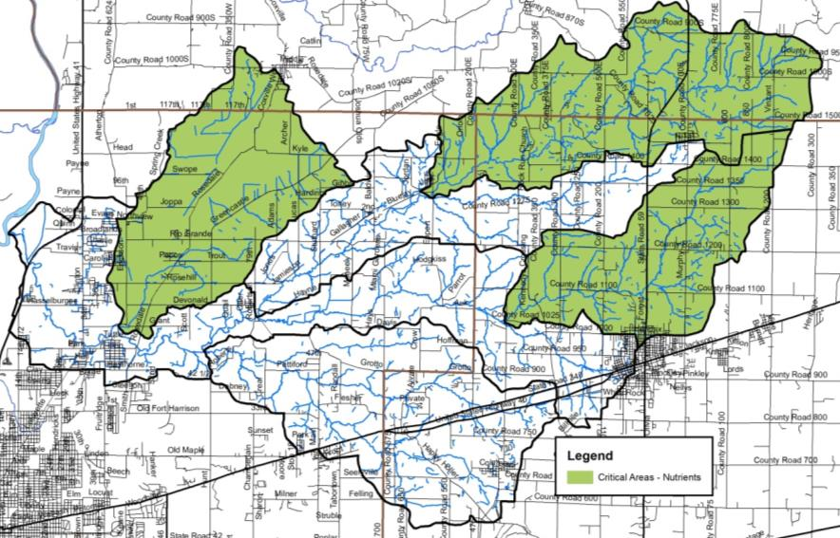
Figure 68. Critical areas for nutrients in the Otter Creek Watershed: Gundy Ditch, North Branch Otter Creek and Headwaters Otter Creek.

Critical Areas for Sediment
Total suspended solids were used to determine sediment-based critical areas (Figure 69). Total suspended solids enter streams Otter Creek through streambank and bed erosion, unfiltered runoff, agricultural land use in floodplains, stormwater runoff, and livestock access. Based on the data reviewed by the steering committee, the following targets were priorities for nutrient critical areas:
- Percent of samples exceeding target concentrations historic data
- Percent of samples exceeding target concentrations current data
- Percent agricultural land use
- Percent urban land use

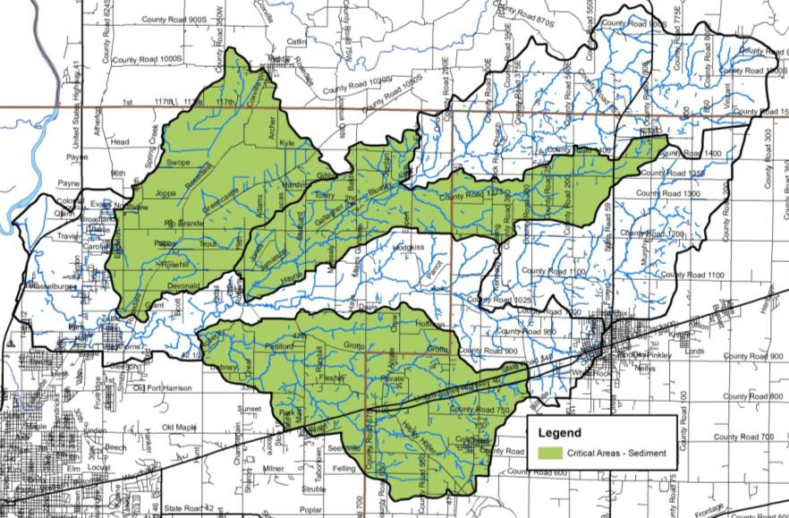
Figure 69. Critical areas for sediment in the Otter Creek Watershed

Critical Areas for E. coli
E. coli was used to determine our critical areas. E. coli enters streams in the Otter Creek Watershed through human and animal waste, livestock access, and infrastructure issues. Additional areas of concern, such as areas with manure management issues or failing septic systems, may also be included. While those areas have not been quantified, dense unsewered areas were included as a method for identifying these areas. Based on the data reviewed by the steering committee, the following targets were priorities for E. coli critical areas:
- Percent of samples exceeding target concentrations historic data
- Percent of samples exceeding target concentrations current data
- Manure volumes
- Percent urban land use

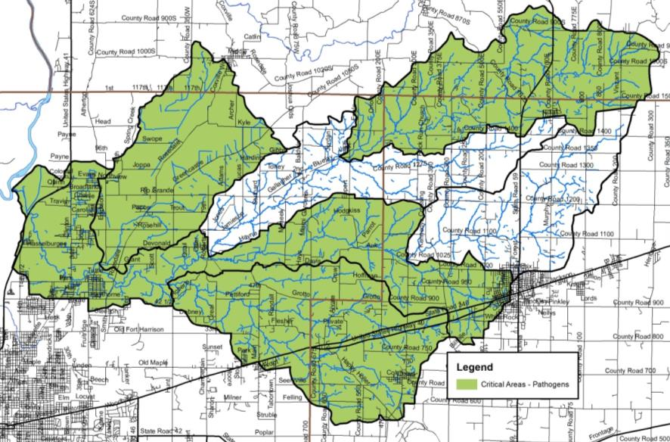
Figure 70. Critical areas for E. coli in the Otter Creek Watershed.

Critical Areas Summary
The subwatersheds identified as critical areas for each parameter are summarized in Figure 68 to Figure 70. To identify the highest priority subwatersheds, the steering committee decided to divide them into three tiers (high, medium and low priority), based on the number of parameters that were determined to be critical. The highest priority subwatersheds are those that were determined to be critical for three parameters. The medium priority subwatersheds are those that were determined to be critical for two parameters. The lowest priority subwatersheds were critical for one parameter (Figure 71).

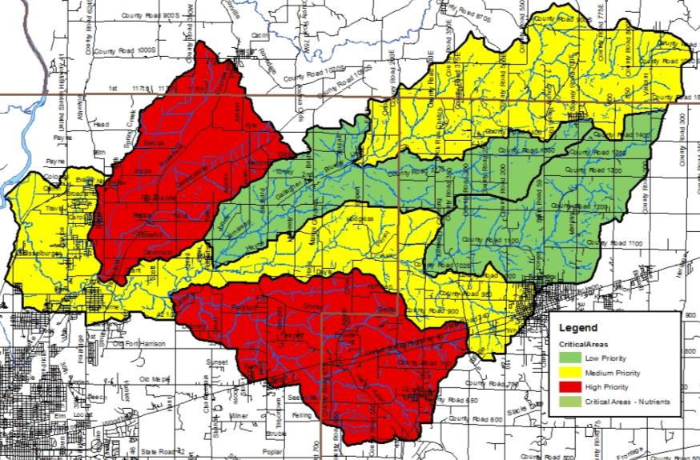
Figure 71. Prioritized critical areas in the Otter Creek Watershed.

GOAL SETTING
Based on watershed inventory efforts; stakeholder input for concerns, problems, and sources; and watershed loading information, the following goals and strategies were developed.

Goal Statements
The steering committee wrote goals for each parameter or area of concern based on a goal of meeting the target concentrations identified by the committee. In an effort to scale goals to manageable levels, a thirty year timeframe was used for most goals. Short term (5 year goals) and medium term (10 year goals) were also generated.

Reduce Nutrient Loading
Based on collected water quality data summarized for each subwatersheds pour point, the committee set the following short term, medium and long term goals (Table 38 and Table 39).

Short term: Reduce total phosphorus inputs from 67,163 pounds per year to 3,760 pounds per year (94% reduction) and nitrate-nitrogen from 530,147 pounds per year to 89,932 pounds per year (83% reduction) in high priority subwatersheds in the Otter Creek Watershed by 2026 (5 years).

Medium term: Reduce total phosphorus inputs from 237,177 pounds per year to 14,119 pounds per year (94% reduction) and nitrate-nitrogen inputs from 1,194,926 pounds per year to 223,057 pounds per year (80% reduction) in medium priority subwatersheds in the Otter Creek Watershed by 2029 (10 years).

Long term: Reduce total phosphorus inputs from 78,464 pounds per year to 4,004 per year (95% reduction) and nitrate-nitrogen from 451,090 pounds per year to 66,728 pounds per year (85% reduction) in low priority subwatersheds in the Otter Creek Watershed by 2049 (30 years).

Table 38. Nitrate-nitrogen short, medium and long term goal calculations for prioritized critical areas.
 | Current | Target | Reduction | % Reduction
Low | 530,146.6 | 89,931.9 | 440,214.7 | 83%
Medium | 1,194,925.6 | 235,330.8 | 959,594.7 | 80%
High | 451,090.5 | 66,728.2 | 384,362.2 | 85%

Table 39. Total phosphorus short, medium and long term goal calculations for prioritized critical areas.
 | Current | Target | Reduction | % Reduction
Low | 67,162.8 | 3,760.6 | 63,402.2 | 94%
Medium | 237,177.0 | 14,119.9 | 223,057.2 | 94%
HIgh | 78,464.6 | 4,003.7 | 74,460.9 | 95%

Reduce Sediment Loading
Based on collected water quality data summarized for each subwatersheds pour point, the committee set the following short term, medium and long term goals (Table 38).

Short term: Reduce total suspended solids inputs from 20,390.762 pounds per year 2,679,958 pounds per year (87% reduction) in high priority subwatersheds in the Otter Creek Watershed by 2026 (5 years).

Medium term: Reduce total suspended solids inputs from 49,647,782 pounds per year to 7,059,925 pounds per year (90% reduction) in medium priority subwatersheds in the Otter Creek Watershed by 2029 (10 years).

Long term: Reduce total suspended solids inputs from 22,115,007 pounds per year to 2,001,847 pounds per year (91% reduction) in low priority subwatersheds in the Otter Creek Watershed by 2049 (30 years).

Table 40. Total suspended solids short, medium and long term goal calculations for prioritized critical areas.
 | Current | Target | Reduction | % Reduction
Low | 20,390,761.7 | 2,697,958.0 | 17,692,803.8 | 87%
Medium | 49,647,782.1 | 7,059,925.3 | 42,587,856.8 | 86%
High | 22,115,006.9 | 2,001,847.2 | 20,113,159.7 | 91%

Reduce E. coli Loading
Based on collected water quality data summarized for each subwatersheds pour point, the committee set the following short term, medium and long term goals (Table 41).

Short term: Reduce E. coli inputs so that they do not exceed the state standard in high priority subwatersheds from 9.6x10¹⁴ col/year per year to 7.7x10¹⁴ col per year (80% reduction) in the Otter Creek Watershed by 2026 (5 years).

Medium term: Reduce E. coli inputs so that they do not exceed the state standard in medium priority subwatersheds from 3.1x10¹⁵ col/year per year to 2.6x10¹⁴ col per year (84% reduction) in the Otter Creek Watershed by 2029 (10 years).

Long term: Reduce E. coli inputs so that they do not exceed the state standard in low priority subwatersheds from 7.7x10¹⁴ col/year per year to 6.3x10¹⁴ col per year (82% reduction) in the Otter Creek Watershed by 2049 (30 years).

Table 41. E. coli short, medium and long term goal calculations for prioritized critical areas.
 | Current | Target | Reduction | % Reduction
Low | 9.6E+14 | 1.9E+14 | 7.7E+14 | 80%
Medium | 3.1E+15 | 5.0E+14 | 2.6E+15 | 84%
High | 7.7E+14 | 1.4E+14 | 6.3E+14 | 82%

Increase Public Awareness and Participation
Short term: Reach 70% of individuals in the watershed by 2026 (5 years).

Long term: Identify a measured change in the knowledge of watershed concepts and potential practices that can be implemented by 2049 (30 years).

Indicators, Strategies, and Milestones for Reaching Goals
Implementation of policies, programs, and practices will improve water quality and watershed conditions within the Otter Creek Watershed, helping reach goal statements for high, medium, and low priority critical areas by 2049. Activities to be completed as part of this watershed management plan are identified in the action register in Error! Reference source not found.. Measurement of the success of implementation is a necessary part of any watershed project. Both social indicator and water quality data will be used to measure observable changes following implementation.

Indicators of Success
Water quality, social, and administrative indicators will be used to monitor progress towards successful achievement of the goals for the high, medium, and low priority critical areas. Water quality indicators will include monitoring orthophosphate, nitrate-nitrogen, and ammonia-nitrogen. Monitoring of total phosphorus, nitrate-nitrogen, turbidity, and E. coli will occur as part of the Hoosier Riverwatch volunteer program. If local laboratory partners will continue to analyze collected samples as an in-kind service, laboratory data will be utilized as an indicator for each parameter. Social indicator surveys will occur within the first year of implementation and every five years after implementation begins, with results of these surveys compared to results observed during the planning phase of this project. Administrative indicators will be listed with each strategy included in the action register.

Reduce Nutrient Loading
- Water Quality Indicator: Nitrate-nitrogen and total phosphorus will be measured monthly during the growing season at the six pour point subwatershed sample stations (Sites 3, 4, 6, 7 , 11 and 12). After five years of implementation, water quality samples will show a decreasing trend, with more samples annually meeting the target level for nitrate-nitrogen of 2 mg/L and for total phosphorus of 0.6 mg/L.
- Administrative Indicator: The number of BMPs that can reduce nitrate-nitrogen and total phosphorus will be tracked annually. Individual load reductions calculated for each BMP will be reviewed to determine if cumulative loading rates for nitrate-nitrogen and phosphorus are sufficient to meet the target reductions.

Reduce Sediment Loading
- Water Quality Indicator: Total suspended solids will be measured monthly during the growing season at the six pour point subwatershed sample stations (Sites 3, 4, 6, 7 , 11 and 12). After five years of implementation, water quality samples will show a decreasing trend, with more samples annually meeting the target level for total suspended solids of 35 mg/L.
- Administrative Indicator: The number of BMPs that can reduce total suspended solids will be tracked annually. Individual load reductions calculated for each BMP will be reviewed to determine if the cumulative loading rate for total suspended solids is sufficient to meet the target reduction.
Reduce E. coli Loading
- Water Quality Indicator: E. coli will be measured monthly during the growing at the six pour point subwatershed sample stations (Sites 3, 4, 6, 7 , 11 and 12). After five years of implementation, water quality samples will show a decreasing trend, with more samples annually meeting the state standard.
- Administrative Indicator: The number of BMPs that can reduce E. coli will be tracked annually.

Increase Public Awareness and Participation
- Administrative Indicator: The number of people who attend education and outreach events will be tracked. The percent of targeted households reached will increase annually.
- Social Indicator: Pre and post surveys of attendees will be conducted at workshops to determine changes in individuals’ knowledge of the topic as a result of attending the workshop. It would be expected that 75% of workshop attendees would have a better understanding of the topic after the workshop.

LITERATURE CITED
Blatchley, W.S. 1938. The Fishes of Indiana: With descriptions, Notes on Habits and Distribution in the State. The Nature Publishing Company, Indianapolis, IN. 121 pp.

Bradsby, H.C. 1891. History of Vigo County, Indiana.

Cable, L.W., F.A. Watkins, Jr and T.M. Robison. 1971. Bulletin No 34 of the Division of Water. Hydrogeology of the principle aquifers in Vigo and Clay Coutnies, Indiana. U.S. Geoglogical Survey in cooperation with the Indiana Department of Natural Resources, Division of Water

Center for Watershed Protection. 2003. Effects of impervious cover on aquatic resources. Ellicott City, Maryland.

City of Terre Haute. 2015. Stormwater Quality Master Plan for the Cleanwater Coalition of the Wabash Valley.

Clark, T. 2018. ETR and high quality natural communities database search, personal communications, 5 February 2018.

Coulter, J. 1886. Indiana Geological Report for 1886.

Elvidge, C. D., C. Milesi, J. B. Dietz, B. T. Tuttle, P. C., Sutton, R. Nemani, and J. Vogelmann. 2004. U.S. constructed areas approaches the size of Ohio, Eos Trans. AGU, 85(24), 233.

Gerking, S.D. 1945. The distribution of the fishes of Indiana. Investigations of Indiana Lakes and Streams 3:1–137.

Goodrich, B. unpublished [web page] http://brazil.in.gov/wastewater/ Visted 22 April 2018.

Greninger, H. 2016. H2O Know: Across the valley, customers have varied relationships with their drinking water. http://www.tribstar.com/news/local_news/h-o-know-across-the-valley-residents-have-varied-relationships/article_d8d240b2-7180-5eeb-a9f9-f035c3cc49ea.html

Grossman, G.D., M.C. Freeman, P.B. Moyle, and J.O. Whitaker, Jr. 1985. Stochasticity and assemblage organization in an Indiana stream-fish assemblage. American Naturalist 126:275–285.

Grossman, G.D., P.B. Moyle, and J.O. Whitaker, Jr. 1982. Stochasticity in structural and functional characteristics of an Indiana stream-fish assemblage: A test of community theory. American Naturalist 120:423–454.

Grove, G. 2009. Bedrock aquifer systems of Vigo County, Indiana. Indiana Department of Natural Resources, Division of Water, Indianapolis, Indiana.

Hay, O.P. 1894. The lampreys and fishes of Indiana. Annual Reports of the Indiana Department of Geology and Natural Resources 19:146–296.

Homoya, M.A., B.D. Abrell, J.R. Alrich, and T.W. Post. 1985. The natural regions of Indiana. Indiana Academy of Science, 91.
Indiana Department of Environmental Management. 2007. [web site] Wetlands. http://www.in.gov/idem/4138.htm [Accessed 22 February 2018

Indiana Department of Environmental Management, 2013. E. coli TMDL report for Otter Creek, Indianapolis, Indiana.

Indiana Department of Natural Resources. 2001. [web page] https://www.in.gov/history/markers/20.htm Visited 13 February 2018.

Indiana Geological Survey. 2015. Aquifer sensitivity near surface. Source: IndianaMap

Indiana State Department of Agriculture. 2017. [web page] Tillage transect data. http://www.in.gov/isda/2383.htm [Accessed 4 February 2018]

Iowa Department of Natural Resources. 2009. Water quality standards review: chloride, sulfate and total dissolved solids.

Jenkins, O.P. 1887. List of the fishes collected in Vigo County in 1885 and 1886. Hoosier Naturalist 2:93–96.

Jordan, D.S. 1877. On the fishes of northern Indiana. Proceedings of the Academy of Natural Sciences, Philadelphia 29:42–82.

Jordan, D.S. 1890. Report of the explorations made during the summer and autumn of 1888, in the Allegheny region of Virginia, North Carolina, and Tennessee, and in western Indiana, with an account of the fishes found in each of the river basins of those regions. Bulletin of the United States Fish Commission 8:97–173.

Karns, D.R., D. G. Ruch, R.D. Brodman, M.T. Jackson, P.E. Rothrock, P.E. Scott, T.P. Simon, J.O. Whitaker, Jr. 2006. Results of the short-term bioblitz of the aquatic and terrestrial habitats of Otter Creek, Vigo County, Indiana. Proceedings of the Indiana Academy of Science. 115(2): 82-88.

Krenz, J.L. and B.D. Lee. 2004. Mineralogy and hydraulic conductivity of selected moraines and associated till plains in northeast Indiana.

Lake Hart Research. 1995. Cox Ditch and Otter Creek macroinvertebate biomonitoring results (1991-1994).

Lee, B., D. Jones, and H. Peterson. 2005 Septic system failure. Home and Environment 1: 1-3.

Malott, C.A. 1922. The physiography of Indiana, in Handbook of Indiana Geology. Indiana Department of Conservation.

McCarter, P. 1982. Soil survey of Clay County, Indiana.

Mined-Land Conservation Conference. 1966. Ayrshire Meadowlock Farms enter third decade showing profit.
Montanez, C., J.H. speer, S. Briley, P.Davis, M. Eherenman, W. Everhart, B. Kile, M.Musgrove, K. Reininga, and S.M. Berta. Otter Creek E. coli and Geochemistry Analysis. Group Project ISU ENVI 460, Indiana State University, Terre Haute, Indiana.

Montgomery, R.H. 1974. Soil survey of Vigo County, Indiana.

National Agricultural Statistics Service. 2006. [web page] Agricultural chemical use database. http://www.pestmanagement.info/nass/ [Accessed 25 August 2009]

National Agricultural Statistics Service. 2007. [web page] 2007 Census publications State and County profiles. http://www.agcensus.usda.gov/Publications/2007/Online_Highlights/County_Profiles/Indiana/index.asp [Accessed 22 July 2009]

National Land Cover Database. 2011. [web page] https://www.mrlc.gov/nlcd2011.php [Visited 2 January 2018]

Natural Resources Conservation Service. 2018 [ web page] https://websoilsurvey.sc.egov.usda.gov/App/HomePage.htm [Visited 2 January 2018]

Oakey, C.C. 1908. Greater Terre Haute and Vigo County: Closing the first century's history of city and county. Lewis Publishing Company, Chicago, Illinois.

Omernik, J.M. and A.L. Gallant. 1988. Ecoregions of the Upper Midwest. U.S. Environmental Protection Agency, Corvallis, Oregon. EPA/600/3-88/037.

Parke County APC. 2007. Parke County Comprehensive Plan. [web site] http://www.parkecounty-in.gov/plan_zone Visted 22 April 2018.

Petty, R.O. and M.T. Jackson. 1966. Plant communities. In: Lindsey, A.A. (ed) Natural features of Indiana. Indiana Academy of Science, Indiana State Library, Indianapolis, Indiana. page 264-296.

Plowman, B.W. 2006. 2005 Statewide archers index of furbearer populations. Indiana Department of Natural Resources, Wildlife Management and Research Note Number 915, Indianapolis, Indiana. http://www.in.gov/dnr/fishwild/files/MR_915_Archers_Index_2005.pdf

Powell, R.L. 1972. Coal strip-mined land in Indiana. Indiana Department of Natural Resources. Geological Survey Special Report 6.

Simon, T.P. 2014. Temporal stability patters in fish species richness, diversity and evenness in Otter Creek, Vigo County, Indiana. Northeastern Naturalis, 21 (2): 174-191.

StatsIndiana. 2018. [web page] http://www.stats.indiana.edu/topic/census.asp Visited 27 February 2018

Sugg, Z. 2007. Assessing U.S. Farm Drainage: Can GIS lead to better estimates of subsurface drainage extent? World Resources Institute, Washington, D.C.
Terre Haute Clean Water. 2014 [web page] http://terrehautecleanwater.com/Wastewater_Facility.html Visited 22 April 2018.

TetraTech, Inc. 2006. Wabash River nutrient and pathogen TMDL development. Illinois EPA and Indiana Department of Environmental Management, Indianapolis, Indiana.

Tribune Star. 2016 [web page] http://www.tribstar.com/community/canal-played-key-role-in-terre-haute-s-history/article_2623dc8c-8418-55a6-bb53-1c9b8ef8125b.html. Visited 13 February 2018.

U.S. Climate Date. 2018. [web page] https://www.usclimatedata.com/climate/terre-haute/indiana/united-states/usin0660. Visited 6 February 2018.

U.S. Environmental Protection Agency. 2018 EPA FRS Facilities State Single Download. Exported 21 February 2018. [web page] https://www.epa.gov/enviro/epa-frs-facilities-state-single-file-csv-download [visted 1 March 2018]

U.S. Fish and Wildlife Service. 2017. National Wetland Inventory. https://www.fws.gov/wetlands/

U.S. Geological Survey. 2018. [web page] National Hydrography Dataset. https://nhd.usgs.gov/ [Visited 2 January 2018]
Ulrich, H.P., A.L. Zachery, T.E. Barnes, P.T. Veale, G.H. Robinson, A.P. Bell, and J. Combes. 1967. Soil survey of Parke County, Indiana.

Vigo County APC. 2006 Vigo County Comprehensive Plan: ThriVE. [web site] http://www.vigocounty.in.gov/egov/apps/document/center.egov?view=item&id=785 Visted 22 April 2018.

Weiman, M.L. 2006. Otter Creek, Vigo County, 2006 Fish management report. Indiana Department of Natural Resources, Indianapolis, Indiana.

Whitaker, J.O., Jr. 1976. Fish community changes at one Vigo County, Indiana locality over a twelve-year period. Proceedings of the Indiana Academy of Science 85:191–207.

Whitaker, J.O., Jr., and D.C. Wallace. 1973. Fishes of Vigo County, Indiana. Proceedings of the Indiana Academy of Science 51:450–464.

